ЖАС ЗЕРТТЕУШІЛЕРДІҢ НАУЧНЫЕ РАБОТЫ
ҒЫЛЫМИ ЕҢБЕКТЕРІ МОЛОДЫХ ИССЛЕДОВАТЕЛЕЙ

УДК 372.881.111.1

Kovalenko, A.V.,
4-th year student, KSPI

Kudritskaya, M.I.,
head of the department of foreign languages, candidate of pedagogical sciences,
KSPI, Kostanay, Kazakhstan

ERRORS AND TECHNIQUES OF THEIR CORRECTION IN THE FOREIGN LANGUAGE TEACHING
Abstract
This article discusses notions of «error» and «mistake», their importance in the foreign language teaching and main types of errors. The focus of the article is on the techniques of error correction of English learning students’ speaking wri- ting in the classroom. How teachers deal with errors has a significant impact on the students' performance and desire for participation. Traditionally, teachers cor- rect all the errors made by students. However, recent trends of language teaching advocate that teachers need not correct all the errors right after they are made.
Keywords: error, mistake, types of errors, correction techniques, foreign language teaching.

Introduction.
We may agree that we are all bound to make mistakes and it is our natural part of learning process. And since no human learning is perfect, this is inevitable that students make a plenty of mistakes in the process of second language acquisition. Providing feedback is viewed – both by teacher and students – as an important part of foreign language learning. One type of feedback that ESL teachers provide is error correction. Often in the form of feedback, it draws learners' attention to the mistakes they have made and acts as a reminder of the correct form of language. Error correc- tion refers to different ways in which the student is made aware of drawbacks in his use of the target language and necessity being corrected. Although the process of correction may seem ordinary on first sight, but in fact it is very complex issue which requires a lot of decisions from a teacher before any correction is actually carried out. It is always tricky to know when and if to correct students and how to go about it.

Methods.
For our research we used such methods as synthesis and analysis of methodological and scientific literature; observed the process of teaching and learning foreign language at school.

Discussion.
A traditional definition of error is given by Dulay et al. (1982) as follows: «Errors are the flawed side of learner’s speech or writing. They are those parts of conversation or composition that deviate from some selected norm of mature language performance». In Second Language Learning, however, one of the advantages of errors is that they can show us that «learning is taking place and that learners are taking risks with the language». Thus errors are not seen as signs of failure or inhibition, but rather as evidence that students try experimenting with language. Moreover, errors can be beneficial for everyone involved in the learning process: it is a message for the learner about how far he or she has got in learning; it is a chance for other students to learn from other people’s errors; and finally, it is information the teacher gets to see how effective her teaching methods are and whether any remedial teaching is necessary. Julian Edge (1990) suggests dropping the term errors and replacing it with learning steps. It provides a new point of view on student’s language as
«something developing in the student».

ҚМПИ ЖАРШЫСЫ №3 (47), 2017 ВЕСТНИК КГПИ №3 (47), 2017
ISSN 2310-3353 ISSN 2310-3353

It would be useful at this stage to distinguish between different types of error:
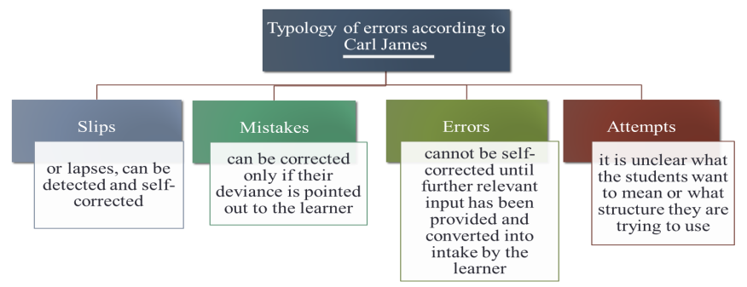
Picture 1. Typology of errors according to Carl James

- The first deviant form means slips of the tongue or lapses of memory that can be easily detected and self-corrected by its creator.
- Mistakes are language misfires that are so easy to self-correct. The learner is only able to correct mistakes if their deviance is pointed out to them. If learners are not made aware of their mistakes through teacher indication or further association with correct forms, there is the chance that fossilization could occur.
- Deviant language production of the third type, errors, cannot be self-corrected by the lan- guage learner until the learner receives additional relevant input, i.e., errors require more learning to make self-correction possible.
- Finally, solecisms are breaches of the rules of correctness as lay down by purists and usually taught in schools: split infinitive and dangling participles, for example.
In the distinction between errors and mistakes it is necessary not to forget about the criterion of correction, which also makes a difference. According to Allwright & Bailey (1991) «L2 learners can often correct their own mistakes, but the errors they make … are part of their current system of interlanguage rules and hence are not recognizable (to the learners themselves) as wrong». Hence if the learner is able to self-correct, we assume that the incorrect utterance is a mistake. When, however, the learner is not able to perform self-correction, we shall assume that it is an error.
Perhaps the most difficult challenge of language teaching is determining when not to ignore student’s errors. The role of a teacher is to distinguish between the different types of error and deci- de which need to be corrected immediately, which to focus on later and which not to correct. To make these decisions teacher should consider the level that students are at; what they have been working on recently in class and what the students should have mastered by now.
The simplified system which is proposed to resolve questions of correction is based on the following four criteria:
- Comprehensibility. Errors that cause a misunderstanding or lack of comprehension should be corrected by teachers in the first instance. While the main purpose of using a language is to com- municate ideas, correction becomes necessary to make the forms comprehensible.
- Frequency. The criteria distinguishes those errors that are made by an entire class or by individual students the value of learning a correct form of a frequent error is greater than with isolated mistakes because it is usually made on a common point of grammar.
- Pedagogical focus. If errors occur after a class spends time studying a particular grammar feature, they should be corrected. If error goes uncorrected, it may cause misconception of the grammar point by all of the students who hear it. This tendency is particularly relevant in the tradi- tional classroom where students are motivated by and concerned about tests and grades.
- Individual student concerns. Another aspect teachers should take in consideration is lear- ners’ personality. While more capable students can profit from corrections of minor points, others are more easily to become inhibited. Good teachers get to know the students and to learn who are the most sensitive to correction. Many SLL theorists agree that teachers should always suit correcti-

ЖАС ЗЕРТТЕУШІЛЕРДІҢ НАУЧНЫЕ РАБОТЫ
ҒЫЛЫМИ ЕҢБЕКТЕРІ МОЛОДЫХ ИССЛЕДОВАТЕЛЕЙ

on to their learners’ needs and individualities: «the most important thing is for the teacher to be flexible and to be aware of the effect on each individual learner of correcting errors».
Questions that arise when we come to error correction are how and by whom errors should be corrected. In general, it is possible to say that learners expect their teachers to correct them, because «that is the traditional view of what a language teacher does». Thus it means that due to the dominant position in classroom corrective feedback will be provided mostly by the teacher. But with CLT it slightly changed and teacher became one of the possible sources of correction. As Julian Edge claims, «The more the students are involved in correction, the more they have to think about the language used in the classroom». And since error correction supports the learning process, it is necessary to give such opportunities to learners.
There are several ways of correction that can be employed in the classroom.
1. The best form to use for correction is self-correction. After the student recognizes what is incorrect in his/her response, s/he should be able to correct him/herself. Self-correction is the best technique, because the student will remember it better.
To the positive effects of self-correction researcher refer this:
- With repeated self-correction, students better remember the right language and use it... which leads to establishing the right pattern, or habit... which leads to correct use of the language over time;
- Students' confidence increases with self-correction because they catch and correct their own mistakes.
On the other hand, it can have the opposite effect. Self-correction should take place quickly, hardly affecting the flow of the conversation. If students correct themselves too much, it hinders fluency. In addition, teacher also cannot always rely on students to catch their own mistakes. These may go uncorrected.
Peer correction: If the student cannot correct him / herself the teacher can encourage other students to supply correction. This technique is to be applied tactfully, so that the student who origi- nally made the mistake will not feel humiliated. In the case of errors, it is useful if after peer correc- tion the teacher goes back to the student who made the error and gets him/her to say it correctly. Advantages of peer correction are:
- It encourages cooperation, students get used to the idea that they can learn from each
other;
- Both learners (who made the error and who corrects) are involved in listening to and
thinking about the language;
- The teacher gets a lot of important information about the learners’ ability – if students learn to practice peer correction without hurting each other’s feelings, they will do the same in pair- work activities.
However, there are two problems with peer correction:
- It may happen that whenever the teacher asks for peer correction from the whole class, it is always the same students who answer. The idea of peer correction is to encourage cooperation, not to put one or two students in the traditional place of the teacher. In this case the teacher has to make sure that other students are involved as well.
- If students are not used to correcting each other, they may find it difficult to change their habits. They may feel that they are being criticized by people who have no right to criticize them. They may feel that the teacher is not doing his or her job properly. In this sort of atmosphere, peer correction is useless if not damaging.
Teacher correction: If no one can correct, the teacher must realise that the point has not yet been learnt properly. In that case the teacher can re-explain the problematic item of language, espe- cially if the teacher sees that the majority of the class has the same problem. There might be more repetition and practice necessary. We must not forget that the main aim of correction is to facilitate the students to learn the new language item correctly. That is why it is important that after correcti-

ҚМПИ ЖАРШЫСЫ №3 (47), 2017 ВЕСТНИК КГПИ №3 (47), 2017
ISSN 2310-3353 ISSN 2310-3353

on the teacher has to ask the student who originally made the error or mistake to give the correct response.
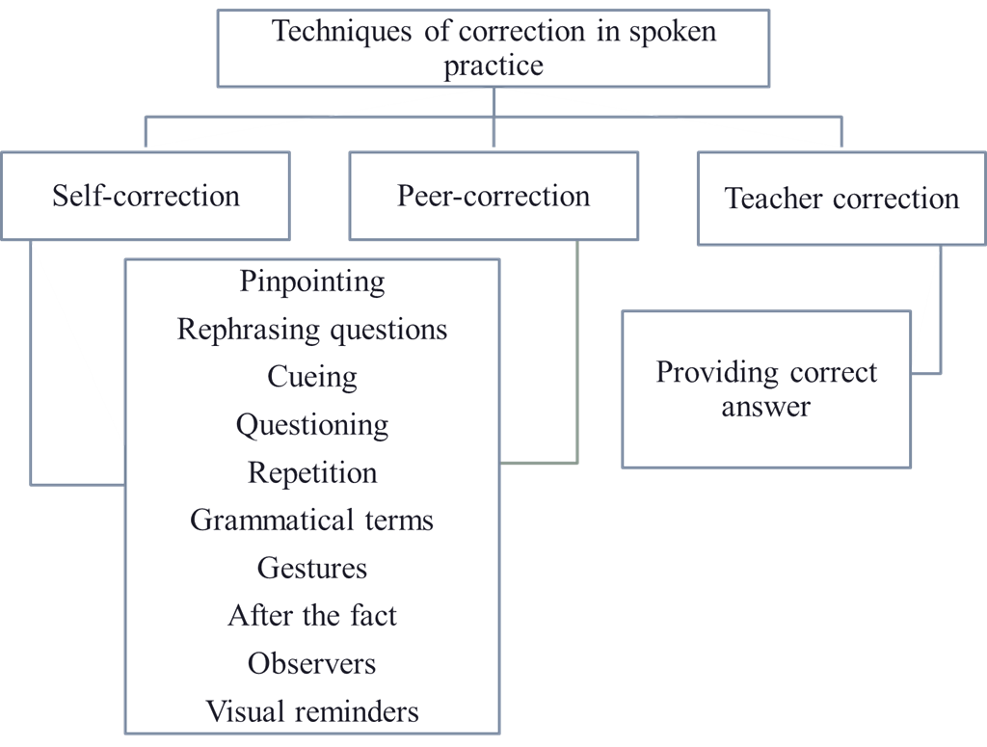
It can be concluded that teachers need to create a supportive classroom environment in which their students can feel confident about expressing their ideas and feeling freely without suffe- ring the threat or embarrassment of having each of their oral or written errors corrected. Further- more, teachers should know the techniques of error correction, both in oral and written errors.
Picture 2. Classification of correction techniques in spoken practice

The first group of techniques includes correction activities which can be applied for self-, peer- and teacher correction in spoken practice.

Self-correction techniques:
Although the students correct their own errors, the teacher does play a role by calling attention to the fact that a statement contains an inaccuracy.
- Pinpointing.
This is the term used to describe the teacher’s localizing an error without giving it away. It is suggested to repeat the student’s sentence up to the error. The last word before the error should have a slightly exaggerated vowel length and trailing intonation for the student to catch the idea that the fragment needs to complete again.
- Rephrasing question.
It is used in order to reduce the number of words. This technique should be used when the student indicates a lack of understanding of the question but does not make a grammar error.
- Cueing.
The teacher gives the grammatical variations of a key content word. This is possible when a student indicated difficulty forming a specific word.
- Questioning.
If the student uses a word that the teacher does not understand, the teacher should ask a question about it. The student should reveal the meaning of the word without making an obvious correction.
- Repetition.
Teachers should ask a student to repeat the sentence containing the error. In order to realize that an error has been made or where it is, teacher says the target language word for «Repeat» or

ЖАС ЗЕРТТЕУШІЛЕРДІҢ НАУЧНЫЕ РАБОТЫ
ҒЫЛЫМИ ЕҢБЕКТЕРІ МОЛОДЫХ ИССЛЕДОВАТЕЛЕЙ

«Again» with a question look, so the message would be clearer. It is a technique to try with the better students in class who need a challenge.
- Grammatical terms.
Localizing an error by mentioning what function it plays in the sentence (e.g., ‘verb’) can have limited use. This practice eliminates destroying the student’s chain of thought in the middle of a long sentence. Obviously, it is only useful with students who understand the vocabulary and who are fairly proficient. It should be noted that this technique does not focus on communication but rather on form or linguistic correctness.
- Gestures.
Under certain circumstances, errors can be corrected nonverbally. The great advantage of using gestures is that there is no additional verbal input to confuse the student. Furthermore, gestu- res often take less time than verbal correction, teachers may find several of these gestures useful.
- Yes-no. Nodding or shaking the head will get a student to continue or stop an utterance.
- Continue. Rolling the hand in a forward circle at the wrist will encourage a student who hesitates for fear of having made a mistake or let a student know that the sentence is not complete.
- Stop. Holding the palms toward a student will stop an unwanted interruption or an unnecessary lapse into the native language.
- Syntax. Flipping one hand over the other will let a student know that the word order is

wrong.

- Number. Singular can be indicated with one finger; plural with several.
- Stress. On the extended index finger of one hand, the teacher taps out the rhythm of the

word with the other index finger, using a more forceful tap on the stressed syllable.
- Elision. In languages where forms are elided, a gesture can indicate this type of error. The teacher puts the two palms parallel to each other and then moves them closer together in a pushing motion.
- Missing word. The teacher holds up all finger and points to each one as the student re- peats the sentence. When the student arrives at the missing word, the teacher exaggerates the gesture to indicate that word.
- Tense. A gesture of the hand can indicate that a sentence should be in the past (thrown over the shoulder) or the future (moved forward).
To be more clear, the teacher could accompany the motion with the name of the tense until the students learn the meaning.
After the fact.
To be used in freer activities like role plays, student monologues and discusses, where inter- rupting the student is not desirable. The teacher makes a note of the more frequent and serious errors and waits until the activity has finished before calling the student’s attention to the mistake and inviting him or the other students to correct. This may be followed by brief remedial work on any grammar points that have arisen.
Visual reminders.
Very often students forget the final «-s» in the simple present, third person singular. You may have a big S stuck on a wall that you can point to on such occasions, or point to something that will trigger the right response, like the picture of an S-shaped snake. Visual reminders are also great for vocabulary-related mistakes. A student may say «childs» instead of «children». You point to a picture of a group of children to indicate that something is wrong; the student has to figure out he or she used the wrong plural.

Peer-correction techniques:
There are no specific techniques for getting students to correct one another's errors in class. The teacher can use any of the techniques for self-correction suggested above simply by calling on another student who understood what he or she was trying to indicate to the first student. Instead of the teacher's providing possible answers, several students can do the same thing. The teacher can

ҚМПИ ЖАРШЫСЫ №3 (47), 2017 ВЕСТНИК КГПИ №3 (47), 2017
ISSN 2310-3353 ISSN 2310-3353

then return to the student who made the original error, and it will seem as if no correction had been made.
Observers.
In fluency activities, interruption of the learners is unwanted. They should concentrate on what their partner is saying. Occasionally it is useful to have someone concentrating on how things are said. In addition to the teacher walking round the class and making notes, it is possible to turn someone into observers.
  - The students work in groups of four. Three of them carry out the activity while the fourth one listens and tries to note down some mistakes that the others make. This person is the observer. The teacher makes sure that different students take turns at being the observer.
  - When the activity is finished, the observer shows the others what he or she has written down and the group discusses what is correct and what is wrong. Disagreements can be referred to the teacher.

Teacher correction techniques:
Providing correct answer.
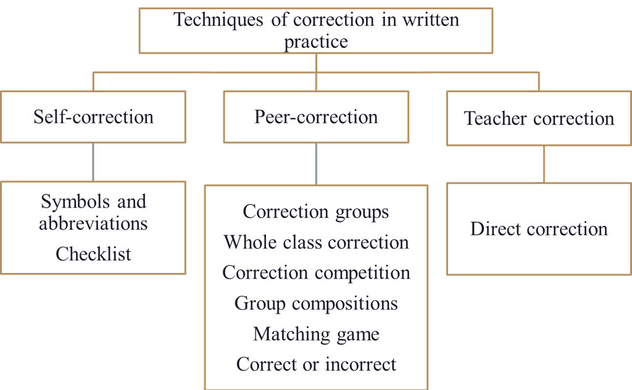
Although this has been widely criticized as not demonstrating that real learning is taking place, there comes a time when the teacher must tell the class what the proper form is. Often it is a question of saving time or reducing confusion, especially when two errors must be corrected. The teacher should re-turn to the student who made the error, ask for a repetition or reformulation, and look for a glimmer of understanding.
Picture 3. Classification of correction techniques in written practice

The second group of techniques proposes correction activities that will be useful for correc- ting students’ writings and practicing accuracy.

Self-correction techniques:
- Symbols and abbreviations.
The most frequently suggested method to motivate students to correct their own mistakes is to use a symbol or abbreviation for a grammatical term.
So, by underlining mistakes, or by giving clues in the margin, or by using both together, the teacher can help students see and correct mistakes in their own writing. These are some other signals that I have found useful:
sp = spelling;
p = punctuation; wo = word order; t = tense.

ЖАС ЗЕРТТЕУШІЛЕРДІҢ НАУЧНЫЕ РАБОТЫ
ҒЫЛЫМИ ЕҢБЕКТЕРІ МОЛОДЫХ ИССЛЕДОВАТЕЛЕЙ

Students go through that particular sentence to identify the error and correct it themselves. These approaches are more encouraging as students are usually able to correct themselves. It also supports the learning process by getting students to think for themselves and by getting them into the habit of reviewing their work.
Variations to make the task more complex:
Underline the mistakes; write the nature of the mistake, the student has to correct them.
- First phase, underline the mistakes and write the right symbol in the margin on the same
line.
- Second phase, underline the mistake and do not write the symbol. This helps the students
find the type of the mistake themselves
- Third phase, write the symbol on the margin, next to the line where the mistake is, but do not show exactly where the mistake is, and show only the line. This helps the student find the mistake, helped by the symbol put on the margin.
- Fourth phase, put a cross (X) on the margin, put as many crosses as mistakes are in a line.
The students will find the mistake and the type, knowing how many mistakes are in one line.
- Fifth phase, put a cross next to the line in the margin, but do not show how many mistakes are. This is a more difficult way of correction; it makes the students think about mistakes, knowing that there is something wrong in a particular line.
- Checklists.
Several writers have prepared checklists that students can use as reminders when they write compositions. Students go over their written work several times with a particular structure in mind each time. This can be individualized if a teacher knows a particular student has trouble with adjective agreement, for example.

Peer-correction techniques:
The simplest way of doing peer correction is to proceed in the ways described above for self-correction, but to have students work together in pairs or groups. There are two great advantages to this:
- When two students work together on correcting each other’s work, the discussion helps each one to learn from his/her own errors. Two heads are better than one.
- We all have difficulty in seeing our own mistakes, even if a teacher has given us a signal as to what sort of a mistake it is. Cooperation helps to develop an ability to see our own mistakes.
Another way of using peer correction is to organize a correction group.
- Correction groups.
- Divide your class up into four or five groups. The groups then take it in turns to be the correction group for a writing class.
- While the rest of the class gets on with this week’s writing task, the correction group is given last week’s piece of work which the teacher has marked, as described above, but not cor- rected. This means that three quarters of your class do the new writing task each week.
- Each student in the correction group, then, has his or her own paper and two others to look at. The students in the correction group work in twos or threes to correct the important mistakes that the teacher has marked.
- For the last part of the lesson, the students from the correction group return the papers to the students who wrote them and explain the corrections that they have made. The teacher goes round the class and helps where there are any disagreements or questions.
- Whole class correction.
The teacher can make a collection of mistakes from a class’s writing and put them on the board for discussion. Obviously, you choose mistakes that you think it would be useful for the stu- dents to think about and correct. This activity then allows the teacher to use actual student writing for class correction without embarrassing any individual student. Another possibility is to mix in with the mistakes examples of student writing which you think are particularly good. In this way, students are being invited first to evaluate what they read rather than just look for mistakes. It also

ҚМПИ ЖАРШЫСЫ №3 (47), 2017 ВЕСТНИК КГПИ №3 (47), 2017
ISSN 2310-3353 ISSN 2310-3353

means that the teacher can make positive comments on the class’s writing while giving useful mo- dels and encouragement.
- Correction competitions.
- The teacher can put ten mistakes on the board, or ten sentences of which seven or eight contain mistakes.
- The class is divided into groups of four.
- The groups work to correct the sentences.
- Then the teacher calls out one of the sentences on the board and asks one of the groups to say if something is wrong.
- If so, they must say what is wrong, and what a suitable correction would be. For each of these steps, the group gets one point if they are right.
- Other groups can challenge their answer and win points for themselves.
- Eventually, the mistake is corrected on the board and the class moves on to another item and another group.
- Finally, the points are counted to find the winning group.
The basic idea is to give the students some fun while they are concentrating on accuracy. At the same time, they are getting used to cooperating with fellow students to correct their own mista- kes.
- Group compositions.
This technique is useful to teachers who have a large number of students and cannot grade written work frequently. Groups of five students get together to write an essay. The teacher has less work because there are fewer papers and fewer errors to correct. In addition, the students get oral practice by discussing the assignment in the target language. The group writes the finished product on a same master and reproduces it for the entire class.
- Matching game.
This game needs a bit more preparation, but it is highly effective. It has two phases. In phase one, teacher creates and print one set of cards containing sentences with errors and another set of matching cards with the explanation of the errors. Teacher creates these sets of cards for each pair of students in the class. The aim of the game is for students, working in pairs, to match the errors with the explanations. Phase two. As a follow-up, and hopefully to reinforce learning, the cards are taken back and then teacher reads out one of the sentences containing an error. In pairs or groups, students now try to remember the explanation of the error and write it down. After each sentence, answers are checked with the whole class before moving on to another example.
- Correct or incorrect?
This is an error-correction activity that encourages discussion and stimulates learning. For this exercise, you’ll need to put students into pairs. As before, select sentences with errors from their essays and prepare two worksheets, A and B, containing a mixture of correct and incorrect sentences. Explain that, on both worksheets, the sentences are the same, but if a sentence on sheet A is correct, the same sentence on sheet B will have an error, and vice versa. Now give sheet A to one student in the pair and sheet B to the other. On their own, they work through the sentences, ticking good sentences or correcting the errors. Allow 10 minutes for this part. You could pair students with sheet A together at this stage to confer. Now, pair students A and B to discuss and compare their sentences, and decide which one is correct. Go over the answers with the whole class.

Teacher correction techniques:
Direct correction.
Amara (2015) suggests that if the student cannot understand indirect corrections, then speci- fic methods can be used. A general technique is to underline a word in order to call attention to a hint written near it. A misplaced word can be bracketed and placed in its proper order with an arrow. Superfluous words are simply crossed out. Semantic errors must often be corrected in the most direct manner possible: by providing the exact word. A direct correction, as defined by Amara,

ЖАС ЗЕРТТЕУШІЛЕРДІҢ НАУЧНЫЕ РАБОТЫ
ҒЫЛЫМИ ЕҢБЕКТЕРІ МОЛОДЫХ ИССЛЕДОВАТЕЛЕЙ

is when the teacher tells the student where the error is and what the correct form is. The teacher uses symbols whenever possible to save time in rewriting the sentence.

4. Conclusion.
In conclusion we can say that, whichever way is chosen to correct students, we should try to keep the experience positive for the learner. Being corrected constantly can be a really demotiva- ting, as every language learner knows. As you are listening out for your students’ errors, make sure you also listen out for really good uses of language and highlight these to the group too. In the case of language learning we really do believe the classic saying, «you learn from your mistakes».

References
- Amara, N. Errors Correction in Foreign Language Teaching [Text] / N. Amara // The Online Jour- nal of New Horizons in Education. – 2015. – №3. – С. 58-68.
- Allwright, D. Focus on the language classroom [Text] / D. Allwright, & K.M. Bailey. – Cambrid- ge: [w.e.], 1991. – С. 80-85.
- Dulay, B.M. Errors and Strategies in Child Second Language Acquisition [Text] / B.M. Dulay. – [w.p.]: TESOL Quarterly, 1982. – С. 60-68.
- Edge, J. Mistakes and correction [Text] / J. Edge. – Harlow: Longman, 1990. – С. 10-18.
- Ellis, R. Corrective Feedback and Teacher Development [Text] / R. Ellis // L2 Journal. – 2010. –
№1. – С. 3-18.
- Spratt, M. et al., The TKT course [Text] / Spratt, M. et al. – Cambridge: CUP, 2012. – С. 25-39.

Article submitted to editorial office: 17.05.2017

КОВАЛЕНКО А.В., КУДРИЦКАЯ М.И.
ШЕТ ТIЛIН ҮЙРЕТУДЕГІ ҚАТЕЛЕР ЖАНЕ ОЛАРДЫҢ ТҮЗЕТУ ӘДІСТЕРІ
Мақалада қатенің мағынасы және оның маңызды бөліктері, шет тілдерін үйренуде алатын орны жөнінде айтылған. Мақалада ағылшын тілін оқыту және жазуды үйренуде негізгі бөлінетін қателіктердің әдістері де қарастырылған. Егер мұғалім қателерді жөндеп отырса, оқушылардың сабаққа деген шабыттары оянады. Әдетте мұғалімдің оқушылар жіберген барлық қатені жөн- дейді. Бірақ тіл үйретудің соңғы тенденциялары мұғалімге бала қате жібергеннен кейін бірден жөн- деудің керек еместігін сілтейді
Мақаланың мәнін ашатын сөздер: қате, қаnелерді жөндеу, қателердің түрлери, шет тілдерді үйрену.
КОВАЛЕНКО А.В., КУДРИЦКАЯ М.И.
ОШИБКИ И МЕТОДЫ ИХ КОРРЕКЦИИ ПРИ ОБУЧЕНИИ ИНОСТРАННОМУ ЯЗЫКУ
В статье рассматривается понятие ошибки и ее основные типы, а также значимость оши- бок в обучении иностранному языку. Основное внимание в статье уделяется различным методам коррекции ошибок в устной и письменной речи учащихся при изучении английского языка. То, как учи- теля справляются с ошибками, оказывает значительное влияние на деятельность учащихся и жела- ние участвовать. Традиционно учителя исправляют все ошибки, допущенные учениками. Тем не ме- нее, последние тенденции преподавания языка свидетельствуют о том, что учителям не нужно исправлять все ошибки сразу после их создания.
Ключевые слова: ошибка, коррекция ошибок, типы ошибок, обучение иностранному языку.

