КОСТАНАЙСКИЙ ГОСУДАРСТВЕННЫЙ ПЕДАГОГИЧЕСКИЙ УНИВЕРСИТЕТ ИМЕНИ У. СУЛТАНГАЗИНА
ЕСТЕСТВЕННО-МАТЕМАТИЧЕСКИЙ ФАКУЛЬТЕТ
КАФЕДРА ИНФОРМАТИКИ, РОБОТОТЕХНИКИ И КОМПЬЮТЕРНЫХ ТЕХНОЛОГИЙ

Ерсултанова З.С.
Айтбенова А.А.
Даулетбаева Г.Б.

“INFORMATION AND COMMUNICATION TECHNOLOGIES. PART 2”
(учебное пособие на английском языке)

КОСТАНАЙ
2019
УДК 004.4(075.8)
ББК 32.973я73
Е 73

Авторы:
Ерсултанова З.С. к.т.н., ассоциированный профессор кафедры
ИРиКТ КГПУ им.У. Султангазина
Айтбенова А.А. м.п.о., старший преподаватель кафедры
ИРиКТ КГПУ им.У. Султангазина
Даулетбаева Г.Б. м.е.н., старший преподаватель кафедры
ИРиКТ КГПУ им.У. Султангазина
Рецензенты:
Баймухамедов М.Ф. доктор технических наук, профессор, проректор
по науке и международным связям КСТУ
им. З. Алдамжарова
Касымова А.Г. к. ф.-м., ассоциированный профессор кафедры
физико-математических и общетехнических
дисциплин КГПУ им.У. Султангазина

Ерсултанова З.С.
Е 73 “Information and communication technologies. Part 2” : учебное
пособие на английском языке / З.С. Ерсултанова,
А.А. Айтбенова, Г.Б. Даулетбаева. – Костанай: КГПУ
им.У. Султангазина, 2019. – 164 с.

ISBN 978-601-7934-94-1

Пособие на английском языке можно рассматривать как единую систему целей, содержания, методов, форм, средств обучения и управления учебной деятельностью с использованием новейших информационных технологий. Основной целью учебника является расширение профессиональных знаний и развитие информационной компетентности будущих учителей в школе.

УДК 004.4(075.8)
ББК 32.973я73

Рекомендовано к печати решением научно-методического совета Костанайского государственного педагогического университета
им. У.Султангазина

ISBN 978-601-7934-94-1

© Ерсултанова З.С., Айтбенова А.А., Даулетбаева Г.Б. , 2019.
© КГПУ им.У. Султангазина, 2019.
CONTENT

 | IINTRODUCTION.......................................................................... | 4
I LECTURES
1.1 | Lecture№8. Cybersecurity…………………………………………. | 5
1.2 | Lecture №9. Internet technologies………………………………… | 17
1.3 | Lecture №10. Cloud and mobile technologies…………………… | 24
1.4 | Lecture №11. Multimedia technologies…………………………… | 30
1.5 | Lecture №12. Smart Technologies………………………………... | 37
1.6 | Lecture№13. E-technologies. Electronic business. E-learning. Electronic government…………………………………………….. | 42
1.7 | Lecture №14. Information technologies in the professional sphere. Industrial ICT………………………………………………. | 50
1.8 | Lecture №15. Perspectives of development of ICT…………….. | 55
II PRACTICAL WORKS
2.1 | Practical work № 1 Introduction to MS Office Power Point 2007. ………………………………………………………………… | 60
2.2 | Practical work №2 Use of triggers in ms office Power Point 2007…………………………………………………………………. | 68
2.3 | Practical work №3. Create presentations with Prezi…………… | 72
2.4 | Practical work №4. Introduction to HTML……………………….. | 77
2.5 | Practical work №5. HTML. Work with paragraphs, line breaks and horizontal lines………………………………………………… | 86
2.6 | Practical work №6. Character formatting…………………………. | 90
2.7 | Practical work №7. Create lists……………………………………. | 94
2.8 | Practical work № 8. Insert graphic image (picture) creating hyperlinks…………………………………………………………… | 97
2.9 | Practical work №9. Graph editors: Inscape……………………… | 103
2.10 | Practical work №10. Introduction to Snagit and Snagit editor…. | 107
2.11 | Practical work №11. Writing a video file in Camtasia Studio…... | 117
2.12 | Practical work №12. Create video with presentation Power Point on Camtasia Studio………………………………………….. | 123
2.13 | Practical work №13. Internet. Cloud technologies……………… | 128
2.14 | Practical work №14. Electronic Government……………………. | 138
2.15 | Practical work №15. Create a course in Moodle for distanse education……………………………………………………………. | 141
 | Test assignments…………………………………………………… | 148
 | Activities …………………………………………………………….. | 155
 | References………………………………………………………….. | 162

INTRODUCTION

Information and communication technologies is one of the fundamental branches of scientific knowledge that forms the system-information approach to the analysis of the world, studying information processes, methods and means of obtaining, transformation, transmission, storage and use of information.
The most important methodological principles of information and communication technologies is the study of objects and phenomena of the world in terms of data collection, processing and delivery of information about them, as well as a certain similarity of these processes in their implementation of artificial and natural systems. The most important task is the study of computer science and software interface between humans and hardware processing.
The purpose of the book is to train highly qualified professionals with skills to use modern information technologies in the professional sphere. As a result of studying the discipline the student will
-basic concepts of automated data processing;
-basic methods and means of processing, storage, transmission and storage of information;
-basics of algorithms tasks;
-purpose and principles of the use of system and application software;
-basic components and principles of information and telecommunication networks;
In these book considered second module content: Cybersafety; Internet technologies; Cloud and mobile technologies; Multimedia technologies; Smart Technology; E-technologies. Electronic business. E-learning. Electronic government; Information technologies in the professional sphere. Industrial ICT; Perspectives of development of ICT. The modules have are both theoretical and practical materials.
The textbook in English is intended for studying the discipline "Information and communication technology" by students of various pedagogical specialties and includes both theoretical and practical material for mastering the subject. Materials for the study of the first seven topics of the discipline program are chosen in a clear and accessible way, which include accompanying drawings, tables and other illustrations by topic. Also, the training manual is supplemented with questions for self-preparation and test assignments,activities for testing knowledge and a list of references recommended for self-study of the discipline.

I LECTURES
1.1Lecture 8. Cybersecurity.

Objective: To have an idea of information security in business and government.
Plan: 1. Information security risks and their classification. Cybersecurity industry. Cybersecurity and Internet control.
2. Malicious applications. Measures and means of information protection.
3. Standards and specifications in the field of information security. Acts of the Republic of Kazakhstan governing legal relations in the field of information security.
4. Digital signature. Coding.

1. Information security risks and their classification. Cybersecurity industry. Cybersecurity and Internet control.
One of the key aspects of the Security Automated System (AS) problem is the identification, analysis and classification of potential threats to specific speakers. A list of the most important threats is their key to optimize their probability and assessing the attacker's model.
Information security risk is a set of circumstances and factors causing potential or actual threats to information security. AS security risk is the ability to promote the processing of information processed in the IS that may cause the privacy, integrity, or availability of information, as well as the ability to affect IT components, or the cancellation or decommissioning of the operation.
A threat to information security is an entity that is a direct cause of the danger of the security information
Key Sources of Security Damage AS:
• accidents and disasters (fire, earthquake, storm, flood, etc.);
• Hardware malfunctions and malfunctions;
• Components of design and development of AC (software and data processing technology, hardware, etc.); Work error;
• Intentional acts of violators.
Risk classification has many dimensions. Consider the most widespread.
1. Nature of nature: natural and man-made Natural hazards - the danger caused by the natural physical processes or natural phenomena associated with AS and its objective elements. In turn, artificial hazards are a threat to AS caused by human activity.
2. Degree of motivation: accidental (casual) and intentional. Depending on the first mistakes - in the design of IP, human error in work with IP, etc. The second group concerns self-sufficiency and other ideological goals. This case is pest. Important material gains, revenge, moral convictions, and so on. may be.
3. Position in relation to managed areas: internal and external threats. For example, external threats may be the retention of a network or PEMIN leaks. Internal threats include theft of mass media with sensitive information, damage to equipment, and use of various types of bookmarks.
4. Degree of exposure to AC: passive and active. Passive risk is the risk that AS does not violate the composition and normal operation. For example, copying, listening, etc., through the technical information channels of leakage of sensitive information. Active risk destroys normal operation, structure, or composition of AC.
5. Confidentiality, Availability, Integrity Privacy Statement.
6. Risk-oriented system: A system based on a personal workstation and a system that has a connection with PSTN.
7. Implementation: Unauthorized access to protected information (including accidental), specific information impacts, leakage of technical information through leakage.
Information security is concerned with the confidentiality, integrity and availability of data regardless of the form the data may take: electronic, print, or other forms. Means protecting information and information systems from unauthorized access, use, disclosure, disruption, modification, or destruction.
Internet security is a branch of a computer security specifically related to the Internet.
It’s objective is to establish ruls and measure to use against attacks over the Internet.
Goals of information security. The common threat among good information security objectives is that this three core sequrity principles:
- Confidentiality –prevents unauthorized disclosure of systems and information;
- Integrity- prevents unauthorized modification of systems and information;
- Availability- prevents disruption of servise and productivity.
Computer security also known as cybersecurity or IT security, is the protection of computer systems from the theft or damage to the hardware, software or the information on them, as well as from disruption or misdirection of the services they provide.
Advantages of cybersecurity: Defend us from critical attacts. Browse the safe website.
- Cyber - A prefix that indicates relevance to, or involvement with, computers, computer systems, and electronic control systems.
- Cybernetics- The study of control system theory in terms of the relationship between animal and machine behavior.
- Cyber Sapiens- An expression for a computer or robot with artificial intelligence (AI) on the forefront of current technology.
- Cyber security is a set of tools, policies, security principles, security guarantees, risk management approaches, actions, training, insurance and technology, which are used to protect the cyber environment, resources, organizations and users.
- cyberspace 1. Alternative expression for information superhighway. 2. Аlternative expression for virtual reality.
- Cyborg - Acronym of the words cybernetic and organism.1.A human being with at least one artificial body part, such as a prosthesis(artificial limb). 2. A human being who is largely composed of robotic body parts.
- cyber [ADJ-U8] It something is cyber, it is related to computers or the Internet.
- cyber criminal [N-COUNT-U1 OJ A cyber criminal is a person who uses computers and the Internet to commit crimes such as identity theft and fraud.
- cyber vandalism- cyber attacks that deface web pages.
- cyber war- the usage of computers and the Internet in conducting warfare in the cyberspace.
Computer security Challengies. Novice, contrintiutive, involved. Users tent to not see the benefits of security until a failure occurs. Is often an afterthrought to be incorporated into a system after the design is complete. Throught of as an impediment to efficient and user-friendly operation. Conducting warfare.
It uses two methods: forcing the targeted computer(s) to reset, thus consuming its resources so that it can no longer provide its intended service; or obstructing the communication media between the intended users and the victim so that they can no longer communicate adequately. Overwriting virus, piggybacking, replicate, resident possible extension, resident virus, virus consequences Newspaper anti-antivirus virus, hacker, imbed, infect, log in, overwriting virus, piggybacking, replicate, resident possible extension, resident virus, virus consequences:
- Identity Theft- card scanning, cyber, fraud, harming, identity theft, Discussing malware,
- phishing, pretexting, scanner, spyware, suspicions Trojan horse, worm
- Preventative Email - attack, audit log, authenticated, backdoor, bug, firewall, Checking Measures intruder, keylogger, popup, protocol, security certainty
- Anti-virus Advertisement- anti-virus software, backup, block, cyber criminal, detect,
- Software false negative, false positive, rootkit, security software, capabilities sweep, virus removal software, webpage analysis.
Settings. Stay anonymous-choose ganerless screen name. Internet privacy. It includes controlling physical access to the hardware, as well as protecting against harm that may come via network access, data and code injection, and due to malpractice by operators, whether intentional, accidental, or due to them being tricked into deviating from secure procedures.
2. Malicious applications. Measures and means of information protection.
Types of viruses and malware Description
Joke Program Joke Program is a virus-like program that usually changes the appearance of items on a computer screen.
Trojan Horse A Trojan horse is an executable program that does not reproduce itself and is introduced into the system to perform potentially dangerous actions, such as opening ports for hackers to access. This program often uses the Trojan Horses ports to gain access to the system. An example of the Trojan Horse program is the statement that it protects your computer from viruses when it actually injects them into the system.
Virus A virus is a program that can reproduce itself. For this, the virus was attached to any program. As a result, it will be automatically executed during program startup. Boot virus: a type of virus that infects the boot sector of a partition or disk. Java Malware: Platform-independent virus code written in Java or embedded in a Java application. Macrovirus: A type of virus written as an application macro and often included in a document. VBScript, JavaScript, or HTML Viruses: Viruses that are found on web pages and downloaded through a browser. Worm: a standalone program (or set of programs) that can distribute its copies or segments to other computers, often via email
Test Virus A test virus is an inactive file that is detected by an antivirus program. Test viruses (for example, the EICAR test script) are used to verify the correct operation of the antivirus.
Packer Packer is a compressed and / or encrypted executable file for Windows or Linux, and you are often a Trojan horse. Compressing an executable packer is difficult to determine with antivirus software.
Likely virus / malware This category of viruses and malware are suspicious files with some signs of a virus or malware. For more information about probable viruses or malware, see the following page of Trend Micro's online virus encyclopedia: http:// www.trendmicro.com/vinfo/emea/ virusencyclo/default.asp
Other Viruses and malware that do not belong to any of the above types fall into the “Other” category.
- malware- software designed to infiltrate or damage a computer system without the owner’s informed consent
- VBScript - Visual Basic Scripting Edition - an Active Scripting; technology used in Windows to implement component-based scripting support; a language developed by Microsoft social engineering- practice of obtaining confidential information by manipulating users
- Barok trojan - this trojan horse gathers information such as user name, IP address and passwords, and attempts to send the information to the creator of the virus
- hacker [N-COUNT-U?] A hacker is a person who exploits computer hardware and software for their own purposes.
- hang [V-T-U4] To hang a website is to prevent it from loading all the way.
- host [N-COUNT -U?] A host is a computer system that has a computer virus attached to it.

Mainframe- computer used by large companies for critical operations like financial transaction processing
• bot- a program used on the Internet that performs a repetitive function such as posting a message to multiple newsgroups or searching for information or news;
• botnet - a collection of software robots, or bots linked and cooperating with each other;
• cyber war- the usage of computers and the Internet in conducting warfare in the cyberspace;
• cyber vandalism- cyber attacks that deface web pages;
• hacktivism- combination of words: “hack(er)” and “activism” ;
• Denial of Service- a kind of cyber attack which results in unavailability of service.
It uses two methods: forcing the targeted computer(s) to reset, thus.
Consuming its resources so that it can no longer provide its intended service; or obstructing the communication media between the intended users and the victim so that they can no longer communicate adequately.
- overwriting virus, piggybacking, replicate, resident possible
- extension, resident virus, virus consequences Newspaper anti-antivirus virus, hacker, imbed, infect, log in, overwriting virus, piggybacking, replicate, resident possible extension, resident virus, virus consequences
- Identity Theft- card scanning, cyber, fraud, harming, identity theft, Discussing malware, phishing, pretexting, scanner, spyware, suspicions Trojan horse, worm
- Preventative Email - attack, audit log, authenticated, backdoor, bug, firewall, Checking Measures intruder, keylogger, popup, protocol, security certainty
- Anti-virus Advertisement- anti-virus software, backup, block, cyber criminal, detect,
- Software false negative, false positive, rootkit, security software, capabilities sweep, virus removal software, webpage analysis.

Anti-antivirus virus [N-COUNT-U7] An anti-antivirus virus is a computer virus that attacks and often disables anti-virus software.
Anti-virus software [N-UNCOUNT-U1 OJ Anti-virus software searches a computer system for computer.
- Apple® [N-UNCOUNT-U1] Apple is the company that produces Macs® and other computing products.
- applet [N-COUNT-U3] An applet is a small application that is embedded in a webpage.
- attack [N-COUNT-U9] An attack is an attempt to get through computer security.
- audit log [N-COUNT-U9] An audit log is a record of who has accessed a computer system and what actions they took.
- authenticate [V-TRANS-U9] To authenticate something is to make sure that it is legitimate.

3. Standards and specifications in information security field. The acts of the Republic of Kazakhstan governing legal relations in the sphere of information security.
Law of the Republic of Kazakhstan on National Security of the Republic of Kazakhstan (as amended on 26. 07. 2016) Article 4. Types of national security.
Basics of security - information stored on computer systems, programs, commands, data, and more, which is valuable to its owner and security holder.
Information Security Objects:
• All types of information resources
• The right of citizens, juridical persons and states to receive, distribute and use information, confidential information and intellectual property rights
• Formation, distribution and use of information resources, including its various classification information systems, libraries, archive bases and bank data, information technology, regulations and collection, processing, storage procedures and information transfer, scientific and technical and service personnel
• Infrastructure, information processing and analysis center, information exchange and telecommunication channels, mechanisms for the operation of telecommunications systems and systems, including systems and tools for information security
• The public-minded system of public opinion formation
The main principles of public policy in the field of information security, based on information security, are as follows:
• Restricting the use of information is prohibited only through law
• Information storage, confidentiality and disclosure are entrusted to responsible persons
• Access to any information, including restrictions, is governed by a proprietary law
The State creates a legal framework to regulate the rights and obligations of all subjects working in the field of information
- Legal and natural persons, personnel and confidential information collectors and editors are legally responsible for their confidentiality
- The state protects the public from libel, modification and fraudulent information through legal means
- The state exercises control over information security through mandatory certification and licensing
- The state sponsors national media and information security tools and carries out measures to protect against the inadequate access to information and information products
- The state promotes the integration of citizens into global information resources and global information systems
- The state tries to abandon the use of informational technologies and information means abroad, as it develops competitive domestic information technology and information tools.
- Due to the above principles and conditions the state determines the main directions of the establishment of information security in the political, economic, military and other spheres.
- The main object of information security of the Company, individual person, state, society is the information protected by copyright and patent rights, preserving state, commercial secrets, life of society and life of the individual.
- The information security system includes legislative acts and normative legal documents (legal support / information protection of scientific research and technical information, which is based on the following fundamental principles:
- Maintaining an interest balance of an individual, society and state in the information sphere
- Uniqueness of information storage processes
- The complex character of hazard protection
- Economic integrity and so on
- Key elements of the system include information security, legal, organizational-methodological and scientific-technical base, certification and licensing, and training.
- The concept of "protection of information" can be represented by two different hierarchical systems:
- Information security system
- Information security system
- The information security system in the information security system includes information that is transmitted in any form and used to store, process, and transmit information means.
- The information storage system should meet the following requirements:
- Reliable
- Full control of all threats
- Hierarchical organized, uninterrupted, standard ways and reliability of information protection tools and more.
- Information security systems should maintain two key protection features, which eliminates two types of dangers:
- Compromise of confidentiality, ie unauthorized access to information, copying or theft, decoding and decryption of information
- Preventing deliberate or accidental destruction, deletion, blocking or modification of information
- Thus, "information security" describes the degree of information security of human, society, state, and nature, and relates to objects of information, information systems and technologies protection.
- Information resources are protected by law, such as the array of documents and documents, information systems, people, organizations, local administrations, public organizations, objects of state ownership, and other resources.
- In fact, informational resources are defined by the norms as follows:
- Procedure for documenting information
- Ownership of individual documents and arrays in the information system
- Its category of access to information
- The order of legal protection of information
- Personnel is referred to as a documented individual. Personnel entries include nominative and non-nominal data.
- Nomatic is a person's personal identification code, surname, name, patronymic, address, place of work and more.
- Non-natu- ralized, individually-verbose.
- Personnel entitlements include limited access to information. It is open information for the subject, and the subject solves it: whether it can be applied or dispatched or used for any subject. Some of the categories of staff may not have a protection mode, for example, surname, name, patronymic, date of birth of public figures. Procedure for removing the nominal data from the personal information removes the protection regime, which allows applying the data for historical, statistical, sociological and other scientific research.
- An agreement with a subject shall be made upon the conclusion of a contract with the staff of non-state legal and natural persons.
- There are rights and responsibilities of the staff.
- State authorities and organizations, local authorities have the right to work with the personnel assigned under the law or licensed under their competence.
- Non-state juridical and physical persons also have the right to work with personnel under license

4. Digital signature. Encoding.
In 1976, Diffie and Hellman introduced the concept of authentication on the basis of "digital signature" to authenticate the information. Each customer in the system has a secret key that is required for the signature, the public key for this key is key to the signature, which is known to other users of the system, known to all users / users. In the proposed scheme, the digital signature is determined on the basis of a secure consumer information and a private key that transmitted this information. Each customer can authenticate the information with a public key corresponding to it. Also, knowing the public key can not change the signature. Such authentication schemes are called asymmetric.
Despite the algorithm used, the signing procedure has two procedures: the signature creation procedure and the verification procedure, the difference between them is that only the secret key used by this procedure is applied to the executing procedure. Only in this case may arise the dispute arising in the decision of the arbitrator, that the signature being issued by the person having the appropriate key.
The scope of the digital signature is the information systems between the non-trusting environment (financial systems, systems for monitoring compliance with international treaties, such as nuclear explosive agreements, etc.). Digital signature schemes may be used to create an "electronic notary" for the purpose of copyrights for software products. When it comes to digital signature:
1. Everyone uses their universal key for signing documents.
2. It is virtually impossible to document the document without the knowledge of a secret key, which is practically impossible for the secret key to be used.
3. The digital signature in the document is the function of keeping this document and secret key.
4. A copy of the digitally signed copy of the document does not differ from the original (there is no problem with signing up for each copy).
Methods for creating digital signatures
1. Everyone has a unique characteristic of himself / herself, which is characterized by the typing of letters, pressure on the pen and so on.
2. Signature attempts are determined by graphological analysis.
3. The signature and the signed document are issued only on one sheet of paper. The signature does not depend on the content of the document.
4. A copy of the signed document will be canceled if it is not actually signed. / or, valid, if any.
Passwords
Passwords typically use as a key used to sign in, which are used for other purposes: locking the drive on a disk, blocking the command line commands, that is, when required actions and actions are required only with the legitimate owners or software consumers that require a certain degree of reliability.
The following passwords can be divided into seven main categories:
• User-generated passwords / user-defined passwords /
• System - generated passwords / generated system /
• Random access codes are provided by the system
• Partial words
• Key words
• Interactive circuits, "question - answer" type / interactive follow - up type "question - answer" /.
• "strict" passwords / password "password".
The first group is widespread. Most of these passwords belong to the "self-selection" type. To protect against unauthorized access, you need to select a long password, so the system typically requires at least four to five passwords. There are other measures that do not allow the consumer to create unwanted passwords. For example, the system may require the following: password contains parentheses and uppercase letters. There are many programs on a variety of operating systems to view passwords, analyze user passwords, and determine how secretly they are. Switches invalid passwords.
If a person initiates a computer for the first time and then asks for a password, that password may be relative to all chapters in general. When a question appears on the monitor screen, people are thinking about doing something promptly. All people think about the same thing when making a quick decision. Consumers will come to their thoughts for the first time. At the same time, they have heard or seen what they do after launching the computer. In such a hurry case, a password is generated, and subsequent repetition of it is very rare. That's why most passwords created by customers are quickly opened.
The system itself generates random passwords and codes. The system software can use a randomly generated symbol sequence. or generating procedures. Computer-generated passwords are derived from ordinary words such as onah.foopn or ocar-back-treen.
Half-words are often consumers, sometimes a process. If a consumer loses an easy password, for example, a "paragraph," the computer makes a confusing password such as "paragraph 3y37".
The key phrases are long and easy to handle, and are easy to use because they are easy to remember. Phrases should be meaningful, for example, "we are concerned about it" or "fishing nose." It should be noted that gradual use of key words has become widely used in programming. Key concepts of the concept of acronym concepts near the concept of code acronym /, intelligence experts will shorten it as the safest form of password. In the acronym, the user will quickly save the phrase, phrase, poem line, and so on. and, as a password, use their capital letters. For example, the two abbreviations mentioned above are called "boa" and "bam" / "we are concerned about it" and "fishing nose". Such innovation is a lot of trouble in the theory of passwords in electronic espionage.
Interactive circuits "question-answer" usually recommends the consumer to answer individual questions: "Your fiancée's daughter's name?", "Do you love / color /?" Many responses to these questions remain on the computer, and when the customer logs on, the computer compares the received responses with "correct" answers.
Systems that use the "Questions and Answers" password break down the customer every 10 minutes and ask questions and ask them to verify their ability to work with the system. These passwords are not currently valid.
Strong passwords are typically used with external electronic or mechanical structures. In this case, the computer simplifies several options, and the customer must respond accordingly. These passcode types are found in single-use systems. This type of password is used by potential customers to create temporary copies of the guests for the convenience of the system. They are used when entering the customer for the first time. The customer enters his / her personal password in his / her first session and then logs in with the password in the system. One-time codes may be used on the system if the user first logs in to the user, after which the customer should replace the user with his / her secret personality code. If a group of people uses the system and needs to be kept confidential, it will refer to the list of single-use codes. Each customer in this case will enter the code according to that date or the day of the week.
In order for the password to be reliable, it must meet certain requirements:
• Availability of a certain length
• Writing and uppercase characters input / included in propisn, as well as strict buckets /
Contains one or more numbers Contains no one and no alphanumeric characters.
Encryption - reversible transformation of information in order to conceal from unauthorized persons, providing, at the same time, authorized users access to it. Mainly, encryption is the task of the confidentiality of information transmitted. An important feature of any encryption algorithm is to use the key that approves the choice of conversion of the plurality of potential for this algorithm.
- The Vigenure encryption is a method of encrypting alphabetic text by using a series of different Caesar ciphers based on the letters of a keyword. It is a simple form of polyalphabetic substitution.
- The Vigenure encryption has been reinvented many times. The method was originally described by Giovan Battista Bellaso in his 1553 book La cifra del. Sig. Giovan Battista Bellaso; however, the scheme was later misattributed to Blaise de Vigenure in the 19th century, and is now widely known as the "Vigenure encryption".

Questions:
- What kind of attachment was in the ILOVEYOU worm?
• It was a visual basic script.
2. In what language was the ILOVEYOU worm written?
• VBScript programming language
3. When was the ILOVEYOU worm detected?
• 4th May, 2000
4. Who created the Barok trojan?
• Onel de Guzman, a Filipino student
- What action did the Pentagon take in order to protect itself from the ‘I Love You’ virus?
• Pentagon had to shut down own e-mail system.
6.What is the basis of security?
7. What is information resources?
8. What type of staff are listed?
9. Describe the concept of digital signature.
10. What are "strict" passwords?
11. What is keyword?

1.2 Lecture number 9. Internet technologies.

Objective: to acquaint the student with the Internet, to acquaint with e-mail.
Plan:
1. Basic concepts of the Internet. Universal resource identifier (URI), its purpose and components. DNS service.
2. Web technologies: HTTP, DHTML, CSS and JavaScript.
3. Email. Message format
4. Protocols SMTP, POP3, IMAP.

1. Basic concepts of the Internet. Universal resource identifier (URI), its purpose and components. DNS service.
A URL (Uniform Resource Locator) is a form of URI and is a standardized naming convention for addressing documents available via the Internet and Intranet. An example URL is http://www.com/puterhope.com, which is the URL of the Computer Hope website.
URL Review
Below is additional information about each of the sections http URL of this page.
Http: //
“Http” means the hypertext transfer protocol and allows the browser to find out which protocol it uses to access information specified in the domain. After http is a colon (:) and two slashes (//), which separate the protocol from the rest of the URL.
Then, www.stands for the World Wide Web and is used to distinguish content. This part of the URL is optional and may be skipped many times. For example, entering “http://computerhope.com” will still take you to the Computer Hope web page. This part of the address may also replace an important subpage, known as a subdomain. For example, http://support.computerhope.com redirects you to the main Computer Hope help topic.
computerhope.com
Next, computerhope.com is the domain name for the site. The latter part of the domain is called the “domain suffix,” or TLD, and is used to determine the type or location of the website. Dozens of other domain suffixes are available. To obtain a domain, you must register the name through a domain registrar.
/ Jargon / u /
Further, the jargon and u parts of the above URL are directories of where the web page is located on the server. In this example, the web page consists of two directories, so if you try to find a file on the server, it will be located in the / public_html / jargon / u directory. On most servers, the public_html directory is the default directory containing HTML files.
url.htm
Finally, url.htm is a real web page in the domain that you are viewing. The final .htm is a web page file extension that indicates that the file is an HTML file. Other common file extensions on the Internet include .html, .php, .asp, .cgi, .xml, .jpg, and .gif. Each of these file extensions performs different functions, like all types of files on your computer.
The URL structure is shown in the figure below.

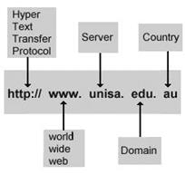
Figure 1. URL structure

There are several domains available on the Internet, such as:
edu = educational institute
com = commercial enterprise
government = government
organization = organization
network = network provider
mil = military

2. Web technologies: HTTP, DHTML, CSS and JavaScript.
Internet protocols

Internet Protocols:
- SMTP SimpleMailTransfer Protocol for sending email
Mail protocol between servers
- POP3 PostOfficeProtocol Used by local email clients for email
version 3 get email from remote server via TCP / IP compound
- FTP FileTransferProtocol Used to transfer files.
from one host to another host files via a TCP based network
such as the Internet.
- HTTP HyperTextTransfer Define show messages worldwide
Protocol formatted and transmitted, Internet (www)
and what kind of web action server browsers should take in response to the wide Range of commands.
- HTTPS HyperTextTransfer Provides WorldWide Authentication
Protocol Secure Web Site and Related Web Site (www)
web server and protects against the man in the middle attacks.
- VoIP VoiceoverInternet It allows people to use online
Internet protocol as chat (there is medium for exceptions) phone calls.
The Internet uses different languages to transfer information from one place to another. These languages are called protocols. Using these protocols, we can purchase services over the Internet. Each protocol has a certain functionality, and www is considered the largest service received among the services provided by the Internet.
Internet is the connection of computer networks all over the world. In other words, it is the hardware that forms the physical layer of these connections that we call the Internet. Consequently, the Internet consists of a network of computers, fiber optic cables, copper wires and wireless networks. But www is software that is used to access information from the Internet. It consists of files, folders, and documents that are stored on different computers. Now it is completely clear to you that the work of the Internet depends on the Internet.
Introducing buzz words on the web
World wide web
WWW is the part of the Internet that works using HTML. WWW
works on the HTTP protocol.
A browser is computer software that you can use to view documents on the Internet. Web browsers interpret HTML code and display images and text.
Search system. A search system is an automated website that is programmed to search for specific keywords and as a result provides web sites and documents based on the Internet.
Customer. A computer capable of receiving information from a server on the Internet is called a client. Home PC is the perfect example for this.
Server. Client computers download files to the Internet from the server. These servers are directly connected to the Internet and consist of many documents.
Domain is the top-level identification string for a specific server (yahoo.com). There are various types of domains. It can be classified using one or more extensions.
FTP is a standard Internet protocol that refers to the file transfer protocol. Using this protocol, we can transfer files from one computer to another via the Internet. This is the easiest way to share files between computers on the Internet. FTP is an application protocol that uses the TCP / IP Internet protocols. FTP is typically used to transfer web page files from their creator to a computer that acts as their server for everyone on the Internet. It is also commonly used to download programs and other files to your computer from other servers.
HTML is an abbreviation for Hypertext Markup Language. Web pages are called hypertext documents, because when you click a hyperlink to a word or image, you can move to another location. From there you can go to another web page. This was made possible because HTML allows the author of the document to insert hyperlinks.
HTTP is the basis of data transmission for the World Wide Web. HTTP (Hypertext Transfer Protocol) is a set of rules for transferring files (text, graphic images, sound, video and other multimedia files) to the World Wide Web. When a browser user enters file requests by “opening” a web file (by entering a uniform resource locator or URL) or by clicking a hypertext link, the browser creates an HTTP request and sends it to the Internet protocol (IP) address. specified in the URL. The HTTP daemon on the destination server computer receives the request and sends back the requested file or files associated with the request.
Example URL: http://www.yahoo.com
HTTPS stands for Secure Hypertext Transfer Protocol. This means that data transmitted electronically is encrypted and cannot be accessed by unauthorized persons. HTTPS provides authentication of the website and its associated web server, which interacts with it in such a way as to protect against Man-in-the-middle attacks.
Abbreviated from Cascading Style Sheet, CSS is a concept first created by HåkonWium Lie in 1994. In December 1996, the W3C made CSS the specification and today allows web developers to change the layout and appearance of their web pages. For example, CSS can be used to change the font used in a particular HTML element, as well as its size and color. A single CSS file can be associated with multiple pages, which allows the developer to change the appearance of all pages at once.
3. Email. Message format
A person can digitally exchange their email messages. Email has so much to do with postal mail. As with regular mail, email can also be sent to anyone, but the mail will be received by the person who owns the specific email address. Of course, you would use email to send messages to a person living in another part of the world.
How does email work in brief?
The letters you send will be temporarily stored on your mail server. Mail servers receive, forward, deliver and store messages. Neither users nor their computers are required to be online at the same time; they only need to connect to the mail server to send or receive messages. The mail server is also used to designate a computer that acts as a mail transfer agent (MTA) that runs the appropriate software.
Email use
E-mail address. An email address consists of 3 parts. If we enter an email address, it will be in the following format.
For example: username @ hostname

1: The first part identifies the user. Usually case sensitive. 2: The @ sign, which is between email addresses.
support@computerhope.com
• The first part of all email addresses, the part in front of the @ symbol, contains an alias, user, group, or department of the company. In our example above, support is the Computer Hope technical support department.
• Next, the @ symbol (in the sign) is used as a separator in the email address;
• Email clients
• The mail client is a computer program used to access and manage user e-mail. He is also referred to as an email reader or mail user agent (MUA). It can refer to any system capable of accessing a user's email inbox, regardless of whether it is a mail user agent, a relay server, or a person typing text on a terminal. In addition, a web application that provides a message
4. Protocols SMTP, POP3, IMAP.
Learn more about the email concept.
SMTP server
When we send an email, our computer connects to the mail server of our postal service. A server is a centralized computer that manages a specific type of service. For example, an email server handles emails. The e-mail server responsible for sending e-mail is called the Simple Mail Transfer Protocol (SMTP) server. One SMTP server can send mail to another SMTP server and relay it to its destination through several transitions.
Each letter has the sender's address (for example, sender@sendermail.com) and the recipient's address in the "To" field.
Field (for example, receient@recipientmail.com). When the email is sent, the email client connects to
SMTP server of the sender's mail service (for example, mailserver.sendermail.com). The client transmits the sender's address, the recipient's address and the contents of the message.
The SMTP server starts searching for the location of the recipient. Using the recipient's email ID (for example, receient@recipientmail.com), he finds the domain name — for example, .recipientmail.com.
Each domain name is a unique web address called an IP address. Think of it as Internet postal addresses. The connection between domain names and their IP addresses is stored in the domain name registry. The SMTP server then communicates with the server on which the registry is stored (DNS server). The DNS server sends the address back to the SMTP server.
The SMTP server then proceeds to send the email to the recipient's mail service's SMTP server (let's call it mailserver.recipientmail.com). This SMTP server verifies and confirms that mail addressed to receient@recipientmail.com belongs to it and sends it to its colleague, the POP3 server (or IMAP server).
POP3 server
Mail Protocol (POP3) servers are servers that do the work of receiving mail. The number “3” is the version number of the protocol used. POP3 servers have mail accounts (our mail IDs). Each email account is matched with a combination of username and password. As soon as the message is transmitted to the POP3 server, it is saved and stored in the mail account until the recipient logs in and checks the mail.
IMAP server
The email client connects to the POP3 server and tells it to allow email downloads. Once downloaded to a local computer, POP3 mailboxes do not save a copy of the email. Thus, you cannot check your email from another computer since it has already been downloaded. To solve this problem, IMAP was introduced. IMAP (Internet Message Access Protocol Version) simply stores a copy of the email messages on the server. It allows you to access your email from anywhere with an Internet connection.

Questions:
1. What is a “mail server”? Describe how to send an email between two people.
2. What is an email client? Name two types of mail clients with examples.
3. Define the following conditions.
SMTP
DNS server
4. What are the benefits of a POP server and an IMAP server?
5. When sending an email, what is the difference between CC and BCC?
6. How can you attach a document to your email?
7. List the three etiquette e-mail and indicate the reasons for their implementation.
8. What are the three parts of an email address?
9. When creating an email account, for what purpose is this code entered in the box provided?
10. What is the purpose of Inbox in an email account?

1.3 Lecture number 10. Cloud and mobile technologies.

Objective: The purpose of this lecture is to analyze current hardware trends that have led to the emergence of cloud computing technology.
Plan:
1. Data centers. Trends in the development of modern infrastructure solutions.
2. Principles of cloud computing. Virtualization technology. Web service in the cloud.
3. Basic terms and concepts of mobile technologies. Mobile services. Mobile standards.
Date centers. Trends in the development of modern infrastructure solutions.
Data center (from the English Data center.), Or the data center (and storage) (data center / TSHOD) is a specialized building for hosting (hosting) server and network equipment and connecting users to Internet channels,
The data center performs the functions of processing, storing and distributing information, as a rule, in the interests of corporate clients - it is focused on solving business problems by providing information services. Data centers are usually located inside or near a node or connection point of any one or more media. The quality and bandwidth of the channel do not affect the level of service, since the main criterion for assessing the quality of any data center is server availability.
Modern infrastructure solutions. Every year the requirements for business continuity increase, and outdated equipment is almost impossible to ensure uninterrupted operation. In this regard, the largest IT suppliers produce and implement more functional and reliable hardware and software solutions.
Consider the main trends in the development of infrastructure solutions, which, one way or another, contributed to the emergence of the concept of cloud computing.
Increased computer performance. The emergence of multi-core and multiprocessor computer systems, the development of blade systems. The emergence of data storage systems and networks2. Infrastructure Consolidation The Emergence of Blade Systems
In the development of computer technology has always existed a large class of problems requiring a high concentration of computing resources. These include, for example, complex high-performance computing (scientific problems, mathematical modeling), as well as the tasks of servicing a large number of users (distributed databases, Internet services, hosting). The increase in the number of computing units in the data center requires new approaches to the placement of servers, and also leads to an increase in the cost of premises for data centers, their power, cooling and maintenance. What is a Blade server? By definition, this is a marketing research firm IDC Blade-server or blade server — a modular single-board computer system that includes a processor and memory. Blades are inserted into a special chassis with a backplane (backplane), providing them with a network connection and power supply.
The emergence of systems and storage networks Another feature of the modern history of the development of computer systems, along with the advent of blade servers, was the emergence of specialized systems and storage networks. The internal storage subsystem servers often cannot provide the required level of scalability and performance in the face of increasing information processing. As a result, external storage systems have emerged that are focused solely on solving data storage problems and providing an interface to access data for use.
Consolidation of IT Infrastructure Consolidation - combining computing resources or management structures into a single center.
Analysis of foreign experience allows us today to talk about a clear trend towards consolidation of corporate IT resources. That it is able to significantly reduce IT costs. Savings tools can be aimed at improving the quality of available information services and the introduction of new ones. In addition to optimizing IT costs, consolidating IT resources, improving the manageability of enterprises by obtaining more relevant and complete information about their operation. They usually talk about consolidation:
a) servers - the movement of decentralized applications distributed on different servers of the company in one cluster of centralized homogeneous servers;
b) Storage — sharing centralized storage across multiple heterogeneous hosts;
c) Application - placing multiple applications on a single host.
2. Principles of cloud computing. Virtualization technology. Web service in the cloud.
Terms such as "cloud" and "cloud computing" from the beginning of zero have become quite often used by the general public and actively force IT start-ups. For many, these concepts are abstract and vague. Let's see what exactly is cloud computing.
Cloud computing is a public term that is defined in authoritative sources like the following:
Cloud computing is a principle (model) according to which computing resources, such as servers, data storage and processing devices (or program services in other sources) available upon request from a client, are provided by a network connection.
At the same time, there are several characteristics that the system should have recognition for its cloud. Here are the most common ones:
1. The same resources (service data) can be obtained regardless of which device and how the client uses the network node;
2. The ability to identify customer resources that it uses; 3. Pricing based on the volume of services used; 4. Flexibility - an opportunity for a client to change the amount of resources used by him in an automatic mode at any time;
5. Availability of a service that provides computing services, API.
6. pooling resources distributed among customers in a single system.
Virtualization Technology According to statistics, the average processor load on a server running Windows does not exceed 10%; on Unix-based systems, this indicator is better, but still averages less than 20%. Low server load is due to the “one application - one server” approach widely used since the beginning of the 90s. Those. each time a company acquires a new server to deploy a new application. Obviously, in practice this means a rapid increase in the server fleet and, as a result, an increase in the costs of its administration, power and cooling, as well as the need for additional space for installing all new servers and purchasing licenses. for server operating system.
Virtualization of resources of a physical server allows you to flexibly distribute them between applications, each of which thus “sees” only the resources allocated to it and “thinks” that it is a dedicated server, in this case “one server - several applications” is implemented.
but without prejudice to the performance, availability and security of server applications. In addition, virtualization solutions allow you to run in different sections of the operating system by emulating system calls to server hardware resources.
The virtual machine will be called a software or hardware environment that hides the actual implementation of the process or object from the view. A virtual machine is a fully isolated software container that runs on its own operating system and applications like a physical computer. A virtual machine acts as a physical computer and contains its own virtual (i.e. software) RAM, hard disk and network adapter.
Web services in the cloud. Often there are three options in the cloud, three service models (English Service - services, services): 1. IaaS - infrastructure as a service. This infrastructure consists of all computer parts and is provided so that it can be configured almost like hardware in the form of a computer. Of course, it is served in an abstract form after virtualization. PaaS - platform as a service. In this case, the client works with the system at a higher level. If we compare these two services with the standard hosting services, the difference between PaaS and IaaS can be seen as the difference between regular virtual hosting and VDS.3. SaaS - software as a service. The user is provided only implemented within the service capabilities.
3. Basic terms and concepts of mobile technologies. Mobile services. Mobile standards.
Mobile technology.
Technological and technical devices of mobile commerce make the user largely independent of stationary computing devices, providing all of the above possibilities for a mobile phone or handheld computer. This independence is very important for a business person: often a decision is made for a limited time, and it should not interfere with such factors as the inability to quickly complete a transaction or lack of access to information channels.
Below are the most common to date mobile devices that allow you to work in the field of mobile commerce.
Mobile phone with WAP, GPRS or its own microbrowser. Mobile (smartphone) has become a significant phenomenon of the late XX - early XXI century. Advances in technology and communication standards of microcircuits reduced the price of the phone by fifteen years, more than twenty times. This functionality has increased many times - a modern smartphone is a powerful computing device with a flexible operating system, large memory, a database, embedded multimedia functions of frequency and time, the ability to communicate with other electronic devices and exit the Internet. ,
Mobile access to the Internet can be carried out via a wireless modem, a built-in WAP-browser or synchronization of a device connected to the Internet (WAP-phone, smartphone, laptop, personal computer). Wireless Application Protocol (WAP) is the result of a joint association of the WAP Forum, which unites device manufacturers and mobile technologies (Nokia, Ericsson, Motorola, Samsung Electronics), telecom operators (Deutsche Telecom, France Telecom, AT & T) and the company engaged in the production of software and services (Microsoft, IBM, RSA, Unwired Planet, Symbian). The association covers about 90% of the wireless device market. The goal of the merger is to develop a single open standard for sharing content between wireless devices and a web server. WAP includes specifications for the transport and session layers (see the Open Systems chapter), as well as data protection.
Increased attention to WAP for several reasons. One of them: the Internet and mobile devices today are two very promising and rapidly developing industries, so the development of a standard connection between them is one of the most popular solutions. WAP is a set of the following protocols:
• protocol that provides data exchange between the client and the server (Wireless Session Protocol - WSP);
• ensuring transactions based on the request and response transport protocol (Wireless Transaction Protocol - WTP, Request and Reply);
• Wireless Datagram Protocol (WDP);
• Provide a security protocol (Wireless Transport Layer Security - WTLS).
Information is transferred between the client and the WAP-WAP server. In a typical WAP mobile phone, a client may appear. Using the microbrowser program, a request is sent to the wireless access network, which is received by the WAP gateway. The WAP gateway, in turn, sends the HTTP URL request to the requested website, and the requested web page must be written in Wireless Markup Language (WML). The site generates a response in WML format, sends it to the WAP gateway, and from there the requested information is transmitted to the mobile phone in binary client format. After that, the information is decoded and presented in a convenient form for the client - audio, video, text message.
Mobile services on the Microsoft Azure platform are one of the most advanced types of applications that can be developed in Visual Studio. The Azure mobile service is a server application that
Manages the cloud database, uses it to store information received from the mobile application on your mobile device. The network diagram “Mobile application - mobile service” is as follows. A user (mobile client) on your smartphone can launch a mobile application that interacts with the mobile cloud service in the Azure cloud. The mobile client enters the necessary information in the form on the screen on the smartphone and refers to the mobile service, stores information in a cloud database. After this possible treatment
This scheme is useful in many areas: for example, a visit to the doctor of the patient, who examines the patient and transmits the data through his smartphone to the cloud database. This cloud database, in turn, can be quickly accessed by other doctors and clinic management, etc. In this regard, the use of the Azure cloud platform provides tremendous opportunities, both in terms of the amount of information stored in the cloud. and in terms of ease of use.

Mobile standards.
Currently there are three standards for mobile communications: CDMA, GSM and UMTS.
GSM standard
The growing demand of customers forced manufacturers to develop various technologies to increase the speed of data transfer. Thus, initially the data is transmitted to GSM at a speed of 9.6 kilobits per second. But with the advent of GPRS technology, subscribers get a decent alternative to Dial-Up for mobile Internet access. Almost all Ukrainian operators have an average GPRS connection speed of about 40-50 kilobits per second and can vary significantly depending on different conditions.
The next step in the development of high-speed GSM capabilities was the development of the EDGE technology. Initially, he had high hopes for supporting streaming video and online TV. But in practice, the claimed speed was practically unattainable, therefore, the EDGE technology was simple, which increases the speed of Internet access from a mobile phone compared to GPRS.
UMTS is a new communication standard, which allows you to get in addition to standard services available on second-generation networks, and additional features such as video calls, online TV and high-speed Internet access. This technology is recognized as a 3G standard. UMTS is implemented in four frequency bands 850/1700/1900/2100 MHz. However, it is possible that this number may soon be extended. In Ukraine, the UMTS connection is only available at 2100 MHz, and there is only one provider, Utel, the other two operators, Kyivstar and Beeline, offer their subscribers roaming access to the network.
Tariffs were offered by the UMTS standard, not for long satisfied customers, so soon HSDPA technology was developed and implemented, thanks to which the data transfer rate increased almost 10 times. However, with such a significant increase in the rate of injection, the reverse flow was too small. This is how the HSUPA technology was born, which, with the same high input speed, increased the speed of the outgoing data stream almost 10 times. At the moment, only HSDPA technology with a maximum speed of 3.6 Mbit / s is implemented in Ukraine, the capabilities of the technology allow it to be increased to 14 MB / s.
The 4G technology standards use LTE and WiMAX.
Many providers often use the term 4G to describe the technologies offered today, sometimes even distorting reality. However, the current implementation of 4G mainly relates to pre-4G, since they do not fully comply with the requirements of high-speed 4G - up to 1 Gbit / s for fixed reception and 100 Mbit / s for mobile devices.
In addition to speed, to be considered a 4G network, it must satisfy a number of other principles. In short, the network must be extremely spectrally efficient, must dynamically allocate and use its resources to support a large number of simultaneous users per cell, should offer high quality of service to support next-generation multimedia and should be based on a switched network. -IP.
The LTE LTE standard Long-Term Evolution (LTE) is considered by many to be the natural successor to modern 3G technologies. This is partly due to the fact that it updates the UMTS network to significantly higher data transfer rates, both at boot and at deployment. The specification provides a peak download speed of 100 Mbit / s, and injection up to 50 Mbit / s. However, tests in real data transfer rates are likely to be in the range of 5–12 Mbit / s for download and 2–5 Mbit / s per injection.
In general, the LTE standard was developed by a consortium of the 3rd Generation Partnership Project (or 3GPP) as the eighth edition of what has evolved from the GSM family standards since 1992.
WiMAX is a broadband wireless standard based on the IEEE 802.16 standard. As the name implies, WiMAX can be considered an extension of the Wi-Fi standard, designed to provide a wide range of devices (from laptops to smartphones) with high-speed mobile Internet access. The current implementation is based on the WiMAX 802.16e specification, which in the range of 30 miles (48.27 km) theoretically offers a transmission rate of up to 70 Mbps.
Questions:
1. What is a data center?
2. What are the principles of cloud computing?
3. What is virtualization technology?
4. What is the Cloud Web Service?
5. What are the differences between a standard like LTE and WiMAX?

1.4 Lecture number 11. Multimedia technologies.

Objective: to have an idea about multimedia technologies and three-dimensional representation of the virtual world and animation.
Plan:
1. Presentation of text, audio, video and graphic information in digital format. The main information compression technology.
2. 3-D representations of the virtual world and animation. Multimedia application development tools.
3. The use of multimedia technologies for planning, describing business processes and their visualization.

1. Presentation of text, audio, video and graphic information in digital format. The main information compression technology.
A modern computer can process numeric, textual, graphical, audio and video information. All these types of information in a computer are represented in binary code, that is, two alphabets are used (only two characters 0 and 1). This is due to the fact that it is convenient to represent information as a sequence of electrical impulses: the impulse is absent (0), the impulse is (1). Such coding is usually called binary, and logical sequences of zeros and ones - computer language. Each digit of the machine binary code carries a quantity of information equal to one bit. Such a conclusion can be made by considering the figures of the machine alphabet as equiprobable events. When writing a binary number, you can realize the choice of only one of two possible states, which means that it carries the amount of information equal to 1 bit. Therefore, two digits carry 2 bits of information, four categories - 4 bits, etc. To determine the amount of information in bits, it is enough to determine the number of digits in the binary machine code. Depending on the object in which the data to be compressed are located, the following are distinguished: 1. Compression (archiving) of files: used to reduce the size of files when preparing them for transmission via communication channels or for transporting to external media of small capacity;

2. Compress (archive) folders: used as a means of reducing the volume of folders before long-term storage, for example, during backup;
3. Compression (consolidation) of disks: used to increase the efficiency of the use of disk spaces by compressing data in the case of recording them on a data carrier (as a rule, by means of the operating system). There are many practical data compression algorithms, but they are all based on three theoretical ways to reduce data redundancy. The first way is to change the data content, the second is to change the data structure, and the third is to simultaneously change both the structure and the data content. If during data compression there is a change in their content, then the compression method is called irreversible, that is, when restoring (extracting) data from the archive does not completely restore information. Such methods are often called compression methods with adjustable loss of information. It is clear that these methods can be applied only to those types of data for which the loss of part of the content does not lead to a significant distortion of information. These types of data include video and audio data, as well as graphic data. Compression methods with adjustable loss of information provide a much higher compression ratio, but they cannot be applied to text data. Examples of lossy compression formats are:
• JPEG - for image data;
• MPG - for video data;
• MP3 - for audio data. If during data compression only a change in the data structure occurs, the compression method is called reversible. In this case, you can completely restore the information from the archive. Examples of compression formats without loss of information:
• GIF, TIFF - for graphic data;
• AVI - for video data; • ZIP, ARJ, RAR, CAB, LH - for any data types. There are many different practical compression methods without loss of information, which, as a rule, have different efficiencies for different types of data. and different volumes. Nevertheless, three theoretical algorithms are the cornerstone of these methods:
• RLE algorithm (run length coding);
• KWE group algorithms (keyword encoding);
• Huffman algorithm.
RLE Algorithm The RLE algorithm is based on the idea of ​​detecting repetitive data sequences and replacing them with a simpler structure, which contains the data code and the repetition factor. For example, let the following sequence of data be set to be compressed: 1 1 1 1 2 2 3 4 4 4 In the RLE algorithm, it is proposed to replace it with the following structure: 1 4 2 2 3 1 4 3 where the first of each pair of numbers is the data code, and the second is the repetition rate. If 1 byte is allocated for storing each data element of the input sequence, then the entire sequence will occupy 10 bytes of memory, while the output sequence (compression option) takes 8 bytes of memory. The compression ratio, which characterizes the degree of compression, can be calculated by the formula: where Vx is the amount of memory required to store the output (resulting) data sequence, Vn is the input data sequence. The smaller the value of the compression ratio, the more effective the compression method. It is clear that the RLE algorithm will give a better compression effect with a longer length of a repeating data sequence. In the case of the above example, if the input sequence has the following form: 1 1 1 1 1 1 3 4 4 4, the compression ratio will be equal to 60%. In this regard, the high efficiency of the RLE algorithm is achieved by compressing graphic data (in particular, for monochromatic images). KWE group algorithms The keyword compression algorithm is based on the principle of encoding lexical units by groups of fixed-length bytes. A common word may be an example of a lexical unit. In practice, repeated sequences of characters that are encoded by a chain of characters (code) of a smaller length, take on the role of lexical units.
There are many implementations of the algorithm, among which the most common are Lempel-Ziva (LZ algorithm) and modification of Lempel-Ziva-Welch (LZW algorithm). Glossary This algorithm is a potentially infinite list of phrases. The algorithm begins with an almost empty dictionary that contains only one encoded string, the so-called NULL-string. When reading the next character in the data sequence, it is added to the current line. The process continues until the current line matches any entry in the dictionary. But sooner or later, the current line stopped performing any dictionary of phrases. At a time when the current line is the last match with a dictionary and just reads the message symbol, the encoder outputs a code that consists of a match index, and it follows the character that broke the string match. A new phrase consisting of the corresponding index and the next character after it has been added to the dictionary. Next time, if a phrase appears in the message, it can be used to build longer phrases, which increases the degree of data compression.
The LZW algorithm is built around a table of phrases that replaces strings of characters with compressed messages in fixed-length codes. The table has a so-called timing property, that is, for each phrase, a dictionary consisting of the phrase w and the character K also introduces the phrase into the dictionary. If all parts of the dictionary are completely filled, it ceases to be adaptive coding (coding is based on existing phrases in the dictionary). Compression algorithms in this group are most effective for large-scale text data and are not effective for small files (due to the need to save the dictionary).
Huffman Algorithm
The Huffman algorithm is based on the idea of coding bit groups. First, frequency analysis of the input sequence data is performed, i.e. set the frequency of occurrence of each character found in it. After that, the characters are sorted to reduce the frequency of occurrence. The basic idea is this: the larger the common symbol, the smaller the number of bits encoded. The result of the encoding is stored in the dictionary required for decoding. Here is a simple example that illustrates how the Huffman algorithm works. Suppose we are given a text in which the “A” consists of 10 times, the letter “B” - 8 times, “C” - 6 times, “D” - 5 times, “E” and “F” - 4 times. Then one of the possible variants of Huffman coding is given in Table 3.

Possible variants of Huffman coding:
The symbol frequency of the appearance of the bit code
A 10 10010
B 8 1000
C 6 110
D 5 1001
E 4 100
F 4 100

In this list, the input text size before compression is 37 bytes, whereas after compression it is 93 bits, which is about 12 bytes (without taking into account the length of the dictionary). The compression ratio is 32%. The Huffman algorithm is universal, it can be used to compress data of any type, but it is not very effective for small files (due to the need to save the dictionary). In practice, software data compression synthesizes these three “pure” algorithms, because their efficiency depends on the type and amount of data. Down lists common compression formats and their corresponding archiver programs that are used in practice.
Compression formats and their corresponding archiver programs:
-MSDOS Compression Format of the Windows Operating System
-Operating System
-Utility for unarchiving the program Utility for unarchiving the program
-ARJ arj.exe arj.exe WinArj.exe WinArj.exe
-RAR rar.exe Unrar.exe WinRAR.exe WinRAR.exe
-ZIP pkzip.exe Pkunzip.exe WinZip.exe WinZip.exe
2. 3 D representation of the virtual world and animation. Multimedia application development tools.
To create computer graphics using special programs called 3D-editors. They provide the user with three-dimensional space where you can create, move, and rotate 3D objects. Moreover, in the modern 3D edition specialized program designed to quickly prepare certain types of multimedia applications;
• more multimedia tools;
• programming languages. The boundary between these three types of programs is gradually erased, but still quite noticeable. To create presentations and publications of the first group of programs. For the development of other types of multimedia products are possible the second and third options. More tools appear between programs, multimedia presentations, and programming languages. The separation between programs, multimedia presentations and authoring tools is rather arbitrary. In general, we can say that the first one is mainly focused on the transfer of information in one direction (from computer to user), and the second is used to create software products with a high degree of user interaction. Using copyrighted media saves time and money, but the effectiveness of the program will be lower. Programming is a more expensive and time-consuming way, but it gives more opportunities to implement the ideas of the author. More and more systems offer a programming environment for a scripting language for designing a user interface. They differ from real programming languages in their limited capabilities. Recently, however, quite a few systems have appeared in which programming is even specialized, but the programming language is not mandatory and complements the capabilities of programs for creating applications on a computer screen. Such features and modern programming languages, they added wizards to quickly create applications whose task is to create source code in a programming language after the user enters basic information about the appearance of the application. Thus, the task of choosing the necessary means for developing multimedia applications is not as simple as it seems at first glance, and these are universal solutions suitable for all occasions. The development of a multimedia product requires a set of technical tools corresponding to a small multimedia studio, including:
• multimedia computer;
• color scanner, improved tablet and software needed for image scanning;
• storing records on CD-ROM;
• video card for video digitizing (otherwise you can order the recording and digitization).

3. The use of multimedia technologies for planning, describing business processes and their visualization.
Speaking of business process modeling, we will use the terminology of several areas of knowledge related to economics, computer science, modeling of complex systems. Therefore, before going further, it is necessary to introduce some basic concepts and definitions. To begin with, try to understand what really is “business process modeling”. A business process is defined as a logically complete chain of related and repetitive actions in which corporate resources are used to process an object (physical or virtual) in order to achieve certain measurable results or create products to satisfy internal or external factors. customers. As a business process client, there may also be another business process. A chain typically includes transactions that are performed in accordance with certain business rules. Under the business rules understand how to implement business functionality within a business process, as well as the characteristics and conditions of the business process. The components of a business process can be executed by people (hand or computer tools or mechanisms) or be fully automated. The order and performance of the person who performs the action, determine the overall efficiency of the business process. The task of each enterprise striving to improve its activity is to build such business processes that would be effective and include only the necessary actions. The term simulation has two basic meanings. First, under the simulation understand the process of building a model as a representative (image) of the original, reflecting the most important features and properties. If the model has already been built, then modeling is the process of studying (analyzing) the operation of the system, or rather its model. The main purpose of business process modeling is to describe the real progress of the company's business processes. It is necessary to determine what the result of the process is, by whom and what actions are performed, their order, what is the movement of documents during the execution of the process and how reliable the process is (probability of failure) and how it can be expanded / changed in the future. To ensure transparency of business processes is important because only in this case the business process owner (employee, business process manager and responsible for its results and effectiveness), business analyst, management and other stakeholders will have a clear idea of how work understand a set of components of the process - business functions;
• the order of performance of business functions;
• control mechanisms within the business process;
• performers of each business function;
• incoming documents / information, outgoing documents / information;
• the resources needed to perform each business function;
• documentation / conditions governing the performance of each business function;
• parameters describing the execution of business functions and the overall process.

Questions:
1. What is a data center?
2. What are the principles of cloud computing?
3. Virtualization technology?
4. What are web services in the cloud?
5. What are the differences between standards such as LTE and WiMAX?
6. What is the purpose of the simulation? What types of modeling do you know?
7. What types of computer simulation can be carried out in three-dimensional graphics?
8. What factors influence data redundancy?
9. What is an archive? What software is called archiver?
Why compression methods for which there is a change in the content of the data is called irreversible?
10. Give examples of lossy compression formats.

1.5 Lecture 12. Smart Technologies.

Objective: to teach students to use software modern smart technologies.
Plan:
1. Internet of things. Big data. Technological chain of blocks.
2. Artificial intelligence. The use of smart services.
3. Green technologies in ICT.
4. Teleconferences. Telemedicine.

1. Analysis methods and analysis methods applicable to big data, as published in the McKinsey report:
• Data Mining class methods: studying the rules, associative classification (methods for categorizing new data based on previously applied data and more extensive data), cluster analysis, regression analysis;
• Crowdsourcing - data categorization and enrichment - wide opportunities, unlimited number of people attracted on the basis of a public offer, without introductory labor relations;
• Combining and integrating data - a set of methods for integrating disparate data from different sources to provide in-depth analysis. As examples of such methods, compiling this class of methods provides digital signal processing and processing in natural language (including analyzing tones);
• Machine learning, including teaching without a teacher, as well as a training ensemble - using models based on statistical analysis, and machine learning for complex projections based on basic models compiled by cf. With statistical ensemble in statistical mechanics);
• Artificial neural networks, network analysis, optimization, including genetic algorithms;
• Pattern recognition;
• predictive analytics;
• Simulation;
• Spatial analysis. Spatial class methods using topological, geometric and geographic information data.
• Statistical analysis, examples of methods are A / B testing and time series analysis;
• Analytical data visualization - presentation of information in the form of drawings, diagrams using interactive functions and animation for results, as well as for use as raw data for further analysis - blocks of a chain of transactions constructed in accordance with certain rules of a chain of transactions. generated blocks. For the first time, the term appeared as the name of a distributed database implemented in the Bitcoin cryptocurrency. The term Blockchain is also widely used as transliteration (English Block chain Blockchain, Block - block, chain-chain).
Transaction lock
Transaction block - a special structure for transaction group records in the Bitcoin system and others.
The transaction is considered accurate (“confirmed”), its format and signature must be verified, and then the group of transactions is recorded in a special structure - a block. Information in blocks can be quickly rechecked. Each block always contains information about the previous block. All blocks can be combined into one chain, which contains information about all committed transactions ever located in this database. The first unit in the chain, the primary unit (block) of genesis, is considered as a special case, since it does not have transactions with the parent unit.
A block consists of a header, and the list of header blocks includes a hash, a hash of the previous block, a hash transaction, and additional overhead information. The first Bitcoin transaction in the block is always indicated to receive a commission that will reward the user for the established flow.
Then go to all or some of the recent transactions that have not yet been recorded in the previous blocks. For transactions in the block, a hash tree is used, similar to generating hash sums for the file in the BitTorrent protocol. The transaction fee for charging in addition to creating the unit contained in the input attribute refers to the transaction data from the previous state (for example, the Bitcoin system makes reference to the transaction for which consumable bitcoins were received). Transaction fees can contain any information in an attribute (for which this field is known as English. Parameter), Coinbase, because they do not have a parent transaction.
The created block is accepted by other users if the numeric value of the hash header is equal to or less than a certain number whose value is periodically adjusted. As a result, the hash (the SHA-256 function) is irreversible, there is no algorithm for obtaining the desired result, except for a random search. If the hash does not satisfy the condition, then the header is changed by the nonce parameter and the hash is recalculated. As a rule, a large number of calculations of the original is required. When the option is found, the node sends the resulting module, connected to other nodes that are testing the module. If there are no errors, the block is considered to be added to the chain, and the next block should include its hash.
The value of the target number, which is compared to the hash in the Bitcoin system, is adjusted every 2016 blocks. It is planned that the entire Bitcoin network system should spend a generation unit for about 10 minutes, and in blocks of 2016, about two weeks. If block 2016 is formed faster, the goal is somewhat reduced, and otherwise it becomes difficult to achieve the goal, including
the goal decreases slightly, and it becomes difficult to achieve, otherwise the goal increases. Changing the complexity of the calculations does not affect the reliability of the Bitcoin network and requires only the system generating blocks at almost constant speed, regardless of the computing power of the network participants.
Block chain


Figure 2. Chain of blocks

The primary sequence of blocks (black) is the longest from the initial (green) to the current. Lateral branches (purple) trimmed.
Artificial Intelligence Science and technology for creating intelligent machines, especially intelligent computer programs;
2) the ability of intelligent systems to perform creative functions that are traditionally considered the prerogative of man
AI is associated with a similar task of using computers to understand human intelligence, but is not necessarily limited to biologically plausible AI methods. There are two directions of development.
- solving the problems associated with the approach of specialized AI systems to human capabilities and their integration, in which human nature is realized;
-Creation of artificial intelligence, which is the integration of existing AI systems into a single system that can solve the problems of mankind, but at the moment there is involvement of many people in the areas of artificial intelligence, which are more practical. relation to AI, not fundamental.
- Many approaches have been tested, but no research group has yet reached the emergence of artificial intelligence. Below are just some of the most well-known developments in the field of AI.
request
• Blue - Deeply defeated world chess champion. Kasparov’s match with the supercomputer didn’t bring satisfaction either to computer scientists or to chess players, and Kasparov’s system was not recognized (see Man vs. Computer). Then IBM's supercomputer line-ups manifested themselves in the brute force Blue Gene projects (molecular modeling) and simulations of the Swiss brain stimulator pyramidal cell system.
• IBM's development prospects, the ability to perceive human speech and perform probabilistic searches using a large number of algorithms. To demonstrate, Watson took part in the American game “Jeopardy!”, An analogue of the “Game” in Russia, where the system was able to win in both games
• -MYCIN One of the first expert systems that can diagnose a small set of diseases, often just like a doctor
• 20Qa project based on the ideas of AI, based on the classic game "20 questions". It became very popular after appearing on the Internet on the website 20q.net.
• Speech recognition. Systems like ViaVoice are able to serve consumers.
Robots in the annual RoboCup tournament compete in a simplified form of football.
Banks use artificial intelligence systems (AIS) in the insurance business (actuarial mathematics), simultaneously playing the stock market and managing assets. Pattern recognition methods (including more complex and specialized, as well as neural networks) are widely used in optical and acoustic recognition (including text and speech), medical diagnostics, spam filters, air defense systems (definition of targets), and also to ensure a number of other national security issues.
2. The use of smart services. Green technologies in ICT.
Synonyms: SMART-approach / method This term refers to the method of formulating the immediate goals of the so-called smart goals (from the English Travel smart-smart.) - a goal that meets the following requirements.
Specific - specific - determine the original movement.
Measurable measurable - set its units.
Achievable achievable - compare with the realities of the day and the environment. Realistic - realistic / pragmatic - to have the possibility of subsequent use of achievements.
Timeda specific time - determine the date / time to reach the last.
One of the producers of D TV are the additional features of TVs called Smart TV. These TVs are also called “smart TVs”, and they provide access to the Internet and install additional applications, as well as provide additional features for media content (video files, photos, music) on the TV.
This feature will allow you to download various applications to search for TV content in a chat while watching live programs, search for information on the Internet from your sofa, keep in touch with friends and family, find reviews about movies and much more. Tv
Hub-Smart is a service in which all the advanced features of Samsung, the app store, browser, search and, of course, the apps themselves. The number of Smart Hub features available may vary depending on the series to which the TV belongs.
3.Teleconferences. Telemedicine.
There are tens of thousands of conferences or newsgroups (news) on the Internet, each of which is dedicated to the discussion of any problems. Each conference is allocated to your mailbox on web servers that support this conference call.
Users can send their messages to any of these servers. The server is periodically synchronized, that is, it exchanges a mailbox with the newsgroup content, therefore the conference materials are fully accessible to the user on any such server.
How it works in newsgroups is not much different from the principle of e-mail. The user can send their messages to any newsgroup and read messages sent by other members.
For work in newsgroups, the same e-mail programs are usually used as when working with e-mail, for example, Outlook Express. Setting up Outlook Express to work with newsgroups is similar to setting up e-mail, you created an account for news, for example, “Conference”. Outlook Express creates the same name from an older conference that is initially empty.
Telemedicine is one of the directions of medicine, based on the use of modern communication technologies for remote medical care and timely counseling.
The main direction of telemedicine is the following: Telemedicine consultations, tele-education, online broadcast operations, remote biomonitoring and home telemedicine should be highlighted among the main areas of telemedicine.
Telemedicine counseling. Telemedicine is a remote consultation, and patient diagnosis is considered the most common and popular service. With the help of video conferencing systems between the consultant and the patient, full-fledged audiovisual contact is improved. Thus, the patient and the doctor can not only see and hear each other, but also exchange graphic and textual data (for example, x-rays of a patient, a picture of a doctor or a license).
Medical tele-education. Medical seminars, conferences and lectures broadcast a videoconferencing system that allows higher-level professionals to share their knowledge and skills not only in theory but also in practice. Thus, more experienced specialists can even remotely monitor the progress of work and give practical advice to their colleagues.
Online broadcast surgery. Using webcams to transmit various information over the Internet allows broadcasting operations. In this area, telemedicine is also used for telemarking, when a more experienced expert remotely monitors the actions of his colleagues in the online mode. During the operation, one person can transfer various images of medical equipment (microscope, endoscope or operating table) applied to the digital video cameras of his colleague. In addition, you can transmit telemetry information (about the patient’s condition, pressure, pulse rate, and many others. Al.).
Home Telemedicine. This area includes the provision of telemedicine care for patients who are being treated at home. Specially designed for such purposes, telemedicine equipment transmits and collects information about the patient directly from his home. This is done as follows: the patient connects to the home PC a special complex containing sensors for measuring body temperature, blood pressure and other data required for a healthcare professional. Thanks to the videoconferencing systems, all this information is automatically transmitted from the patient’s home computer to the telemedicine center for further processing by specialists. Home telemedicine is especially important for patients who need regular surgical examinations (for example, people with heart disease).

Questions:
1. What is the Internet of Things?
2. What is big data technology block chain?
3. Give artificial intelligence exams.
4. How to use smart services correctly?
5. What are green technologies in ICT?
6. What are the advantages of ICT in teleconferences, telemedicine?

1.6 Lecture number 13. Electronic technology. E-business. E-learning. E-government.

Objective: Learn about e-business and e-government.
Plan:
1. Electronic business: the main models of electronic business. Information infrastructure of electronic business. Legal regulation in electronic business.
2. E-learning: architecture, structure and platforms. Electronic textbooks.
3. E-government: concept, architecture, services. Formats of e-government implementation in developed countries.

1. Electronic business: the main models of electronic business. Information infrastructure of electronic business. Legal regulation in electronic business.
According to the definition of IBM, e-business (e-business) Transform key business processes using Internet technologies. Thus, to e-business is any business activity that uses the capabilities of global information networks to transform internal and external communications for profit.
An important part of e-business is e-commerce. Under e-commerce (e-commerce) refers to all forms of business transactions that are carried out using the definitions of information networks.
The e-business terms dictionary from PriceWaterhouseCoopers and eTopS Consulting are as follows:
E-business - an increase in business efficiency, based on the use of information technology in order to ensure the compatibility of business partners and create an integrated value chain.
E-commerce, marketing, bidding, selling, renting, licensing, supplying goods, services or information via computer networks or the Internet.
An online business can be described as an environment that allows companies to
increase revenues • because new revenue channels and increased sales are created;
• reduce costs by reducing transaction costs and overhead costs;
• improve the quality of services, improve the quality of services offered to customers, and better satisfy them;
• improve investment conditions;
• provide corporate information for companies worldwide or just a target group of clients;
• automate and optimize business processes both within the company and in relations with suppliers, dealers and partners;
• ensure business continuity (7 days a week, 24 hours a day).
The basic model of Internet business models There is a purely electronic business.

Table 5. The basic model of Internet business
State (G) Business (B) Citizen (C)
G2G State Coordination G2B information and G2C illiquid sales
B2B B2B business supplying B2Ge-commerce B2CE-Commerce
Citizens C2G Taxes C2B Price Comparison C2C Auctions
B2B “Business to Business” or “Business to Business” - in these terms all interactions between enterprises, companies and firms are indicated. Organization of deliveries, exchange of documents, purchase orders, financial flows, coordination, joint activities - all this is business interaction with another
Basic B2B tools include:
-corporate site (information page with a list, projects of goods and services, events, offers of cooperation),
Internet incubator (a company that specializes in creating start-up companies for the purpose of their subsequent sale to investors; Internet marketing.
Internet marketing is an essential tool for effective Internet business. Internet allows companies. More automated marketing through the use of the B2Cor Business-Consumer B2Cor Business-Consumer database is the relationship between the seller and the buyer, which includes the purchase of any product or service by the client, consultation with insurance, etc.
The entire trading system via the Internet can be categorized as web-shop windows, online stores and online business systems.
A web storefront designed for web design means a price list for a trading company that does not contain the business logic of the sales process.
2.Shop Online also includes online store windows, all the necessary business logic for managing the e-commerce process (back office).
3. The online trading system (OTS) is an online store whose back office is fully (in real time) integrated into the business processes of the trading company, as well as into the internal automation of the company's documents.
Today, the focus is on the so-called B2C model, in which buyers of individuals are the main consumers of e-commerce services. A very important point that must be kept in mind when it comes to the growth of the B2C e-business market is the general development of the economy, the improvement of the well-being of the “average” customer. If there is an active development of the economy, the most promising high-tech markets will remain in a dead end. A person is willing to spend money in an online store only when they are left with him after they have met their basic needs for food, clothing, etc.
Another aspect of the problem is the quality of services. Online stores can only be developed with the high quality of all its components. Logistics is probably the decisive component of the B2C e-commerce model, and it is practically not developed here. Transport infrastructure, e-mail system - for quality delivery Culture continues to evolve and develop. In addition, it takes a lot of money and considerable time to create a functioning delivery infrastructure.
Well, the fundamental problem hindering the rapid growth of the use of B2C in our country is -. Standard of living
C2Cmodel “Client-Client”, C2C reflects the business relationships that arise between individuals in online auctions and exchanges:
Internet market, the marketplace through which companies trade in goods and services. The owner receives a commission or, in each transaction, it is the seller or buyer, reducing costs.
The Exchange is a program of the trading and information system that provides traders (participants) with equal rights and opportunities to make transactions that impartially implement a set of trading rules. The trading system is open and secure due to the availability of information on the Internet: an online auction Trading window, where sellers put up for sale goods belonging to them, and buyers apply for the purchase of this product to "Business Government".
“B2G” B2Gor is a special type of trading ordered by government organizations. A commodity market in infrastructure is a must-have component of any integrated economic system. The word "infrastructure" refers to the base, the internal structure of the economic system. Infrastructure business is a set of components that ensure the free flow and overflow of various resources: financial, trade, labor, information, etc. And they connect movement together. Business infrastructure ensures successful management of its work.
Currently, it performs several important functions: the institutionalization of business relations, assistance to business entities in the realization of their interests, specialized enterprises, increasing the efficiency of their work based on the differentiation of niche markets filled with them, facilitating the rule of law forms and government regulation of business practices.
Under the trading market refers to the scope of the implementation of a product or group of goods associated with certain features of the market of production or consumption.
There are many different signs of product classification.
by territorial scope. Market analysis in a specific study conducted within the internal, external and regional market;
the nature of the final product (consumer goods markets, capital markets);
By the ability of goods to meet the needs of certain groups of consumers (the market for men, women’s clothing, the market for goods for photographers, tourists,
etc.). According to the conditions of use of the goods (durable goods, average term of use, short-term), the product sales market is part of the market, within
Financial market.
Modern financial markets are an extremely complex structure with many participants - financial intermediaries operating with various financial instruments and performing a wide range of functions for supporting economic processes and management. A special commodity is presented on the financial market - money provided for use at a time, in the form of loans under obligations or on an ongoing basis, under the action.
Labor market.
JobsWays, community organizations and mechanisms that allow people to find work according to their abilities and skills, and employers hire the workers they need to organize a business or other activities.
Salary: the amount of remuneration paid to an employee for performing a certain task, the amount of work or the performance of their duties for some time.
The market has two unique features that leave their mark on the action of common market mechanisms. The universality of the goods sold there and the desire of sellers of social justice to produce the universality of the workforce are due to the fact that a person is able to master various professions and retrain for life if it is profitable and justifies the investment of time, effort and money. In developed countries, it is not uncommon that even people with higher education change their profession.
In addition, the flexibility of labor as a commodity is manifested in the fact that specialists of the same profession can work in various companies, parts of the same country, and even change the country in which they have to work a lot.
Information market.
The market of information services is a set of economic, legal and organizational relations in the sale (purchase and sale) of information services between suppliers and consumers and is characterized by a certain range of services, as well as the conditions of their representative mechanisms.
The emergence of modern information services has expanded the demand for information about products, as it promoted the individualization of the offer of these products, their approximation to the individual needs of individual users and, thus, the convergence of information models for training manufacturers and users.

- E-learning: architecture, structure and platforms. Electronic textbooks.
An e-learning information system helps to improve the quality of educational services and ensure access to education. The system is designed for all participants in the educational process: students keep a diary and a calendar online, receive alerts about upcoming events, have access to all educational materials, schedules and homework tasks online.
Teachers and teachers conduct an online journal, form online calendar and thematic plans and based on their lesson plans, have the opportunity to notify students and their parents online, generate reports and much more. Parents can get acquainted with the performance and attendance of children, if desired, receiving SMS-mailing, follow the learning materials of a child.
The educational institution is equipped with high-tech computers and broadband Internet access, and the administration - with the best tools for managing the educational process.
E-learning includes:
− Teacher's automated workplace
− (electronic journals, diaries, planning,
− electronic teaching, SMS notification of parents)
− “Online” access of every student and teacher to the world's best educational resources at any time
Digital educational resources - libraries, portals, etc.
− (electronic textbooks, games, virtual simulators, laboratories)
− Automated control system
− Automated collection of primary statistical information
Stages of e-learning implementation
Stage 1, 2011-2015
− more than 50% of organizations will receive broadband access to the Internet (from 4-10 Mb / s)
− more than 50% of educational institutions will have a local network (free access to educational content) Wi-Fi, Wi-Max
− more than 50% of educational organizations will be provided with electronic libraries
− no more than 10 students on 1 PC
Stage 2 2016-2020
− more than 90% of organizations will receive broadband access to the Internet (from 4-10 Mb / s)
− more than 90% of educational institutions will have a local network (free access to educational content anywhere in the school) Wi-Fi, Wi-Max
− more than 90% of educational organizations will be provided with electronic libraries
− no more than 1 student on 1 pc
Project results
− • more than 90% of organizations will receive broadband access to the Internet (from 4-10 Mb / s)
− • more than 90% of educational institutions will have a local network (free access to educational content at any point of the school) Wi-Fi, Wi-Max
− • more than 90% of educational organizations will be provided with electronic libraries
− • no more than 1 student on 1 pc

3. E-government: concept, architecture, services. Formats of e-government implementation in developed countries.
E-Government (eng. E-Government.) Is a method of providing information and assistance to a set of state services already formed for citizens, enterprises, other branches of government and government officials, in which there is personal interaction between the state and the applicant. minimized and information technology used as much as possible. E-government is a state electronic document management system based on automating the entire complex of management processes throughout the country and serving the purpose of significantly improving management and reducing the cost of social communications for each member of society. The creation of e-government involves the construction of a nationwide system of distribution of social management, the implementation of solutions to the full range of tasks related to document management and processing.
E-government is not an addition or analogue of traditional government, but only defines a new way of interaction based on the active use of information and communication technologies (ICT) in order to improve the efficiency of public service delivery.
The EA has the following main objectives:
optimization of the provision of government services to the public and business;
increasing the participation of all voters in the governance and governance of the country;
support and expansion of self-service opportunities for citizens;
growing technological awareness and qualifications of citizens;
reducing the impact of geographic location.
Thus, the creation of an ES should ensure not only more efficient and less costly administration, but also a fundamental change in the relationship between society and the government. Ultimately, this will lead to the improvement of democracy and increased accountability of power to the people.
E-government tasks
E-government:
optimization of the provision of government services to the public and business;
support and expansion of self-service opportunities for citizens;
growing technological awareness and qualifications of citizens;
increasing the participation of all voters in the governance and governance of the country;
reducing the impact of geographic location;
E-government provides:
efficient and less costly administration;
a radical change in the relationship between society and the government;
improving democracy and increasing the responsibility of government to the people.
E-Government Projects of the Republic of Kazakhstan
E-government projects include dozens of different information systems (IS), registers, State databases (GDB), hundreds of applications and services.
These are IS “E-Akimat”, IS “E-notary”, HBD “Physical Persons”, HBD “Legal Entities”, HBD “Register of Real Estate”, Unified Electronic Document Management System of the State Bodies, Integrated Information System “CSC”, IS HBD “E Licensing, the intranet portal of government agencies, the gateway and payment gateway of e-government, and many others.
We will consider only some of them, namely, those resources to which you can refer yourself.
Information system "E-licensing"
The information system "E-licensing" allows all citizens of Kazakhstan to obtain licenses and permits online, which is especially important for residents of remote regions of the republic.
Instead of a significant amount of certificates and documents from various government agencies, one online request is required to obtain a license or permits from the electronic licensing portal. At the same time, the process of obtaining licenses and permits is absolutely transparent.
Moreover, every citizen can check the availability, authenticity and status of the company's license due to the presence of a single register of electronic licenses.
Since 2012, 100% of licenses for all types of activities are issued through electronic licensing.
Unified Notary Information System "E-Notary"
The unified notary information system “E-notary” is a system designed to improve control over notary activities and optimize the work of notaries.
The system involves the registration of notarial actions in the electronic register, and also bears the benefit of all participants in legal transactions. Notaries “E-Notary” allows you to verify the authenticity of documents, obtain data on real estate, keep records of inheritance cases and wills, receive electronic certificates from the e-government portal and verify the authenticity of powers of attorney. Citizens when applying to a notary in this case can be confident in the accuracy of the data, in the legitimacy and legality of the transaction.

Questions:
1. What is e-business?
2. What are the principles of e-government?
3. What are the electronic trainings?
What are the differences between e-learning and e-books?
4. What are the formats for introducing e-government in developed countries to the archive?

1.7 Lecture number 14. Information technology in the professional field. Industrial ICT.

Objective: to teach students to use software for solving specialized professional tasks.
Plan:
1. Software for solving problems of a specialized professional sphere.
2. Modern IT trends in the professional field: medicine, government, etc.
3. The use of search engines and electronic resources for professional purposes.
4. Security issues in industrial information and communication technologies.

1. Software for solving problems of a specialized professional sphere.
An application package is a set of programs designed to solve problems of a certain class (functional subsystem, business applications) oriented on the method:
• the following types of PPP;
• general purpose (universal);
• problem-oriented;
• global networks;
• organization (administration) of the computational process as a whole.
Universal IFR software designed to automate the development and operation of functional tasks and user information systems as a By-RFP class includes:
• text editor (word processor) and graphics;
• spreadsheets;
• database management systems (DBMS);
• integrated;
• packages; Case technology;
• the shell of expert systems and artificial intelligence systems is changing.
Request for proposals for the creation and text documents, graphics and illustrations called the editor.
Text editors are designed to process text and perform mainly the following functions:
- write text file;
- insert, delete, replace characters, lines, text fragments;
-spellchecking;
-formatted text, different fonts;
-text alignment;
-preparation of tables of contents, splitting text on the page;
- search and replace words and expressions;
- the inclusion in the text of simple illustrations;
-text printing;
The most widely used text editors are Microsoft Word, Word Perfect (currently owned by Corel), chiWriter, Multi-Edit, and others.
Graphic editors are designed to process graphic documents, including diagrams, illustrations, drawings and tables. Allows you to control the size and font of shapes, moving shapes and letters, the formation of any image. Among the most famous graphic editors are the Corel DRAW, Adobe PhotoShop and Adobe Illustrator packages.
Publishing systems combine the capabilities of text and graphic editors, developed opportunities for formatting pages using graphic materials and printing. These systems are intended for use in publishing and recruiting systems. Because these systems can be called the products of PageMaker from Adobe and Ventura Publisher from Corel Corporation.
Spreadsheets.Spreadsheet, called RFP for processing tables.
The data in the table is stored in cells located at the intersection of rows and columns. Cells can store numbers, formulas, and character data. The values ​​of the formulas are set depending on the contents of one cell for other cells. Changes in cell content, leading to changes in values ​​in dependent cells.
The most popular PPP of this class are such products as Microsoft Excel, Lotus 1-2-3, Quattro Pro and others.
Database Management Systems. To create a database inside the machine, information support uses a special IFR - database management system.
Database A set of specially organized data sets stored when adding a disc,
Database management includes data entry, data correction and data manipulation, that is, deletion, extraction, updating, etc. The developed database applications provide independence by working with them on the specific organization of information in the databases. Depending on how these organizations differ: network, hierarchical, distributed, relational database management system
Of the available databases, the most widely used are Microsoft Access, Microsoft FoxPro, Paradox (Borland Corporation), as well as Oracle databases from Informix, Sybase, Modern, etc.

2. Modern IT trends in the professional field: medicine, government, etc.
Computers have long been used in medicine. Many modern diagnostic methods are based on computer technology. Such methods are examinations, such as ultrasound or computed tomography, which are usually unthinkable without a computer. But with the more "old" methods of examination and diagnosis computers are increasingly invading. Cardiogram and blood tests, fundus research and dental health. It is difficult to find a field of medicine in which computers would not be applied more and more actively to Active, but only the diagnostic use of computers in medicine is unlimited. They are increasingly beginning to be used in the treatment of various diseases.
Starting from building an optimal treatment plan and managing times.

High-level architecture standard scanner.
The main components of the search engine, indexer, search engine.
As a rule, the system works in stages. First, the scanner receives the content, then the indexer generates a searchable index, and finally, the search engine provides functions for searching the indexed data. To update the search engine cycle indexing is performed again.
Search engines work by storing information about the many web pages they receive from HTML pages. Crawler or "crawler" (English-Crawler) program that automatically runs all the links found on the page, and selects them. A link-based scanner or based on a predefined list of addresses searches for new documents that are not yet known to search engines. The site owner can exclude a specific page using a robots.txt file, with which you can prevent the indexing of files, pages or the site directory.
Searcher works to output files received from the indexer. The search engine receives user queries, processes them using an index, and returns search results.
4. Security issues in industrial information and communication technologies.
Vision of Information Security of the Republic of Kazakhstan
The concept of information security of the Republic (hereinafter - the Concept) is intended to ensure the observance of the interests of society and the state in the information sphere.
Recently, the problem of the equal participation of the Republic of Kazakhstan in the international exchange of information and processes in the international regulation of information security was actualized. The need to protect national interests requires the revitalization of the activities of state bodies in the framework of the implementation of existing international organizations.
Thus, the current state of information security is characterized by the following threats:
1) the imperfection of the information security system and the violation of the work of critical information objects;
2) low level of production, as well as the use of modern information and communication technologies that do not meet the objective needs of society.
3) depending on the Republic of Kazakhstan on the import of information technology, information and information protection, the use of which may damage the national interests of the country;
4) the growth of the information war between the leading world centers of power, preparation and conduct of the struggle of foreign states in the information space;
5) non-constructive policy of foreign countries in the field of global information monitoring, information dissemination and new information technologies;
6) development of information manipulation technologies;
7) the possibility of a destructive information impact on the public consciousness and public institutions, causing damage to the applicator to the national interests of the country;
8) distribution of unreliable or deliberately distorted information that may damage the national interests of the Republic of Kazakhstan;
9) openness and vulnerability of the national information space from external influence;
10) insufficient effectiveness of information support of state policy;
11) weak protection and low competitiveness of the national information space;
12) the discrepancy between the national content and the quality of the objective requirements of Kazakhstan society and the world level;
13) the growth of crime, including transnational crime, as well as extremist and terrorist activities using information and communication technologies;
14) attempts of unauthorized access to information resources of the Republic of Kazakhstan, which caused damage to its national interests;
15) the activities of foreign intelligence and intelligence services, as well as foreign political and economic structures, directed against the interests of the Republic of Kazakhstan;
16) breaches of secrecy when working with information constituting a state secret of the Republic of Kazakhstan, as well as intentional misconduct and unintended errors and disturbances in working with information of limited access;
17) lack of legal regulation of the information sphere system;
18) natural disasters and catastrophes;
19) illegal actions of state structures, resulting in violation of the legal rights and interests of individuals and legal entities, of the state in the field of information goals and objectives.
The purpose of the Concept is to create a national information security system that guarantees the protection of the national interests of the Republic of Kazakhstan in the field of information. To achieve this goal it is necessary to solve the following set of tasks:
1) the development of an information security management system to ensure the security of the national information infrastructure of the country and a single national information space;
2) in 2016, the level of service to eliminate downtime of information systems to protect information will be reduced to 20 minutes;
3) the production of domestic computer equipment, accessories, peripherals and software will be provided.
4) to increase the level of innovative activity of industrial enterprises;
5) the legal framework governing the information sector will be improved, including through international cooperation;
6) will improve the staffing system in the field of information security and protection of state secrets.

Questions:
1. What is software for solving problems of a specialized professional sphere?
2. Security Issues in Industrial Information and Communication Technologies
3. What are the current IT trends in the professional field?
4. What are the differences between using search engines and electronic resources for professional purposes?

1.8 Lecture 15. ICT development prospects.

Objective: To prepare students for the use of acceleration and incubation programs.
Plan:
1. Prospects for the development of the IT-market: the development of free software. Formation of an IT enterprise ecosystem and support for small start-up companies.
2. Acceleration and incubation programs.
3. Development of the necessary infrastructure of electronic payments and logistics.
4. Prospects for the development of E-technologies.

1. Prospects for the development of the IT-market: the development of free software. Formation of an IT enterprise ecosystem and support for small start-up companies.
Free software (SPO, English Free software, also libre software or libre software), free software, where users have rights ("freedom") to install, run, use it for free, learn, distribute and change (improve) . and distribution of copies and the results of any changes. If the software has exclusive rights, freedom is declared using a free license.
As free (free) and free software, SPO can be used to receive and, as a rule, free of charge (but the distributor can charge you for receiving your copies, delivery channels, CD-ROM carriers or additional services). However, free software is usually distributed as executable files without source code are proprietary, and to be free (free software), recipients must be available in source code from which you can create executable files along with the appropriate licenses. Due to the fact that the word "sale" is called the original sale, the distribution of copies for money and paid licensing (usually proprietary terms), some still consider free software a subset of free software.
Frequently, free and open source software (open source) is distinguished - although source code for SPO is required, and many open source programs are free. The choice of name is often related to the language and purpose of the vacancy or openness.
The free software movement began in 1983, when Richard Stallman formed the idea of ​​the freedom to use software (eng. Software) to users. In 1985, Stallman founded the Free Software Foundation to provide an organizational structure for promoting his ideas.
An SPO business model is usually based on the principle of empowerment — for example, new applications, training, integration, configuration, or certification. At the same time, some business models work with proprietary software that is incompatible with free software, especially those that force users to pay for a license to legally use a software product.
2. Acceleration and incubation programs.
An accelerator is a company whose business is to assist other companies (accelerator residents).
Accelerators offer residents a structured program that helps the team hone the business model, get the necessary contacts and increase sales. The program lasts from 3 months to six months. The accelerator, as a rule, is a coworking, where residents can stay during acceleration.
Business model accelerator
Accelerators produce company shares and then sell this share, so they often work together with a venture fund (the fund makes investments, accelerators of educational programs, networks, infrastructure).
For example, the accelerator received a share of 10% of the project N. And Project N, which passed the acceleration program, grew to become a significant player in the market. Google decided to buy a startup for $ 10 million. In this case, the accelerator receives 10% of the purchase amount - $ 1 million.
Incubation program - assistance in the development, promotion and financing of established small innovative or entrepreneurial companies.
To become a resident in an incubation program, small businesses must meet the requirements of:
• be registered as a legal entity or an individual entrepreneur
• the term of activity of a small business entity with state registration prior to the submission of the application should not exceed one year.
Do not carry out the following activities:
• financial, insurance services
• retail and wholesale
•building
• medical services
• nutrition
• real estate transactions
• production of excisable goods
• mining and sale of minerals
• gambling.
During the implementation of the incubation program, office premises or workplaces are provided, and as a result, business consulting services are provided.
3. Development of the necessary infrastructure of electronic payments and logistics.
Electronic logistics is the management and optimization of information flows that arise in managing supply chains of products from producer to consumer. The review covers the main components of e-logistics: the international system of product numbering codes, electronic data interchange (EDI), the global data synchronization network (GDSN), the role of international and local product catalogs.
“Electronic Logistics” is a study of modern trends in the development of a logistics system for managing electronic logistics and mastering techniques and approaches in designing and managing supply chains using modern information, communication and computer technologies (ICT).
The theoretical and applied aspects of e-logistics are considered as part of the overall concept of supply chain management using active learning methods (discussion problems, case studies, and group work).
A payment system is a set of procedures for transferring funds.
It is usually considered that money is transferred through payment systems. If we approach a transfer from a legal point of view, in most cases the transfer of debt occurs: it means that the payment system must be in one of the clients, it becomes mandatory for the other client.
Payment systems are a substitute for cash transactions in domestic and international payments and are one of the main services provided by banks and other specialized financial institutions. The largest service of this kind is the SWIFT system - a society for world-wide interbank financial telecommunications, an international system of interbank information transfers and payments.
Advanced forms of payment systems are financial procedures carried out through ATMs, payment kiosks, POS terminals, and transaction cards with retained cash value in foreign exchange markets, futures, derivatives, and options.
Electronic payment systems are a subset of payment systems that provide for the implementation of electronic transfer of payments through a payment network or chips.
On average, 119.3 thousand transactions in the amount of 753.8 billion tenge pass through the payment system of Kazakhstan per day.
The largest payment systems are WebMoney - instant payment system, Yandex.Money, Qiwi payment service, payment terminals (inside and out).
WebMoney is a universal tool for payments on the Web, the entire financial relationship that is used today by millions of people around the world. Kazakhstan ranks 4th in the number of registrations and, probably, in other indicators. Kazakhstan is ahead of only Russia, Ukraine and Belarus.
Yandex.Money is the largest electronic payment system in RuNet, which offers simple secure ways to pay for goods and services. The offices of Alliance Bank and the branch office money transfer system CONTACT, as well as Quickpay terminals are located. Most Kazakhstanis pay for Yandex.Money online games, entertainment, additional features in social networks and online advertising.
Qiwi payment service is designed to pay for everyday services from mobile communications and utilities to bank loans.
A feature of the Qiwi service is that payments can be made in cash in the network of QIWI payment terminals, as well as through the Internet service and an application for mobile devices. In fact, the user can make payment from his account in the system, being in a convenient place and at a convenient time.
At the moment, with the help of the payment system in Kazakhstan, it will be possible to replenish the account in favor of 157 provider companies, such as utilities, the Internet, cellular communications, IP telephony, and various goods through catalogs, including services of three thousand companies that are connected to Qiwi wallet.
Also in Kazakhstan there is a QIWI-purse in two languages.
Payment terminal is a software and hardware complex that provides for receiving payments from individuals in the self-service mode. The payment terminal is characterized by a high degree of autonomy in its work.
Using the terminal, you can pay for mobile communications, utilities, Internet service providers, repay loans, and replenish a bank account.
Kazakhstan companies providing services in the field of payment terminals: Quickpay, terminal Taulink of Asia ComepayCyberPlat, TelePay.
Quickpay - the company was founded in 2003. The company began its activities as a software developer. For the first time in Russia, the company developed software for payment terminals with a touch screen on the Linux operating system. In 2007, the company entered the Kazakhstan market.
Taulink company began its activities in the Republic of Kazakhstan in 2006 with the commercial launch of the first business solutions at the international telecommunications exhibition KITEL-2006. The TAULINK payment acceptance system is represented in more than 8,200 trade and service points in 507 locations in Kazakhstan.
The company "Asia Terminal" exists in the market since 2006. Under the brand "Asia Terminal" is known since 2008. This is the production of a complete (closed) cycle - from design and cutting to sales, software and service.
Comepay (Campaign) - the company was founded in 2006, operates in the market under the registered brand "Comepay" and is one of the leading companies in the Russian Federation to receive instant payments.
More than 2,000 service providers have been organized - from utility companies to leading domestic banks, which are connected to more than 38,000 payment points and more than 25,000 payment terminals.
The CyberPlat-Kazakhstan company was founded on September 15, 2005. The first payment was made in April 2006. At present, the network of payment acceptance points in Kazakhstan has more than 3,100 outlets that receive payments in favor of mobile operators and Internet services through the CyberPlat payment system.
TelePay - the company has existed since 2004. The system uses the latest telecommunications and banking technology.
The recently introduced Wooppay payment system is more than just an electronic wallet. It is an indispensable tool for solving any daily tasks, leisure, shopping or planning trips. This is a multi-banking system. This means that you can choose which of the partner banks of the system. The money credited to your wallet is in the selected bank, and their electronic rights are in your wallet, which ensures 100% security of your money.
Wooppay marketing director Dmitry Prikhozhan in an interview with CabMarket - about the history of the company and plans for the future.
There are also disadvantages: in Karaganda, it is difficult to find a person who is not in Wooppay. So, if you want to build a great company, and not to talk about work, you need to try, because every second in Karaganda is somehow connected with our company.
So far, we have implemented only a small part of what you have planned, but every day we work on new services, add functions and remove errors. Every week on the site there are changes and services become more convenient. Who cares - register, enjoy and stay tuned. And for all questions you can contact our customer service department.

4. Prospects for the development of E-technologies.
State program "Information Kazakhstan - 2020"
Decree of the President of the Republic of Kazakhstan of February 1, 2010 No. 922 “Strategic Development Plan of Kazakhstan until 2020”
The purpose of the program: to create conditions for the transition to the Basic Information Society.
Objectives of the program:
1) The development of this.
2) to ensure the availability of information and communication infrastructure.
3) automation of the activities of state bodies and electronic services
4) open government
5) Development of the domestic information space.
Targets:
1) the share of the ICT sector in GDP in 2020 - 4%.
2) the number of updated model curricula for his professions in accordance with professional standards: technical and professional university in 2020 – 6.
3) the level of digital literacy in 2020 - 80%.
4) the density of Internet users per 100 inhabitants in 2020 - 75%.
5) digital terrestrial television coverage of the population of Kazakhstan in 2020 - 95%.
6) coverage of state radio channels in the FM range of Kazakh Radio and Shalkar, in 2020 - 95%.
7) the efficiency factor of using information technologies in which the target architecture is developed (ROA-profitability of IT assets) by 2020-2030.
8) the level of Kazakhstan's development index of "electronic government" in 2020 is among the first 25 countries.
9) The index of electronic participation of the Republic of Kazakhstan in 2020 is among the first 20 countries.
10) the number of available local media in Kazakhstan until 2020 – 2280.
11) the proportion of the population that satisfies the basic information needs at the expense of domestic media (according to sociological research), in 2020 - 53%.
Questions:
1. What are the differences between acceleration and incubation programs?
2. What are the prospects for the development of E-technologies?
3. Are there any prospects for development in the field of IT-market?
4. Development of the necessary infrastructure for electronic payments and logistics.

II PRACTICAL WORKS
2.1 Practical work № 1.

INTRODUCTION TO MS OFFICE POWERPOINT 2007. CREATING PRESENTATION.
APPLYING EFFECTS AND DEMONSTRATING
A PRESENTATION.

Theoretical materials:
1.1. Start of the program MS PowerPoint 2007.
To start the program:
1. Click the “Start” button and choose All programs - Microsoft Office - Microsoft Office PowerPoint 2007;
2. Double click on a label a PowerPoint on a desktop.

1.2. MS PowerPoint 2007 interface.

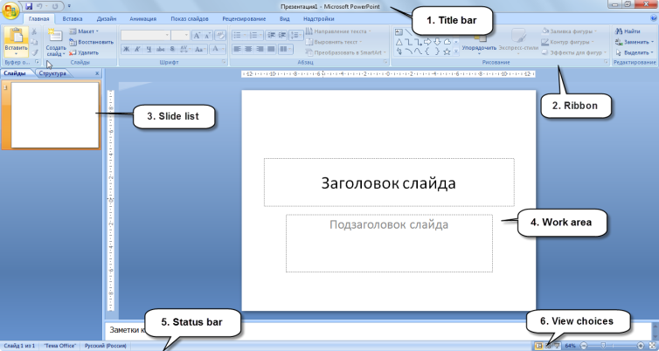
Pic. 1. The graphical interface of Office PowerPoint 2007

The main elements of the program MS Office PowerPoint 2007:
1. Title bar
2. Ribbon
3. Slide list
4. Work area
5. Status bar
6. View choices.

The Ribbon
The Ribbon is the panel above the document. It has seven tabs: Home, Insert, Design, Animation, Slide show, Review and View. Each tab is divided into groups. Perform groups functions. Click here to see the right hand side of each group. A blue information box will pop up your pointer.
- Home (Главная): Clipboard, Fonts, Paragraph, Styles, and Editing.
- Insert (Вставка): Tables, Illustrations, Diagrams, Objects, Multimedia Clips, Sounds, Header And Footer, Text And Symbols.
- Design (Дизайн): Page Options, Themes, Effects, Background Styles.
- Animation (Анимация): View, Animation, Animation Setting, Slides Transitions, Transition Time.
Slideshow (Показ слайдов): Start Slideshow, Customize Demo, Monitors.
Review (Рецензирование): Spell check, annotation, presentation protection.
View (Вид): Presentation View Modes, Scale, Color or Grayscale, Window, Macros.

1.3 Creation of a new slide. Select a layout.
To create a new slide, on the Home tab click Create Slide command.
To select a slide layout, on the Home page, in the group Slide, click Maket command.

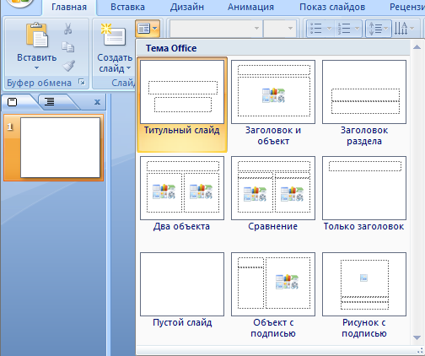
Pic. 2. Slide layout selection

1.4 Insert text, pictures, graphic objects, films and sound into the slide.
To insert text, graphics, graphic objects into the slide, go to the Insert tab of the Ribbon and select from the Illustration group.

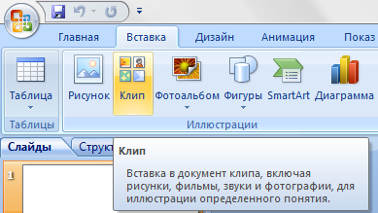
Pic. 3. The "Illustration" group.

To insert movies and sounds into a slide, go to the Insert tab of the Ribbon and select the Multimedia Clips group.

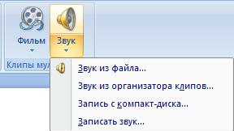
Pic. 4. The Multimedia Clips group.

1.5 Changing Slide Background
To change the slide background, go to the Design tab of the Ribbon and choose from the Themes group.

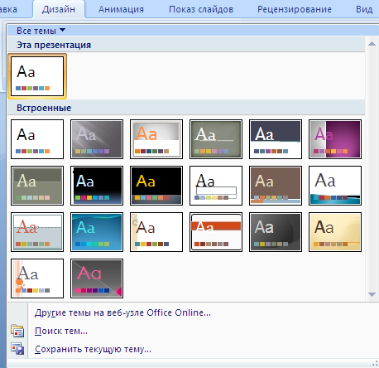
Pic. 5. Choosing a slide design

1.6 Applying Effects
To apply effects to a slide in the Animation tab, select Animation Setup. The corresponding field will appear in the right part of the window, click the Add Effect button.

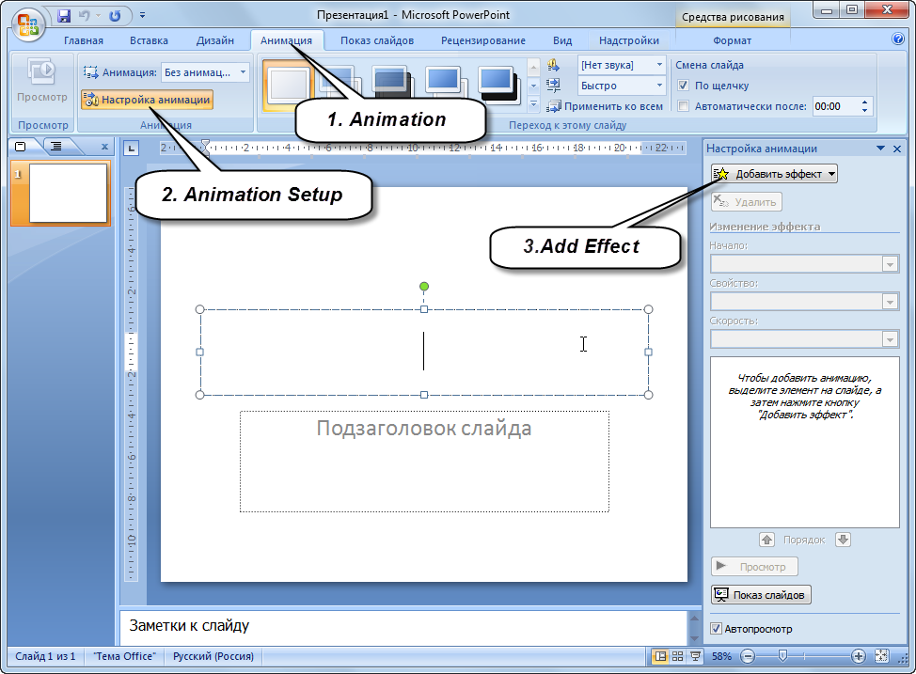
Pic. 6. Applying Effects

Here you can also customize the transitions between slides. To do this, on the Animation tab, select the desired transition effect in the Transition slide group.

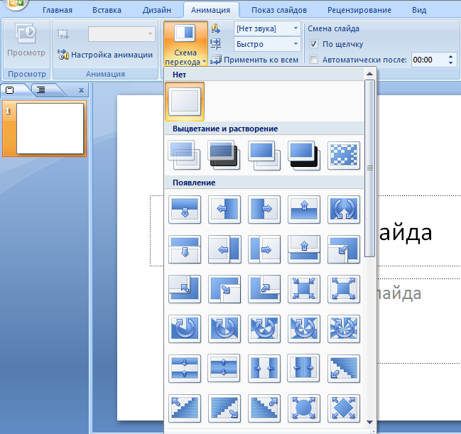
Pic. 7. Slide transition effects

1.7 Install Hyperlink.
In order to set a hyperlink you need:
Select the needed word;
On the «Insert» tab of the Ribbon, click the Hyperlink command in the Links group. The Insert Hyperlink dialog box opens.
Select the slide that should open when you click on a word.
Click the OK button.

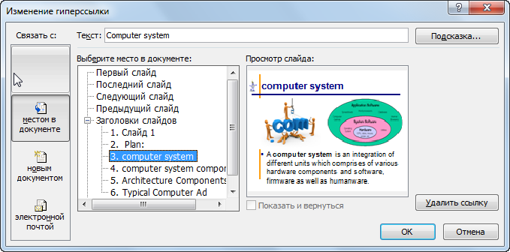
Pic. 8. The Insert Hyperlink dialog box

1.8 Slide Demonstration
To show slides, you must go to the ribbon Slideshow and select either Start (Start) On the « Slideshow» tab of the Ribbon, in the group Start The Slide Show, select the desired or press F5 or the button.

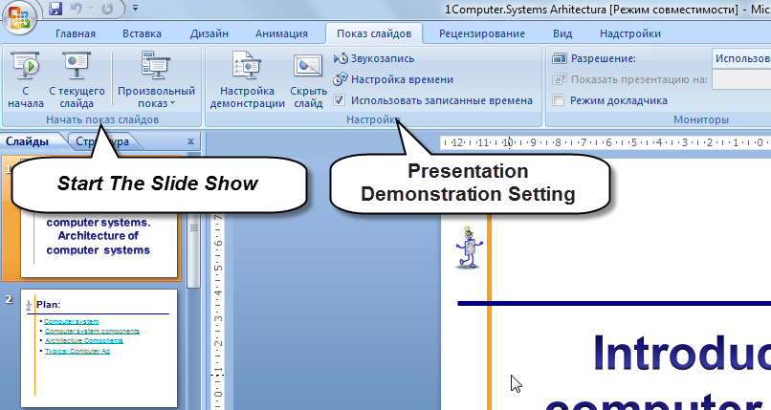
Pic. 9. Slide Demonstration

Tasks:
1. Create the new presentation MS Office PowerPoint on "Computer Architecture".
2. You should edit the following slide structure:
title page;
plan
slide with SmartArt object, picture and text
slide with simple marker text;
slide with table;
slide with picture ;
3. Enter the heading "Computer Architecture" on the title slide using the WordArt object. Apply an animation effect to the theme.
4. Enter the presentation plan for the second slide. Make a hyperlink to every point of the plan. When a computer system is pressed, a slide that contains the relevant information should be opened. Do the same with others.
5. In the third slide, enter a brief description of the computer system, the corresponding picture, and the SmartArt object. Give the slide the effects of the animation you like.
6. In the fourth slide, enter simple Bulleted List describing the components of the computer system. Give the slide the effects of the animation you like.
7. On the fifth slide, make a table of architecture components. Give the slide the effects of the animation you like.
8. In the sixth slide, insert a picture that depicts your computer's system. Give the slide the effects of the animation you like.
9. Background as you like.
10. Insert audio or video on each slide.
11. At the bottom of each slide, put hyperlinks in the form of buttons. Press the right and left arrows to move to the previous or next slide, respectively. Click on a Home button to switch to the title slide.
12. Save the file.
13. You should have the following:

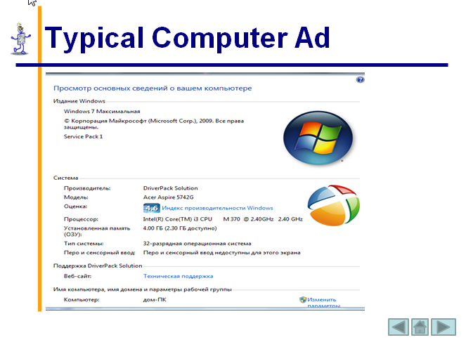
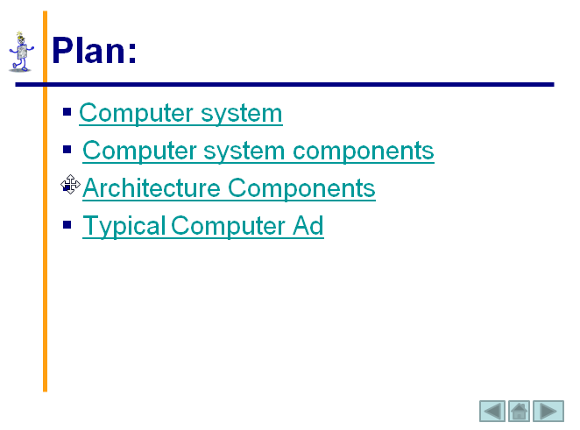
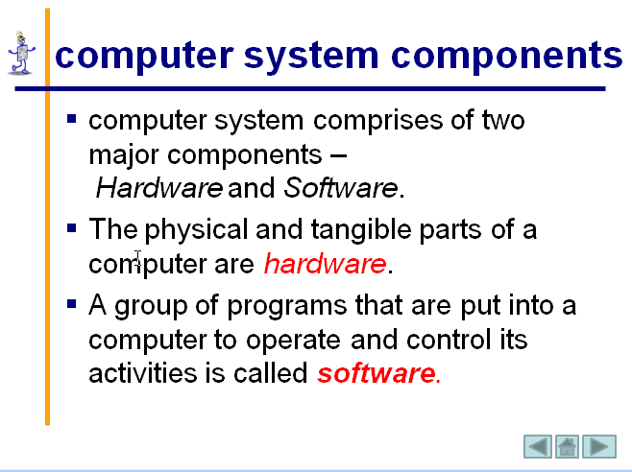
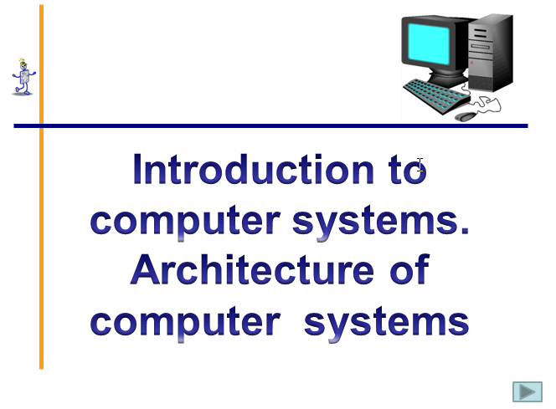

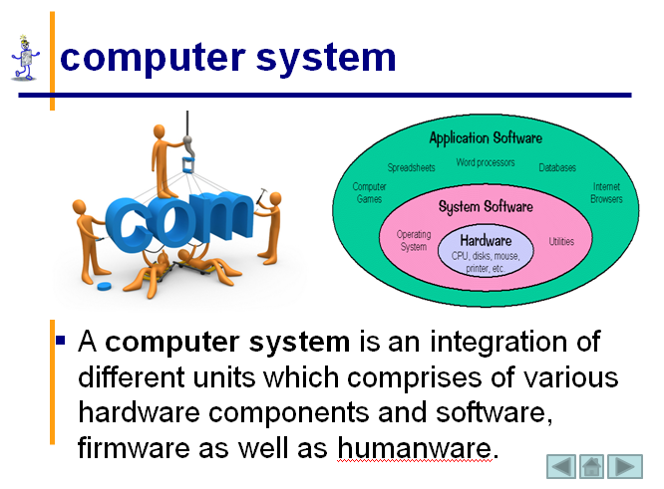
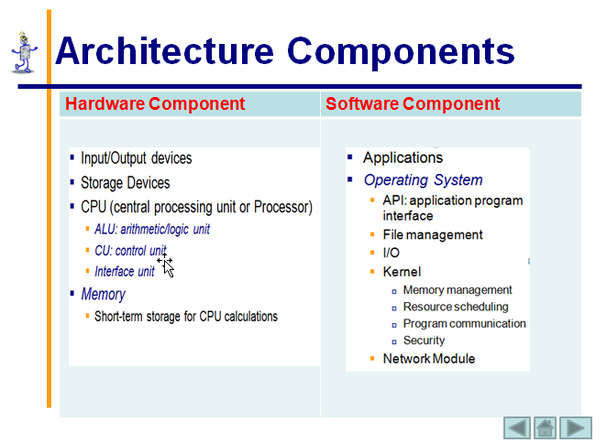
Pic. 10. The result of your work

Тask for individual work:
Make a presentation about students in your group.

Control questions:
1. What is a presentation?
2. How do you explain slide?
3. What are the capabilities of MS Office PowerPoint?
4. How do I change the slide background?
5. What is a hypertext link? Why is it installed?
6. How is slide demo done?
7. Why are the animation effects needed?

2.2 Practical work №2.

USE OF TRIGGERS IN MS OFFICE POWERPOINT 2007.

Theoretical materials:
2.1. The concept of triggers and their scope
You can create various animation effects in PowerPoint. One of these tools is a trigger.
A trigger is an animation tool that allows you to specify an action or time condition for a selected item. At the same time, the animation is launched on click.
The trigger in translation from English means - a trigger, a lock. With the help of a trigger, you can set an action to any object. Moreover, the sequence of these actions, we can choose depending on the wishes and situations. You can open a task as it is completed. Left-clicking on an object animates it, causing it to perform a predefined action. The presence of triggers significantly increases the interactivity of the presentation.
2.2. Create slide with triggers
Trigerrs can be applied to any objects to which the animation applies. First you need to think of what we want and create the slide itself. for example, apply the trigger to the picture on the slide. To do this, follow these steps:
Insert the desired image on the slide;
Set the animation for the picture: on the Animation tab, select Animation setup, in the right part of the screen select Add Effect;
In the Animation area, click on the triangle and in the drop-down box, select Time
In the window that appears, select Start by clicking.
In the Switches area, check the Start Effect when clicked. If you select this line, you will be able to select the desired object.
Click OK, the trigger is ready.

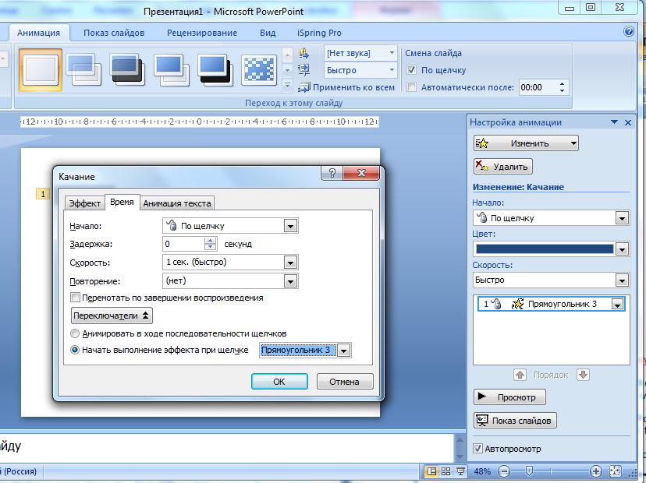
Pic. 1. Create trigger

Tasks:
Suppose we want to select input devices from the proposed PC devices. The remaining devices, when you click on them, will have to disappear. To do this, follow these steps:
1. Create the new presentation MS Office PowerPoint.
2. Enter the heading " PC Input Devices " on the title slide using the WordArt object.
3. Create an empty slide and place pictures of PC devices on it. You should have the following:
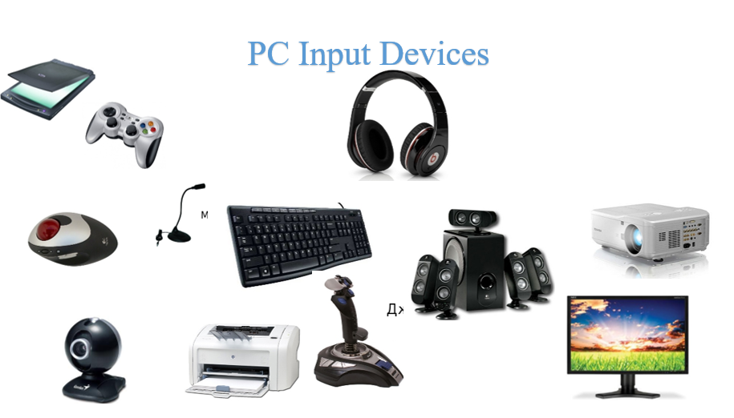
Pic. 2. Sample Slide View
4. We assign devices, except for input devices, to animation of an output (for example, “disappearing”) and for input devices - a selection (for example, “swinging”). Select the Keyboard picture, this is the Input device, so let's apply the “swinging”animation to it.

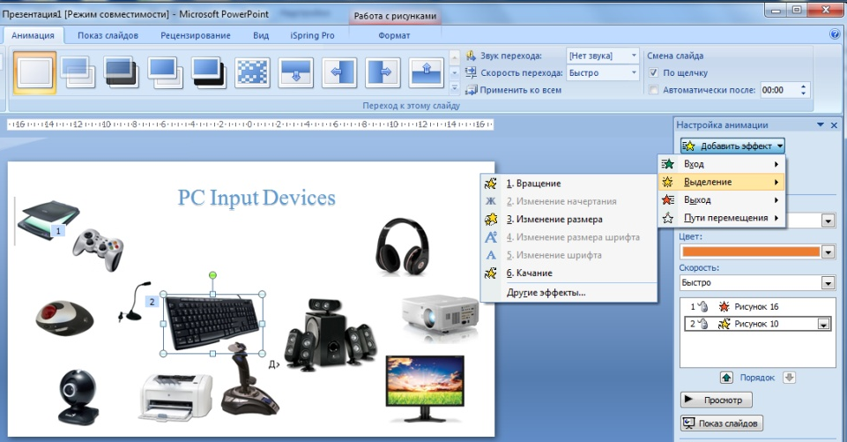
Pic. 3. Create the “swinging” animation

5. In the Animation area, click on the triangle and in the drop-down box, select Time
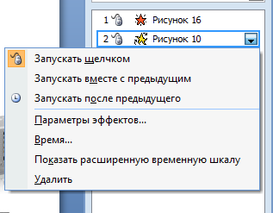
Pic. 4. Open Time dialog window.

6. In the window that appears, select Start by clicking.
7. In the Switches area, check the Start Effect when clicked. If you select this line, you will be able to select the desired object.

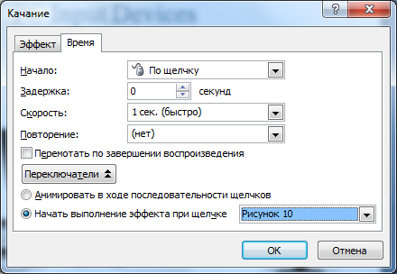
Pic. 5. Start Effect when clicked.

8. Click OK, the trigger is ready.
So we set up triggers for all objects.
After setting up all the triggers, the Animation Area looks like this:
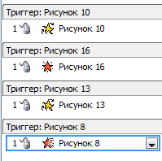
Pic. 6. Start Effect when clicked.

9. There is a chance of accidentally triggering a tuned object with a trigger. And then there will be a change of slides to the next. It’s not a problem. To exclude this possibility, you need to remove the "tick" in the "On Click" slide change. It is located in the tab "Animation"

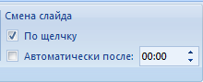
Pic. 7. Slide change group.
To switch to another slide, you can customize the control button.
10. In the Slideshow mode, check the correct operation of the configured triggers.
11. Save the file.

Тask for individual work:
Create a Learning Game (Crossword, Tests, Leader of the 21st century, etc.) using triggers in MS Office PowerPoint.

Control questions:
1. What is a trigger?
2. How to use it properly in presentations?

2.3 Practical work №3.

CREATION OF PRESENTATION PRESI

Theoretical materials:
Prezi is a web-based tool that allows users to create presentations using a map layout. They can zoom in and out of various items and show relationships from an interesting point of view. Keep in mind that Prezi is not capable of anything that is PowerPoint. You have a very limited selection of themes, no gallery of clips, and in Prezi presentations there are no several print options available in PowerPoint.

2.1. Getting Prezi

Prezi offers users a variety of registration options: free of charge, but with restrictions and with payment, but also with additional benefits.

To access Prezi,
Go to http://www.prezi.com/.
Click Get started.


Pic. 1. Get started button

Choose your license Basic-Continue
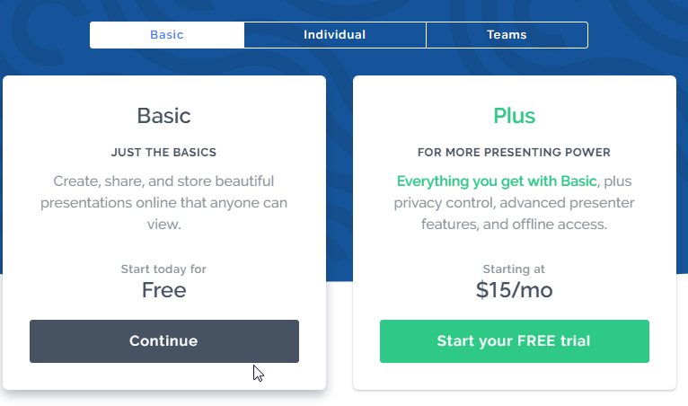
Pic. 2. Choose a license

Fill in the registration data and select a password. Click Create your Basic account.
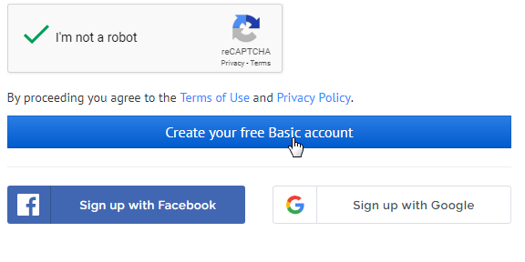
Pic.3. Create Basic account.

You have created your account.

2.2. Creating your presentation

To create your presentation Prezi:
Click New presentation button.
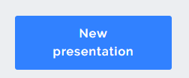
Pic.4. New presentation button

Choose a template for your Prezi. After choosing your template, click Use this template.
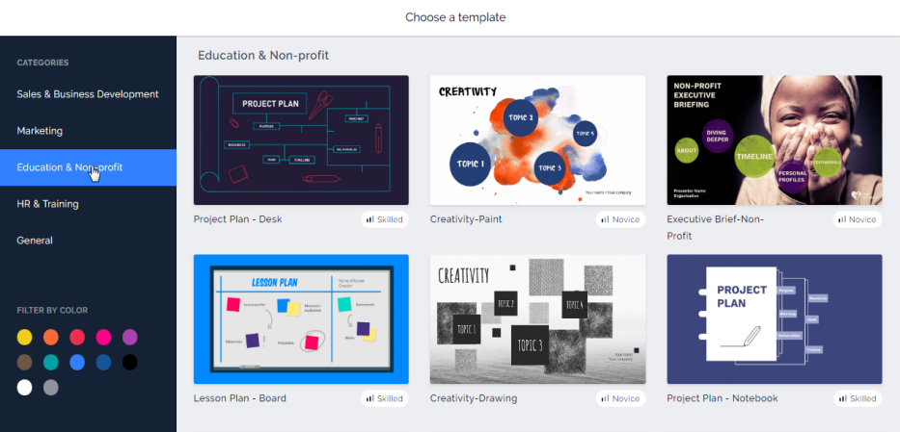
Pic.5. Choose a template

Enter your Presentation Title and choose Anyone on the Web commands.

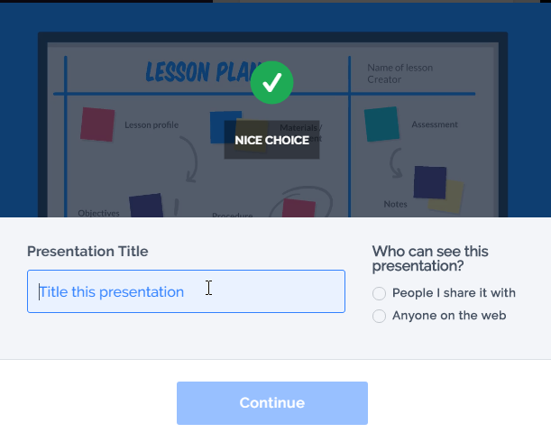
Pic.6. Enter Presentation Title

You have created a new template for your presentation, it remains only to fill the presentation with content.

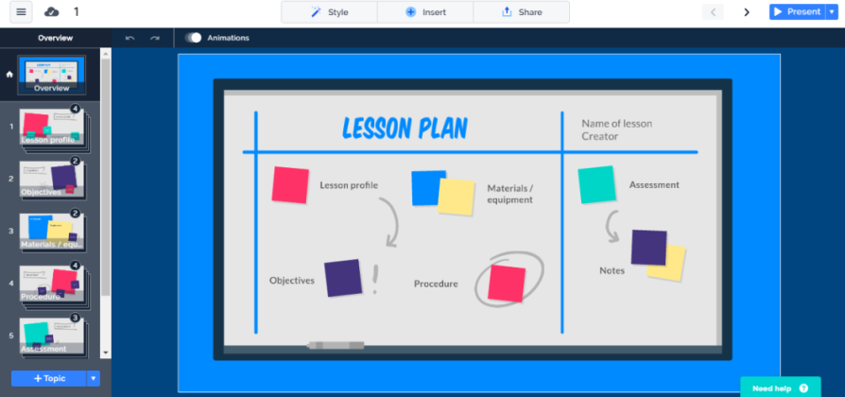
Pic.7. A new template your presentation
2.3. Add information to your presentation
The first step to adding text to your Prezi is to first click on the area you want to use. A text box will appear here.
As you type you will have the formatting options. When you finish editing / formatting text, click outside the box.
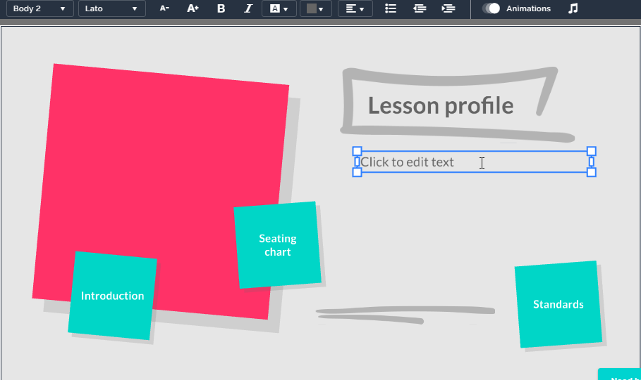
Pic.8. Add text

You can also add shapes, images and videos on YouTube to your Prezi or even import PowerPoint slides! From the top toolbar, select Paste, and then select the media you want to insert.


Pic.9. Insert toolbar

If you want to insert images, click Insert Image, and then Search files to upload your own image or choose Free Image.
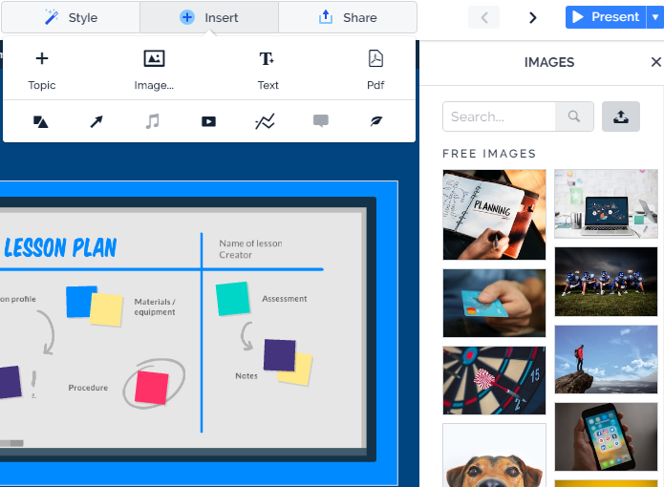
Pic.10. Insert toolbar
Users also have the ability to embed YouTube videos into their Prezi. Please note that the embedded YouTube video will only work if you have an Internet connection.
To insert a video from YouTube, click "Insert", then select a video from YouTube.
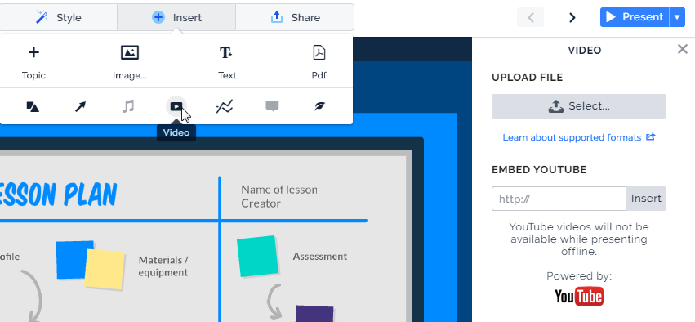
Pic.11. Insert a video from YouTube

b. Copy and paste the URL of the YouTube video into the text box. Click Paste.
By creating a presentation, you can view it. On the toolbar on the left side of the screen, click Present. 
Click "Full Screen" if you want to see the presentation in full screen. Navigate using the arrows at the bottom right or the arrow keys. There is also an autorun button for automatically launching your presentation.

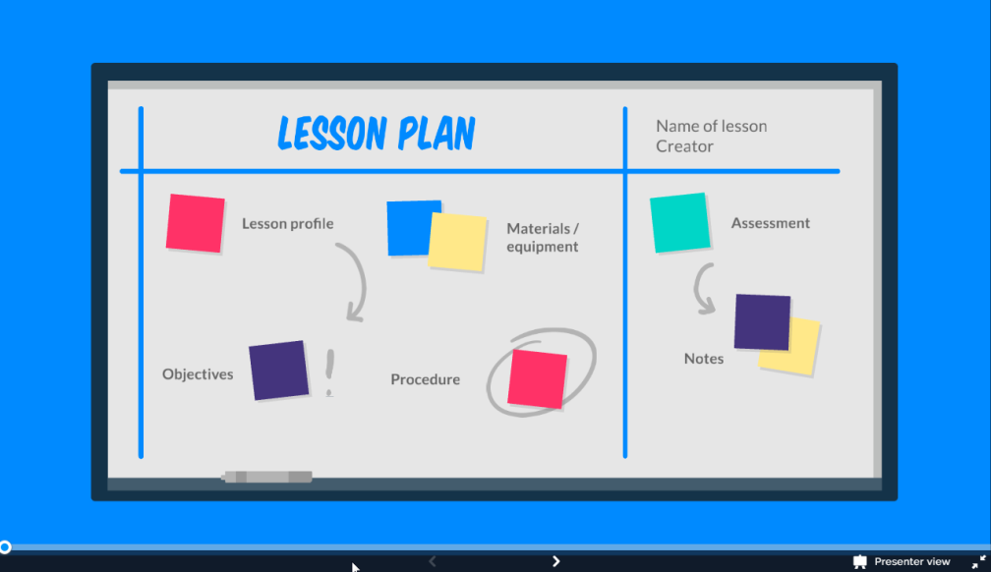
Pic.12. Present the presentation

2.4. Accessing your Prezi Later
When finished working on your Prezi,
1. Click Save periodically, or Exit to exit your Prezi entirely.

When you choose to come back and work on your presentation, log in to Prezi, and click the Your Prezis tab across the top.
Click the presentation you wish to work on.
Along the bottom of your presentation, you will see a toolbar. Click Edit.

Тask for individual work:
Make a presentation about students in your group. The presentation must have at least 4 topics. Also in the presentation should be used text, pictures, videos, figures, etc.

Control questions:
1. What is a Prezi?
2. What are the capabilities of Prezi?
3. How to embed items in a Prezi?
4. How to make a presentation?

2.4 Practical work №4.

INTRODUCTION TO HTML

Theoretical materials:

What is HTML?
HTML (Hyper Text Markup Language) is the standard markup language for creating Web pages.
- HTML stands for Hyper Text Markup Language
- HTML describes the structure of Web pages using markup
- HTML elements are the building blocks of HTML pages
- HTML elements are represented by tags
- HTML tags label pieces of content such as "heading", "paragraph", "table", and so on
- Browsers do not display the HTML tags, but use them to render the content of the page

A Simple HTML Document

HTML Page Structure
<html> <head> <title>Page Title</title> </head><body> The content of the document......</body></html>

Example Explained
- The <html> element is the root element of an HTML page.
- The <head> element contains meta information about the document.
- The <title> element specifies a title for the document.
- The <body> element contains the visible page content.

HTML Tags
HTML tags are element names surrounded by angle brackets:
<tagname>content goes here...</tagname>
- HTML tags normally come in pairs like <p> and </p>
- The first tag in a pair is the start tag, the second tag is the end tag
- The end tag is written like the start tag, but with a forward slash inserted before the tag name
Tip: The start tag is also called the opening tag, and the end tag the closing tag.

Web Browsers

The purpose of a web browser (Chrome, IE, Firefox, Safari) is to read HTML documents and display them.
The browser does not display the HTML tags, but uses them to determine how to display the document:
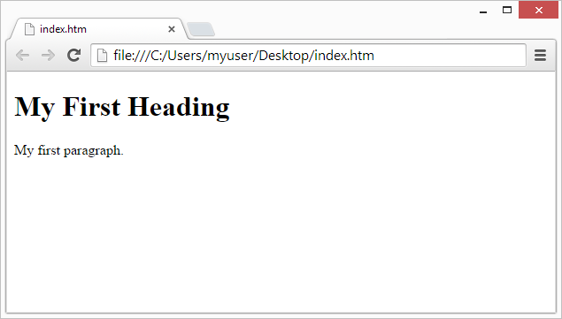

THE <BODY> TAG
The <body> tag defines the document's body.
The <body> element contains all the contents of an HTML document, such as text, hyperlinks, images, tables, lists, etc.
Attributes
Attribute | Value | Description
alink | color | Specifies the color of an active link in a document
background | URL | Specifies a background image for a document
bgcolor | color | Specifies the background color of a document
link | color | Specifies the color of unvisited links in a document
text | color | Specifies the color of the text in a document
vlink | color | Specifies the color of visited links in a document

Colors
Table- 1
Color |  | RGB | Color |  | RGB
black | черный | 000000 | purple | фиолетовый | FF00FF
white | белый | FFFFFF | yellow | желтый | FFFF00
red | красный | FF0000 | brown | коричневый | 996633
green | зеленый | 00FF00 | orange | оранжевый | FF8000
azure | бирюзовый | 00FFFF | violet | лиловый | 8000FF
blue | синий | 0000FF | gray | серый | A0A0A0
Silver | серебристый | C0C0C0 | Fuchsia | Ярко-фиолетовый | FF00FF
maroon | Темно-красный | 800000 | lime | Ярко-зеленый | 00FF00
Olive | Оливковый | 808000 | Teal | сине-зеленый | 008080
navy | Темно-синий | 000080 | aqua | Светло-синий | 00FFFF

Таsk-1. Write HTML Using Notepad
Web pages can be created and modified by using professional HTML editors.
However, for learning HTML we recommend a simple text editor like Notepad (PC).
We believe using a simple text editor is a good way to learn HTML.
Follow the four steps below to create your first web page with Notepad.

Step 1: Open Notepad (PC)
Windows 8 or later:
Open the Start Screen (the window symbol at the bottom left on your screen). Type Notepad.
Windows 7 orearlier:
Open Start>Programs>Accessories>Notepad

Step 2: Write Some HTML
Write or copy some HTML into Notepad.
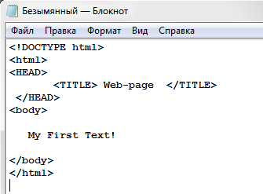
Pic. 1

Step 3: Save the HTML Page
Save the file on your computer. Select File > Save as in the Notepad menu.
Name the file "index.htm" or "1.html" and set the encoding to UTF-8 (which is the preferred encoding for HTML files).

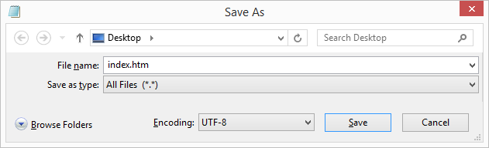
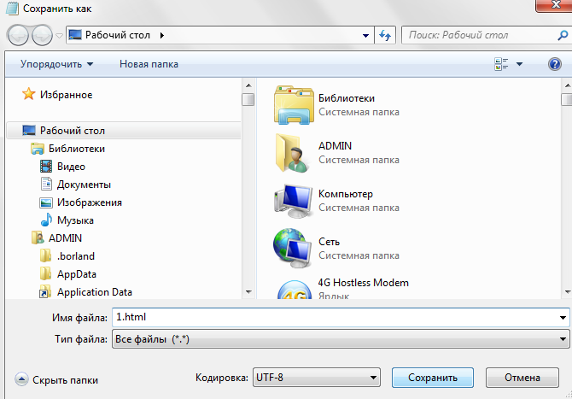
Pic. 2
You can use either .htm or .html as file extension. There is no difference, it is up to you.

Step 4: View the HTML Page in Your Browser
Open the saved HTML file in your favorite browser (double click on the file, or right-click - and choose "Open with").
The result will look much like this:
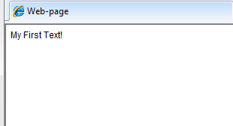
Pic. 3

Таsk-2.
Open the file "1.html".
Write the next body attribute into Notepad.
Save the HTML Page "2.html".
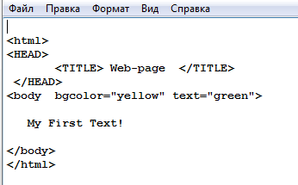
Pic.4

View the HTML Page in Your Browser

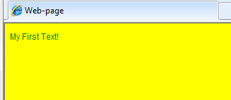
Pic.5

HTML Headings

Headings are important in HTML documents.
Headings are defined with the <h1> to <h6> tags.
<h1> defines the most important heading. <h6 defines the least important heading.

Example

<h1>This is heading 1</h1>

<h2>This is heading 2</h2>

<h3>This is heading 3</h3>

<h4>This is heading 4</h4>

<h5>This is heading 5</h5>

<h6>This is heading 6</h6>
Note: Browsers automatically add some white space (a margin) before and after a heading.
Attributes:
align = left
align = right;
align = center;
align = justify.

Таsk-3.
1. Open Notepad
2. Write some HTML into Notepad.
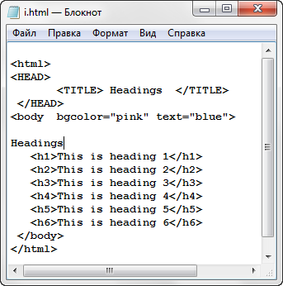
Pic.6

3. Save the HTML Page "3.html".
4. View the HTML Page in Your Browser
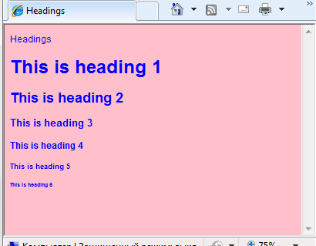
Pic.7

Write the next Headings attribute into Notepad.

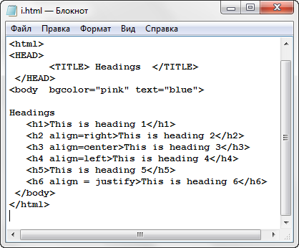
Pic.8

Save and View the HTML Page in Your Browser
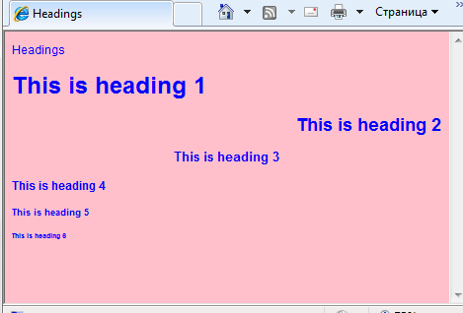
Pic.9

Tasks for independent work

Project “Days of the week”.

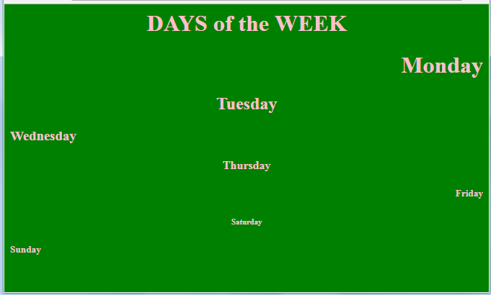
Pic.10

2.5 Practical work №5.

HTML. WORK WITH PARAGRAPHS, LINE BREAKS AND
HORIZONTAL LINES

HTML Paragraphs
The HTML <p> element defines a paragraph:

Example
<p>This is a paragraph.</p>
<p>This is another paragraph.</p>
Note: Browsers automatically add some white space (a margin) before and after a paragraph.

HTML Line Breaks
The HTML <br> element defines a line break.
Use <br> if you want a line break (a new line) without starting a new paragraph:

Example
<p>This is<br>a paragraph<br>with line breaks.</p>
The <br> tag is an empty tag, which means that it has no end tag.

The HTML <pre> Element
The HTML <pre> element defines preformatted text.
The text inside a <pre> element is displayed in a fixed-width font (usually Courier), and it preserves both spaces and line breaks:

Example
<pre>
My Bonnie lies over the ocean.
My Bonnie lies over the sea.
My Bonnie lies over the ocean.
Oh, bring back my Bonnie to me.
</pre>

The <hr> tag
The <hr> tag defines a thematic break in an HTML page (e.g. a shift of topic).
The <hr> element is used to separate content (or define a change) in an HTML page.

Attributes
Attribute | Value | Description
align | left  center  right | Specifies the alignment of a <hr> element
noshade | noshade | Specifies that a <hr> element should render in one solid color (noshaded), instead of a shaded color
size | pixels | Specifies the height of a <hr> element
width | pixels  % | Specifies the width of a <hr> element

Таsk-1. Write HTML Using Notepad
Write or copy some HTML into Notepad.
<html>
<body>
<h1>My First Heading</h1>
<p>My first paragraph.</p>
</body>
</html>
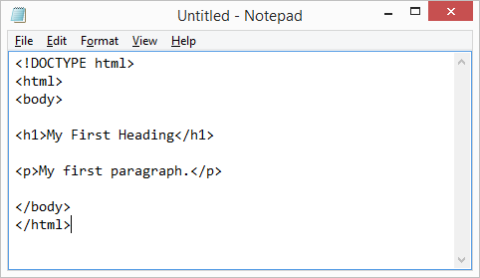
Pic.1

View the HTML Page in Your Browser
Open the saved HTML file in your favorite browser (double click on the file, or right-click - and choose "Open with").
The result will look much like this:
Pic.2

Таsk-2. Below is a visualization of an HTML page structure:
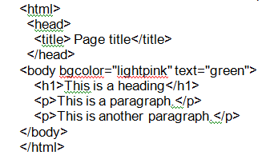
Note: Only the content inside the <body> section (the white area above) is displayed in a browser.
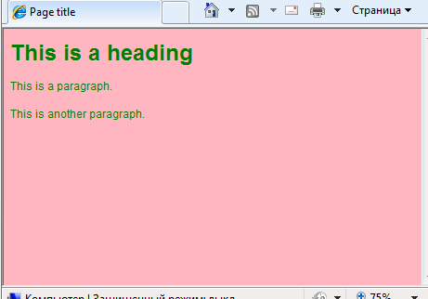
Pic.4

Таsk-3. Use different horizontally horizontal lines.1. Run the notebook text editor.2. Enter the following code in the program window:
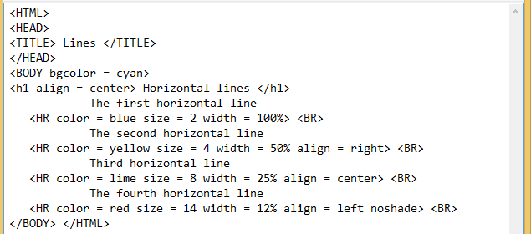
Pic.5
Save the file in your package with Web3.html.

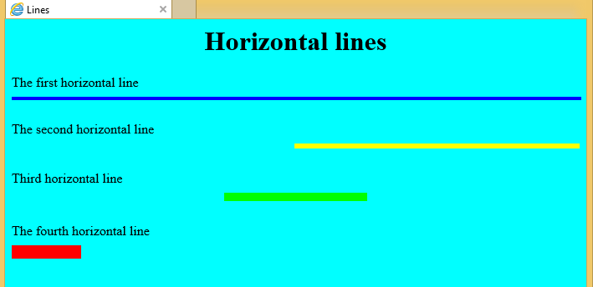
Pic.6

Tasks for independent work

Create these project works.

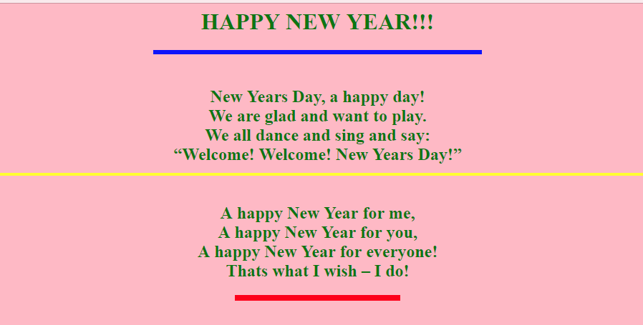
Pic.7 Project work “New Year”.

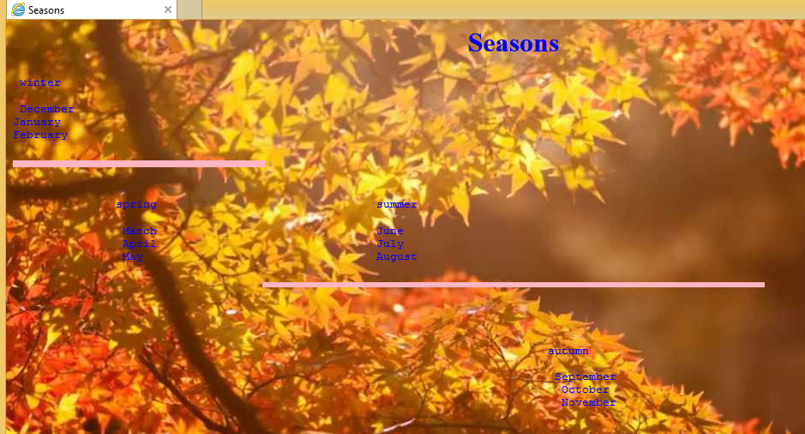
Pic.8 Project work “Seasons”.

2.6 Practical work №6.
CHARACTER FORMATTING

Elements of physical style
The physical style is usually understood as a direct indication to the browser to modify the current font.
To select individual parts of the text, you can use the following style tags:
<B> .. </ B> - fatty enhancement (Bold); ------- example
<i> .. </ i> - italic (Italic); --------- example
<U> .. </ U> - with underscore (Underline); ------- example
<S> .. </ S> - with strikethrough (STRIKE); -------- example
<TT> .. </ TT> - displays text in monospaced font.
<BIG> .. </ BIG> - enlarged font
<SMALL> .. </ SMALL> - reduced font
Superscripts and Subscripts:
<SUB> .. </ SUB> - subscript, for example, H₂SO₄.
<SUP> .. </ SUP> - superscript, for example, (a² – b²) = (a – b) (a + b).
All the above commands define the physical formatting of characters. You specify a specific change in character characteristics.

Таsk-1. Applying physical style tags to text.
Write or copy some HTML into Notepad.
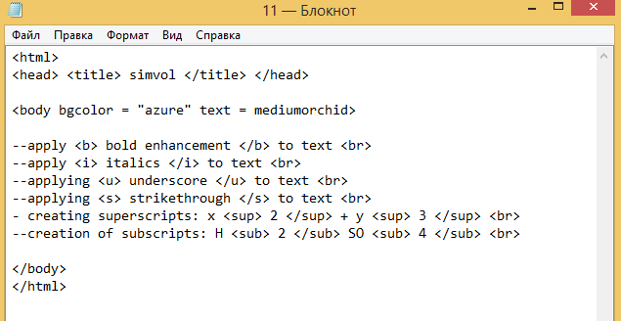
Pic.1

View the HTML Page in Your Browser

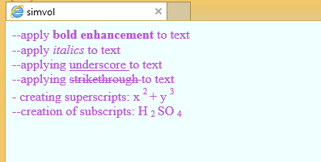
Pic.2
Element <FONT> … </ FONT>
The <FONT> element is used to highlight a word or text in a special font.
Attributes:
- size – determines the size of the text: absolute dimensions: ranging from 1 to 7, where 1 is the smallest font. The default is 3;
relative sizes: with indication of the sign from -2 to +4, where -2 is the smallest.
Calculated by adding to the base size defined by the SIZE parameter of the BASEFONT element.
- color – determines the text color, is set either by the RGB value in hexadecimal, or by one of the 16 basic colors.
- face – defines the typeface of the font (this parameter is used to specify the type of font that the user’s viewer will display the text in (if such a font is on the computer).
Tip: The number of different fonts used in one document must not exceed three. EXAMPLE: <FONT FACE = “Verdana”, “Arial”, “Helvetica”>).
Syntax: <FONT size = n color = “color” face = ”font”> Text </ FONT>

Таsk-2.
Write some HTML into Notepad.

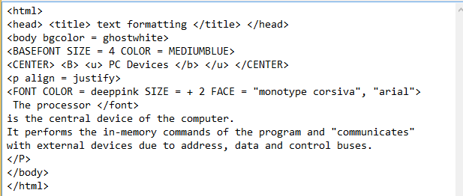
Pic.3
Save the document.
View the HTML Page in Your Browser

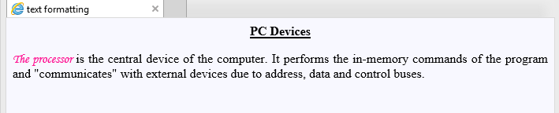
Pic.4
Tasks for independent work
1. PROJECT “Certificate”. Using the tags and the corresponding attributes discussed earlier, create a document. A graphic image is used as the background of this document. Different colors are applied to the text by opening and closing the tags in time, which allow formatting the text.
2. Project “My University”. Using the tags and the corresponding attributes discussed earlier, create a web page about your university. Issue the document yourself.

2.7 Practical work №7.
CREATE LISTS
HTML offers web authors three ways for specifying lists of information. All lists must contain one or more list elements. Lists may contain −
<OL> − An ordered list. This will use different schemes of numbers to list your items.
<UL> − An unordered list. This will list items using plain bullets.
<DL> − A definition list. This arranges your items in the same way as they are arranged in a dictionary.

The list title is not a required element, it is created using the <LH> pair:
<LH> List Title </ LH>
The list content consists of individual paths. Each line is labeled with a single tag <LI> (List Item), for example:
<LI> List line content.

<OL> ..</OL> - ORDERED (NUMBERED) LIST.
If you are required to put your items in a numbered list instead of bulleted, then HTML ordered list will be used. This list is created by using <ol> tag. The numbering starts at one and is incremented by one for each successive ordered list element tagged with <li>.

The Type attribute
You can use type attribute for <ol> tag to specify the type of numbering you like. By default, it is a number. Following are the possible options:
<ol type = "1"> | Default - Case Numerals.
<ol type = "I"> | Upper - Case Numerals.
<ol type = "i"> | Lower - Case Numerals.
<ol type = "A"> | Upper - Case Letters.
<ol type = "a"> | Lower - Case Letters.
The Start attribute
You can use start attribute for <ol> tag to specify the starting point of numbering you need. Following are the possible options:
<ol type = "1" start = "4"> | Numerals starts with 4.
<ol type = "I" start = "4"> | Numerals starts with IV
<ol type = "i" start = "4"> | Numerals starts with iv
<ol type = "a" start = "4"> | Letters starts with d
<ol type = "A" start = "4"> | Letters starts with D

Example
Following is an example where we used <ol type = "i" start = "4" >

Таsk-1. Create a ordered list of different types using the <OL> element.
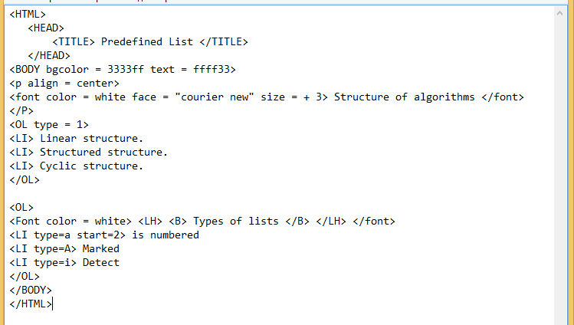
Pic.1

Save the file as 41.html. Then it should turn out as follows:

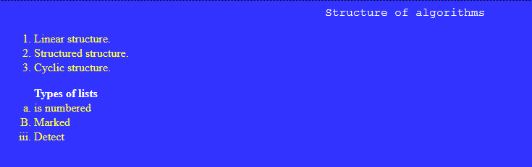
Pic.2

2) <UL>. . .</UL> - UNORDERED (BULLETED) LIST
An unordered list is a collection of related items that have no special order or sequence. This list is created by using HTML <ul> tag. Each item in the list is marked with a bullet.

The Type attribute
You can use type attribute for <ul> tag to specify the type of bullet you like. By default, it is a disc. Following are the possible options:
<ul type = "square"> or <LI type = square>  <ul type = "disc"> or <LI type = disk>  <ul type = "circle"> or <LI type = circle> | small black square  round point  circle

Тask-2. Create a unordered (bulleted) list of different types using the <UL> element.
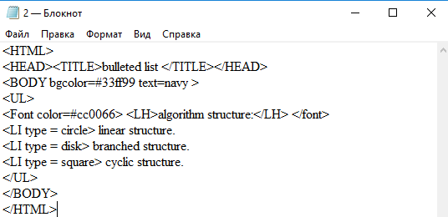
Pic.3
Save the file as 42.html. Then it should turn out as follows:
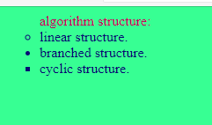
Pic.4

Task for independent work
PROJECT «MENU». Using tags and attributes, create the menu of the day. Issue the document yourself.


Pic.5

2.8 Practical work №8.

INSERT GRAPHIC IMAGE (PICTURE)
CREATING HYPERLINKS
<IMG> Element
The HTML <img> tag is used to put an image in an HTML document.
The <img> tag defines an image in an HTML page.
The <img> tag has two required attributes: src and alt.

Note: Images are not technically inserted into an HTML page, images are linked to HTML pages. The <img> tag creates a holding space for the referenced image.
Tip: To link an image to another document, simply nest the <img> tag inside <a> tags.
Syntax: <IMG SRC="picture.gif">

Attributes:
Attribute | Value | Description | Format
align | top  bottom  middle  left  right | Specifies the alignment of an image according to surrounding elements | <IMG SRC= " Picture.JPG" ALIGN="TOP">
alt | text | Specifies an alternate text for an image | <IMG SRC= " Picture.JPG" ALT="Сурет">
border | pixels | Specifies the width of the border around an image | <IMG SRC= " Picture.JPG" BORDER="3">
height | pixels | Specifies the height of an image | <IMG SRC= " Picture.JPG" HEIGHT="111">
src | URL | Specifies the URL of an image
width | pixels | Specifies the width of an image | <IMG SRC= " Picture.JPG" WIDTH="210">

Task 1: Adding images and setting alignment parameters.
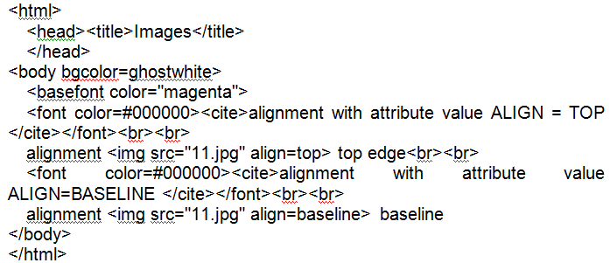
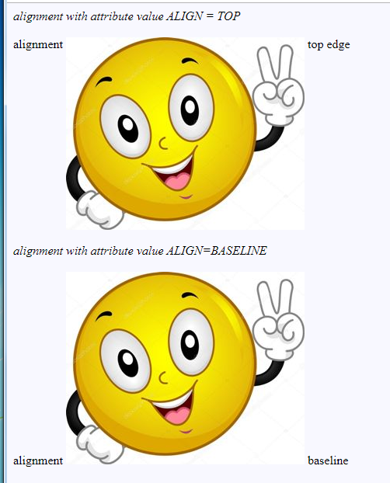
Pic.1
Save the document as pic1.html in your folder.

Task-2. Using the necessary attributes, specify the border, size, height and width of the image.
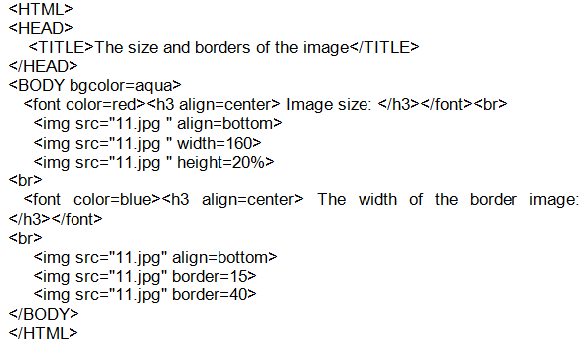Save the document as pic2.html in your folder.

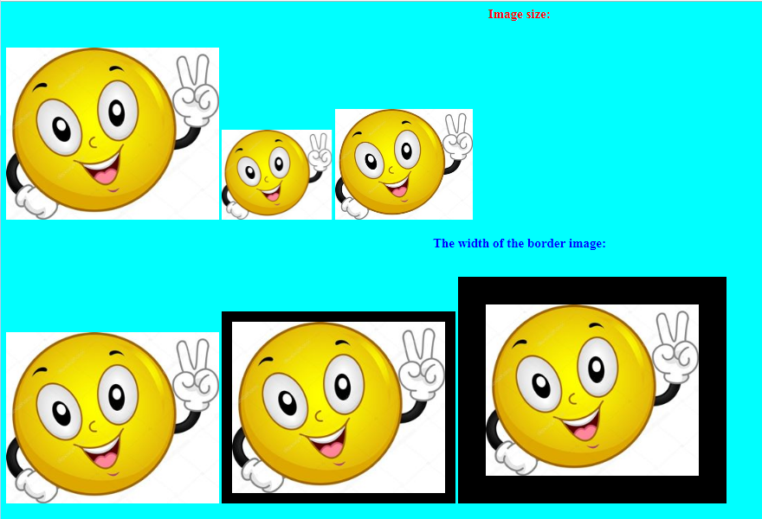
Pic. 2

Creating hyperlinks
HTML links are hyperlinks.
А webpage can contain various links that take you directly to other pages and even specific parts of a given page. These links are known as hyperlinks.
Hyperlinks allow visitors to navigate between Web sites by clicking on words, phrases, and images. Thus you can create hyperlinks using text or images available on a webpage.
When you move the mouse over a link, the mouse arrow will turn into a little hand.
HTML Links - Syntax
In HTML, links are defined with the <a> tag.
The most important attribute of the <a> element is the href attribute, which indicates the link's destination.
By default, links will appear as follows in all browsers:
An unvisited link is underlined and blue.
A visited link is underlined and purple.
An active link is underlined and red.

A simple reference is made as follows:
<a href= "address ”> link text </a>
<A HREF=”Веб1.html”> <IMG src=”А1.jpg”> </A>

Insert picture for the page background
<BODY BACKGROUND="73.jpg" >

The target attribute
The target attribute specifies where to open the linked document.
The target attribute can have one of the following values:
- _blank - Opens the linked document in a new window or tab.
- _self - Opens the linked document in the same window/tab as it was clicked (this is default).
- _parent - Opens the linked document in the parent frame.
- _top - Opens the linked document in the full body of the window.
- framename - Opens the linked document in a named frame.

Task-3. Create a hyperlink to the text and image. Use any image (in advance prepare the image and save it in your folder).
Enter the following code:
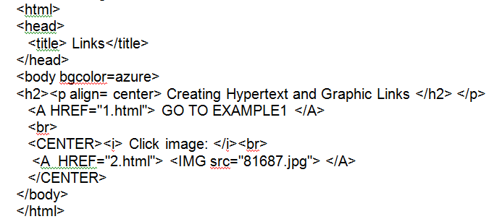

Save the document as link.html.

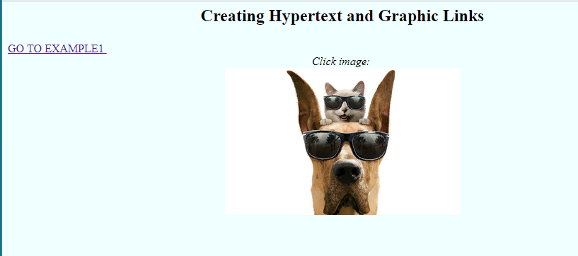
Pic. 3

Task for independent work

1.The project "ZOO". Create a webpage about zoo animals using tags, matching attributes and necessary images. Insert photos of animals and give them brief information. Decorate the document yourself.
2.PROJECT "News AUTOworld". Using the tags and corresponding attributes discussed earlier, create a document
3.The project "Telephone directory". You need to create five web pages that contain several different hyperlinks.

PHONEBOOK

Alphabetical list:
А
В
Б
Г
First page
Name | Telephone
Asanov Nurlan | 53-17-40
Avbakirova B. | 90-13-45

When you click on a picture on each internal page, you must go to the first page.
Internal page

PRACTICAL WORK №9

Pic. 4

2.9 Practical lesson №9.

GRAPH EDITORS: INSCAPE
ABOUT INKSCAPE

Inkscape is a high quality professional tool for working with vector graphics for Windows, Mac OS X and Linux. Creating images, icons, logos, charts, maps and web graphics is widely used by practitioners and professionals all over the world. Inkscape uses standard Scenario SVG (Scalable Vector Graphics) from W3C as its usual format and is a kind of open source software.
Inkscape includes additional tools that can be compared with Adobe Illustrator, CorelDRAW, and Xara Xtreme. In Inxcape, you can save images in many formats such as SVG, AI, EPS, PDF, PS and PNG. Full set of Inkscape tools, simple interface, support for many languages, as well as extensions of user extensions.
The Inkscape project is a growing international community. Most of the training materials can help solve problems. Community assistance and support are provided. Inkscape is a member of the US $ 501 (c) (3) nonprofit organization of the software counterfeit conservator. Donations under the Project will be taxed in accordance with the laws of the United States of America.
Inkscape can edit and save a single page from all PDF documents.
Inkscape's history, several programmers and designers who could code the code, ceased creating conditions for the development of Sodipodi vector graphics editor. When they realized that they could not use their skills properly, they organized a new project called Inkscape. At that time, Linux only had two vector graphics editors that could be used in real life - Sodipodi and SKetch later renamed to Sincil. Since then, the development of Soudepo and Sincil did not appear at all. Many new features have been added in Inxcape 0.91 and more than 700 errors have been fixed in Inoxcape version 0.48. Inkscape was the most popular free editor in the field.
The Inkscape project participates in the Google Code of Conduct since 2005, from the beginning. Due to participation in the program, the project has received new permanent developers. Inkscape developers communicate closely with GIMP and Scribus teams and meet at the Libre Graphics Meeting conferences every year. Users and developers are an important part of Inkscape. In addition, the program is actively used by participants of the Open Street Map project.
Vector graphics - a way of providing graphical information. It allows you to modify formulas using a set of curves described by mathematical formulas. The vector can only be represented by two pairs of numbers (coordinate - beginning and end). When you insert an image, you must use a mathematical description. For example, to describe the linear segment of the updated line, it is enough to show the coordinates of its ends and can be characterized by indicating the coordinates of the circle center and radius. This approach is implemented in the program, for example, in the maximum vector graphic, it draws images based on the instructions (commands), uses the algorithms given in the program. This method involves many drawings. Unlike raster formats, vector graphics have separate information about each point. Complex objects consist of polygons or curves based primitives. Drawings, charts, fonts and rich text are provided for presenting two-dimensional vector shapes.
Such pictures and their individual elements are handled conveniently, easily scaled, and can be transformed. However, the vector form of real-world scene transformation (such as video streaming or photo scanning) is a complex and generally unresolved problem.
There are vectorization programs, but in many cases many resources and pictures are of poor quality. The main thing is to create photorealistic (photography or imaging photos) theoretically and practically require a lot of very complex primitives. Color models are colored, fixed, or displayed in color. The source of human beings can accept many colors. Yu.P. Nemchaninov introduced the vector graphics in Inkscape. In addition, the range of colors and the way they are displayed differ for the monitor and printer settings. Depending on your needs, different color models have been developed for different physical processes. Color models allow mathematical applications. The most common color models are RGB, HSB, and CMYK. One of the most commonly used color models is the RGB model. Any color increase is a combination of three main colors: red, green, and blue. This model is called additive. This model is based on color reproduction through modern monitors. HSB sample (hue - shade, saturation - saturation, brightness - brightness) - version of RGB and also based on base colors
Using Inkscape

Exercise 1.
1. Download Inkscape using the shortcut on the desktop or in the main menu.
2. Familiarize yourself with the program's elements: Menu, Toolbars, Workspace, Worksheet, Properties Panel.
3. Using the status bar, locate the origin of the coordinates on the worksheet.
4. Using the tools from the toolbar and the property bar, create the following shapes (Pic. 1.a):


Pic. 1.a Rectangles and squares



Pic. 1.b Circles, ellipses and arcs







Pic. 1.c. Stars and polygons

Exercise 2.
Creating text with a multi-step gradient fill.
1. Use the Text tool to create the inscription "Rainbow", change its size.
2. Convert the text to the contour: Contours  Continue object.
3. Reduce the number of nodes in the contour: Contours   Simplify.
4. By moving the nodes, change the shape of the contour. See fig. one.
5. Activate the Create and Edit Gradients tool, “drag out” the gradient above the text.
6. Open the Gradient Editor by double-clicking RMB on the start or end point of the gradient.
7. In the Gradient Editor dialog box, select the first point from the drop-down list, specify its color - red.
8. Add a reference point, specify its color - orange and offset.
10. Add points to the gradient and change their properties so that all the colors of the rainbow appear in the gradient (Pic.2).



Pic. 2. The inscription "Радуга"

2.10 Practical work №10.

INTRODUCTION TO SNAGIT AND SNAGIT EDITOR

Theoretical materials:
Snagit helps you create and share high-quality screenshots for your presentations, documents and blogs.
In Snagit:
Save frequently used capture settings as profiles.
Apply edge effects, filters and other effects while capturing
In the editor:
Add stamps, arrows, callouts, edge effects, and more. Assign keywords and flags to images and other media files.
Use powerful search capabilities to search for snapshots by keywords, flags or other information.
Automatically assembled during capture.
Email, copy and paste, as well as print screenshots or upload them to your website.
Snagit Interface

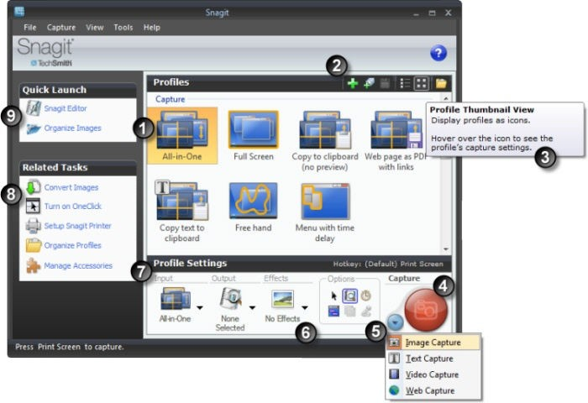
Pic. 1 Snagit Interface

 | The profile includes a combination of Input, Output and Effects. Capture profile properties are displayed as a tooltip when the mouse pointer is over the profile icon.
 | Use the profile toolbar to create and edit profiles.  The new profile saves the current profile settings as a new capture profile.  Use the Profile Wizard to create a new profile by going through all the profile settings.  Save Profile overwrites the selected profile with the current profile settings.  The list view displays the profiles in the list.  View thumbnails displays profiles as icons.  Organize Profiles displays the Organize Profiles dialog box.
 | Find informational tips in the Snagit and Snagit Editor when you hover over icons, buttons, and so on.
 | Click the Capture button to start capturing. You can also use the default global hotkey, <PRINT SCREEN>. See also Hot Keys.
 | Capture mode is the type of capture you want to do. To change the mode, press the blue button next to the Capture button. There are five different capture modes: Image Capture, Text Capture, Video Capture, Web Page Capture, Printer Capture.
 | Parameters define what a capture looks like, or you view it in the editor before sending it to the output. For example, parameters include: grabbing the mouse cursor, setting a timer or delaying the capture, capturing several areas, etc.
 | Use the profile settings to select the capture mode and input, output and effects. Profile settings are updated when you select different profiles in the Profiles panel.
 | Related tasks provide easy access to: image conversion, enabling OneClick, setting up a Snagit printer, organizing profiles, and managing accessories.
 | Quick Launch provides access to the Snagit editor and the library view of the editor.

10.1. Default Profiles
Snagit comes with seven default profiles. These profiles are designed to meet overall capture needs.

Profile | Description
 | Universal profile All-in-One in most cases meets the needs of most users. The All-in-One record can capture regions, windows, and scroll windows.
 | Captures the entire screen. If multiple monitors are used, captures all monitors.
 | Uses the All-in-One input to capture areas, windows, or scrolling windows and sends them directly to the clipboard. Bypasses the editor.
 | Uses the All-in-One input to capture areas, windows, or scrolling windows, along with any hyperlinks in the captured area. Saves hyperlinks as hotspots on an image in a PDF file. Bypasses the editor.
 | Uses All-in-One input to capture RTF text from regions, windows, or scrolling windows. The text is placed on the clipboard and viewed in the editor.
 | Uses input with a free hand to capture a user-defined area using the free hand drawing selector.
 | Uses the menu entry to capture the program menu. The Timed Capture option is enabled, which causes a delay between the start of the capture and its execution. A timer appears on the screen to indicate when a capture is made.

10.2. Image Capture
Capture an image of anything on your screen. Use the following basic capture procedure to take your first capture.
Open what you want to capture.
Without minimizing what you want to capture, open Snagit.
Select a capture profile from the Basic Capture Profiles.

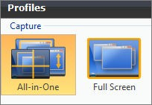
Pic. 2 The Basic Capture Profiles

Click Capture.

Pic. 3 The Capture

Orange crosshairs appear. Hover to select a window or an area inside the window. Click to complete the capture.
The Snagit interface disappears and capture crosshairs appear on the screen.
When complete, the capture appears in Editor. In Editor: Use the Draw tab to annotate the capture.
Use the Image tab to add Effects.
To share the capture, click an Output on the Send tab.
10.3. Video Capture
Use the video capture mode to create video on your screen. Snagit records actions on the screen on the Windows desktop. Then record all mouse movements and application actions, save the video as an AVI file.
The maximum size of the AVI file created by Snagit is 1 GB. Before you reach this size, a warning is displayed. As soon as the size limit is reached, the recording stops. Click Stop to end the recording; Click Cancel to cancel and delete the entry. By default, Snagit selects the best compression for capture and system. Experimenting with the settings is also possible.

Record Your First Video
In Snagit, select Video capture mode.
Click the Capture button.
An orange rectangle appears. Use the rectangle to select a window to capture or drag the mouse to select a region. The Video Capture dialog box appears.
Click Start to start recording.
Press <CTRL + Shift + P> to end the recording. The video is displayed for a moment.

10.4. Include the Cursor in an Image Capture

Use the Enable Cursor option to capture the mouse pointer when an image is captured. To turn on the cursor, click the Enable Cursor button. The image above shows the selected Enable Cursor option. To turn off, press the "Enable cursor" button again.
. 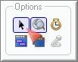
Pic.4

Use the capture timer option or position the cursor and use the hot key combination to capture to ensure that the cursor is in the correct position.

INTRODUCTION SNAGIT EDITOR

In Snagit Editor:
Use Snagit to create professional-quality strokes for your images. Also share or find, view and manage captures and multimedia files.
The Open Captures tray automatically saves snapshots.
Editing options include flips, mirror, pan, rotate, crop and cut.
Adjust the color depth, add text, or view video frames.
Add custom edge effects such as shadows, torn or faded edges, as well as improvements such as arrows, cursors, lines, text, and more.
Use the search bar, find and move / organize pictures.
In a library, a view is recorded as a thumbnail or list and sorted by name, size, type, date, size, flags or keywords.
Share photos by email or FTP, send them to Office applications, or print multiple images.

10.5. Snagit Editor Interface

To open Snagit Editor, do one of the following:
Go to the Windows Start menu > All Programs > Snagit 10 > Snagit 10 Editor
Click Snagit Editor on the Quick Launch bar in Snagit. Select Tools > Snagit Editor from the Snagit menu bar.

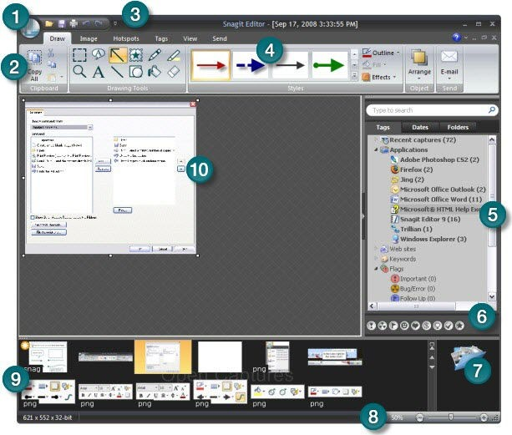
Pic. 5. The Snagit Editor Interface

 | Click the "Snagit" button to access the main commands, such as "Create", "Open", "Save", "Save As", "Send", "Print", "Delete" and "Close".  Also select:  Image conversion for batch image conversion.  Resources for accessing the Snagit website, accessing other TechSmith products, downloading Snagit accessories, etc. Also open the About Snagit dialog box, which contains the version number and copyright information.  Button "Settings Editor" to set the application settings.
 | The Ribbon helps you quickly find the tools and options you need to complete a task.
 | Customize the quick access toolbar using the most frequently used tools and commands. Right-click icons and options throughout the ribbon to add them to the shortcut bar.
 | The Quick Styles gallery is a collection of pre-made styles or effects. To use, select a style from the gallery and drag or click on the canvas.  Click on the “More” button in the gallery to see even more style options to choose from.  Right-click the modified object on the canvas and select “Add to Quick Styles” to add it to the gallery.
 | Using the search bar, you can find and view images, videos and snapshots of text by date, folder, keywords and much more.
 | Click to assign flags, such as Important, Idea or Personal, for snapshots or multimedia files.  All assigned flags are displayed in color in the vertical panel of flags in the search panel when the panel is collapsed, or at the bottom of the search panel when the panel is expanded.
 | Use the library to search, view and manage pictures and media files in the form of thumbnails or lists. Select several files to save, convert file formats, print them and send by email to batches.
 | Use the zoom slider to enlarge the image or thumbnails in the library view.
 | In the "Open captures" tray, thumbnails of the latest images are displayed, as well as all open multimedia files.
 | Canvas is where you edit or comment on your photos. Add callouts, arrows, stamps and more.
10.6. The Ribbon Tabs

The ribbon helps you quickly find the tools and options you need to complete tasks. Tools and options are organized into groups. It has seven tabs: “Drawing,” “Image,” “Hot Spots,” “Tags,” “View,” “Send,” and “Video Management.”

Draw Tab
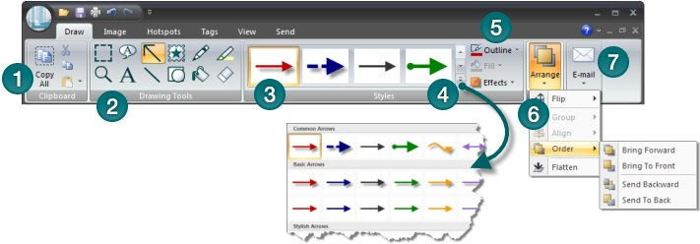
Pic. 6 The Draw Tab

 | The Clipboard group contains the following tools and commands:  Copy All, Cut, Copy, and Paste.
 | The Drawing Tools group contains the following tools and commands: Selection, Scale, Footnote, Text, Arrow, Line, Stamp, Form, Pen, Fill, Selection, Eraser.
 | The Quick Styles gallery is a collection of pre-made styles or effects. To use, select a style from the gallery and drag or click on canvas.er.
 | Click on the “More” button in the gallery to see even more style options to choose from.  Right-click the vector object on the canvas and select “Add to Quick Styles” to add it to the category of quick gallery styles.
 | The Outline, Fill, and Effects options for the selected instrument are available in the Styles group. Click the down arrow on the icon to display the available options.
 | The Arrange group contains the parameters of a vector object for organizing and aligning objects.  Right-click on an object to view the parameters of a vector object.
 | The "Send" group contains output options. Click the top of the icon to send the contents of the canvas to the specified output. Click the bottom of the icon to select a new output from the list.  The “Exit” icon will change to the “Full profile” icon if you are using a profile capture with a designated output. Continue with the fill profile or capture add-in.  When you close the editor, the Ready profile icon closes, and the Output icon appears when you re-open the editor.

Image Tab
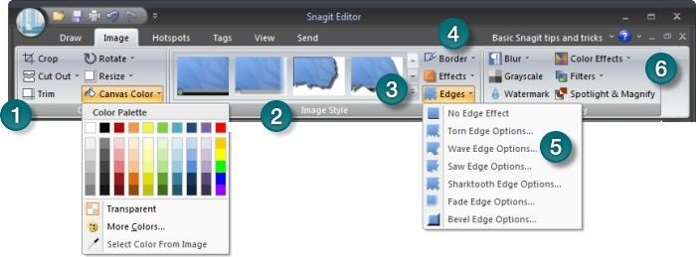
Pic. 7 The Image Tab

 | The Canvas group contains the following tools and commands:  Crop, cut, cut, rotate, resize, canvas color.
 | Extreme effects in the gallery of quick styles add a professional finished look to the selection or to the entire canvas. Extreme effects include shadow, tear, fade, wave, saw, shark tooth, and beveled edge. Click an effect in the gallery to apply the effect to the selection or the entire canvas.
 | Click the “More” button in the gallery to see even more edge effects to choose from. Custom border effects added to the gallery appear in the Quick Styles category..
 | The Styles group contains the Border, Effects, and Edge Effects options for the selected tool. Effects include Shadow, Perspective, Shear and Edges. Click the down arrow on the tool to view the available options.
 | Click Edges to access Edge Effects settings. On the settings taskbar, create an effect and click "Add to Quick Styles" to use it later..
 | The Edit group contains the following effects:  Blur, Grayscale, Watermark, Filters, Spotlight and Scale.
Video Control Tab
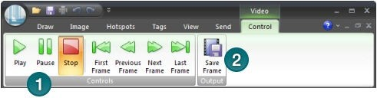
Pic. 8 The Video Control Tab
 | Play options in the play, pause or stop control video group. Use the parameters of the first, previous, next and last frame to move through the video frame by frame.
 | The “Save Frame” option in the “Output” group saves the current video frame as an image file.

Task-1:
Create create a screenshot of the screen using different profiles.
Process the picture of your choice in the Snagit Editor
Save the file.
You might get the following:
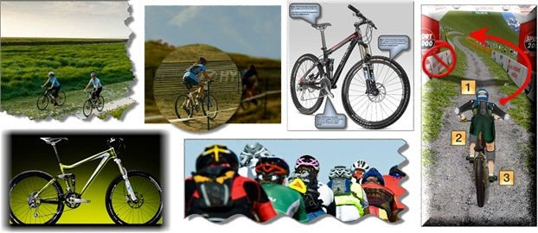
Pic. 9 The possible result of your work

Task-2:
Record a 2 minute video from the screen with voice accompaniment
Save the file.
Control questions:
What is a screenshot?
How to make a screenshot of the screen?
What profiles are available in the program?
How can I process pictures in the Snagit Editor?
How to record video from the screen?

2.11 Practical work №11.

WRITE THE VIDEO FILE IN THE CAMTASIA STUDIO PROGRAM

Copy the file from the package to your computer

Pic.1

2) Download the software and click "Accept":
Pic. 2

Pic. 3

3) Click the 'Next' button:

Pic. 4

4) Select the software installation language and click OK:

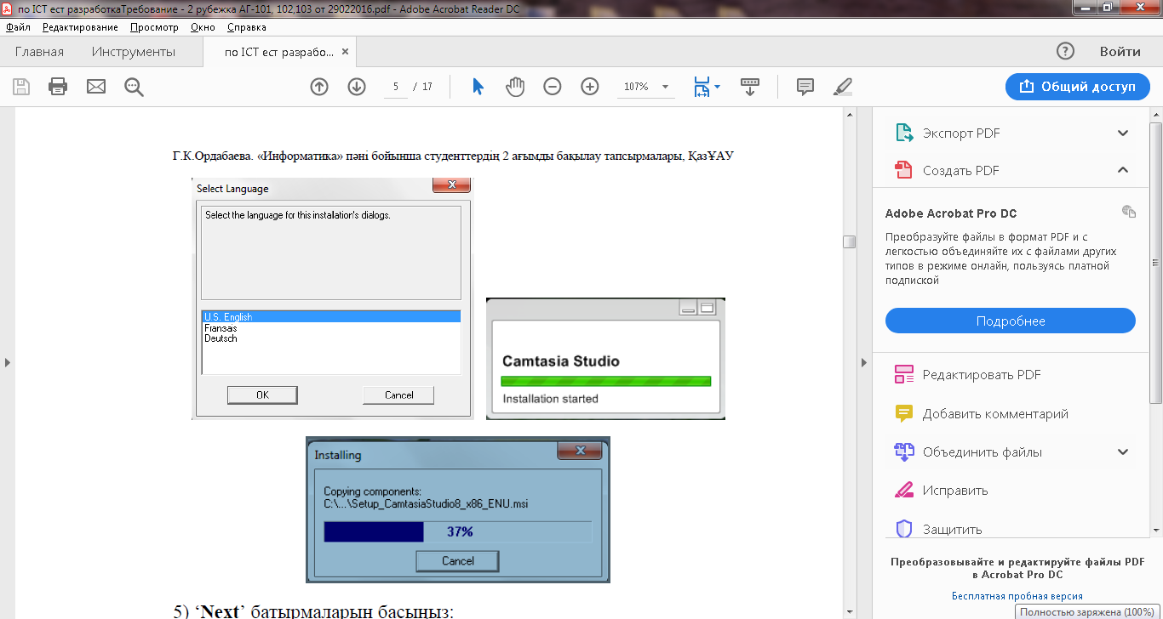

Pic. 5
5) Click the 'Next' button:

Pic. 6

Pic. 7

Pic.8

7) Download the software:

Pic.9

8) The program's main toolbar:
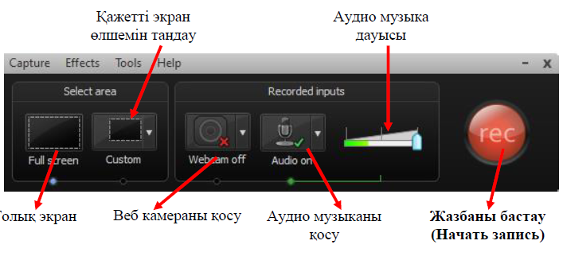
Pic.10

Pic.11

9) After selecting the desired screen size, the recording starts:
Pic.12

10) How to save and edit a recorded note:
Pic.13

You can save the file in * .avi format.
11) Ways to open the final note:

Pic.14

12) The results

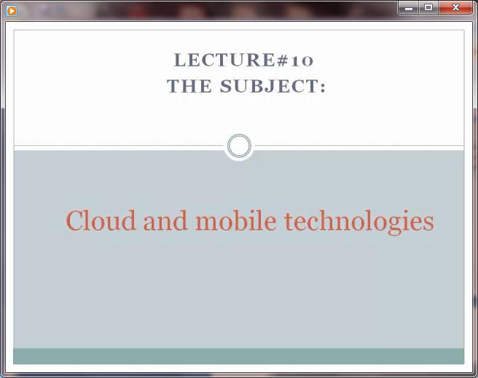

Pic.15

2.12 Practical work №12.

CREATE VIDEO WITH PRESENTATION POWER POINT ON CAMTASIA STUDIO

After saving the slides generated in Power Point, in the JPEG or GIF format, click on the Create button and open the new program in the program.

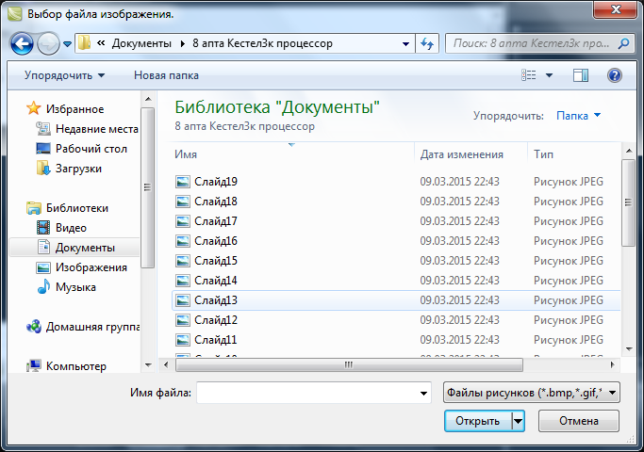

Pic.1 Save slides in the image.
Then, using the Import Media application, we put all the saved slides into

the project

.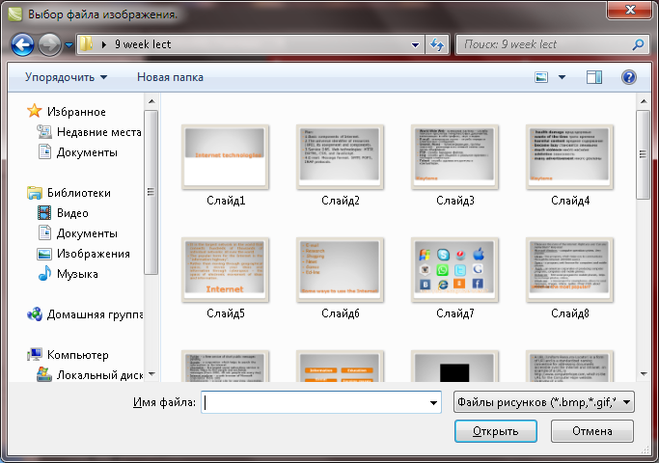
Pic.2 Import media

We will select all the slides in the program and place them on the timeline.

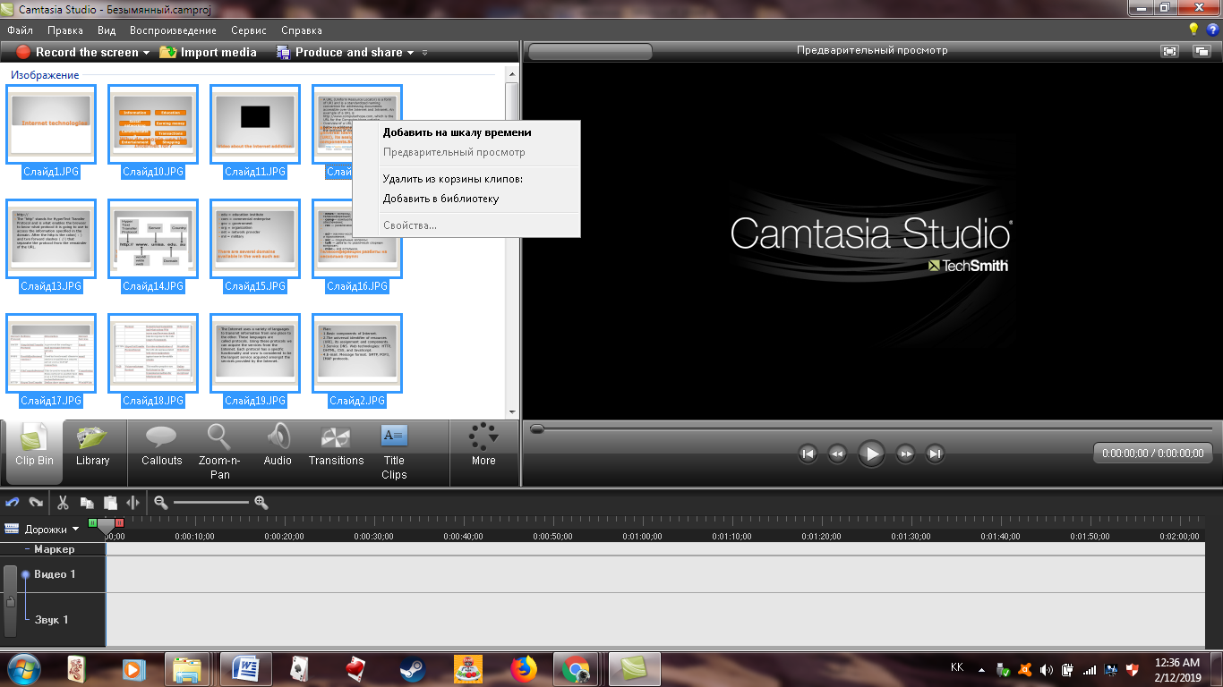
Pic.3 Placement of slides at Camtasia Studios

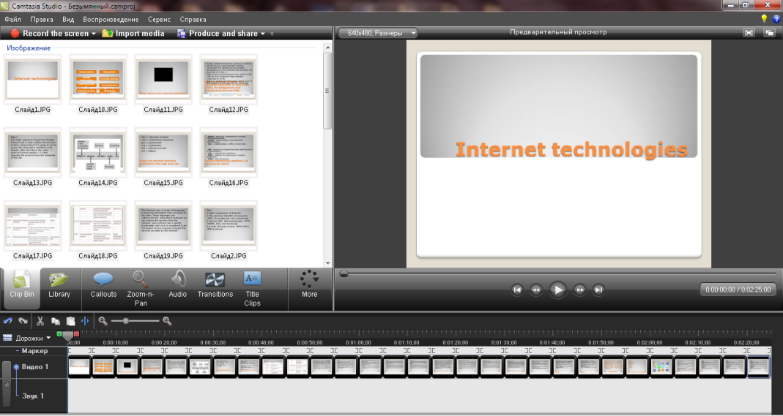
Pic.4 Placing slides on a timeline

Now you can double-click "Transitions" at the bottom of the program window, and then open the transitions.

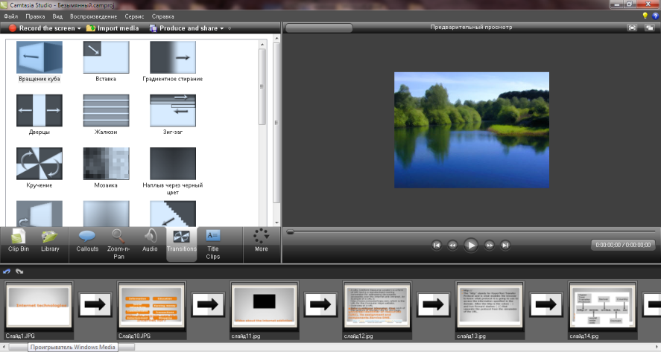
Pic.5

You must open the slides in the bottom of the program window and double-click the animation. We will see that the animation types are open. Selecting the desired type of animation, we place it in place by dragging it.

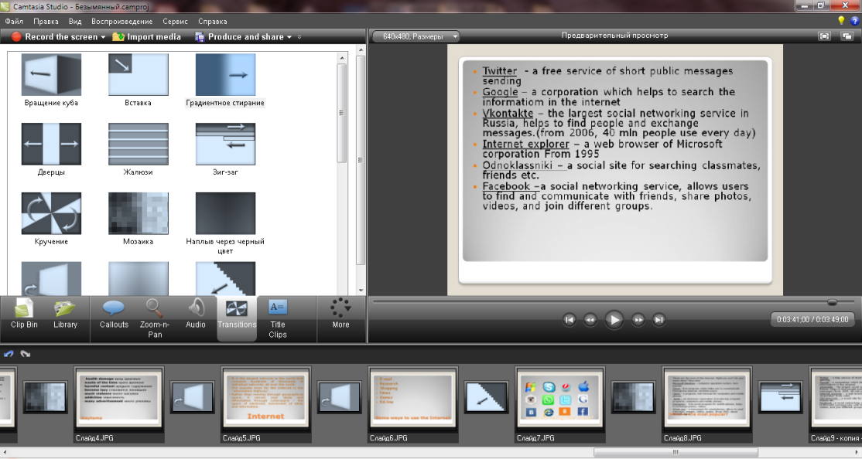

Pic.6 Slide transitions

Open the "Library" tool and place the audio in the project. Select one audio file and add it to the current timeline.

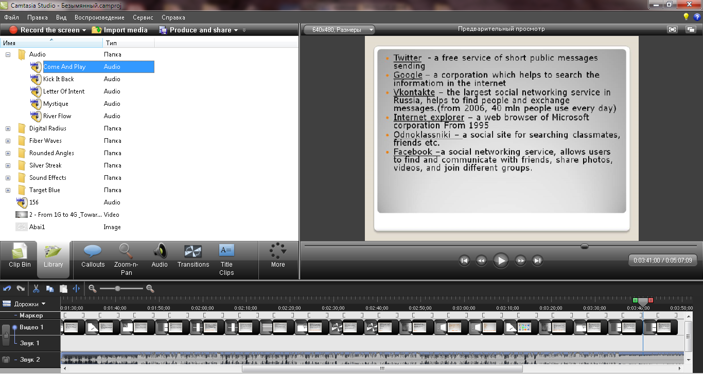
Pic.7 Add audio
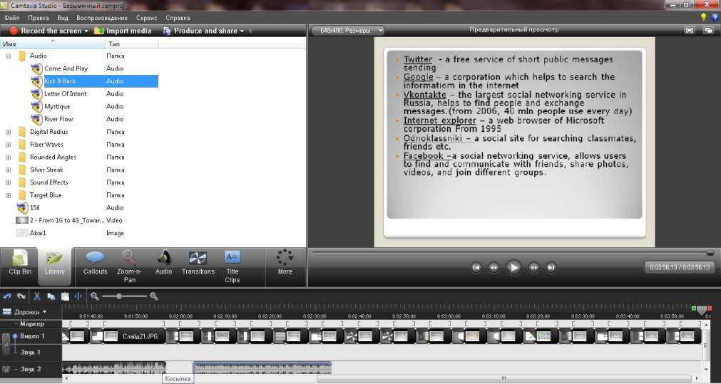
Pic.8 Changing the slide show time

You can open the slides on the timeline and change the duration of their rendering. And you can place another sound on the bottom zoom ring.
Using the menu of the program Produce and Share, we make the project one of the most widely used video clips on the Internet.

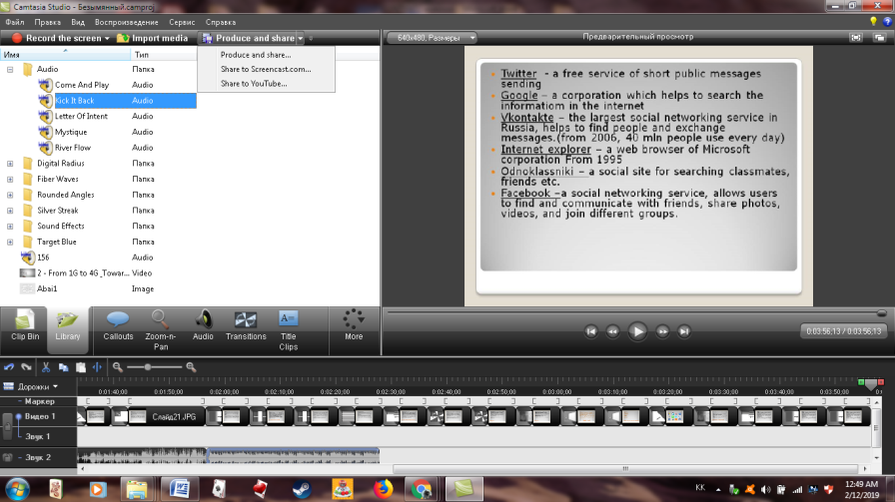
Pic.9 Put in program audio

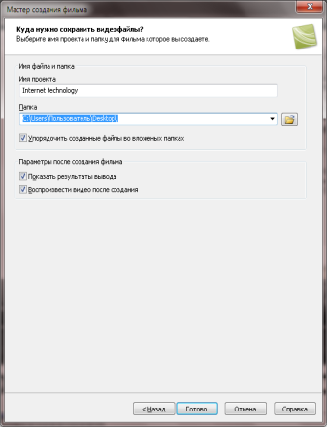
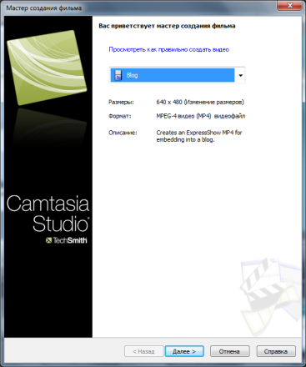

Pic.10 Produce and share menu

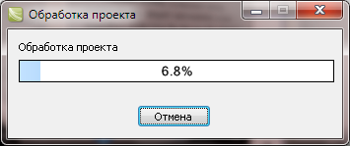

Pic.11 Proccess of slides

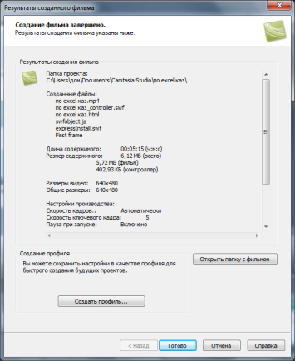
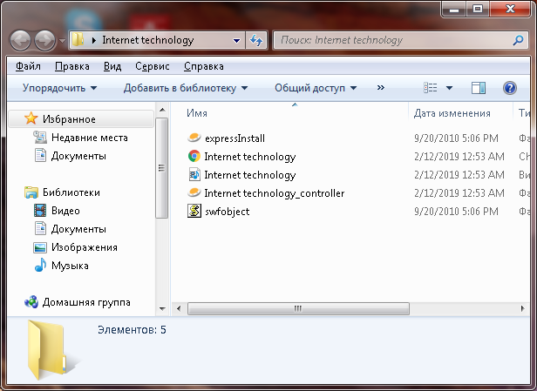

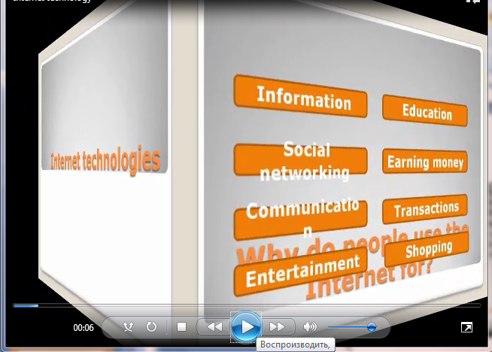
Pic.12Window of the video clip layout
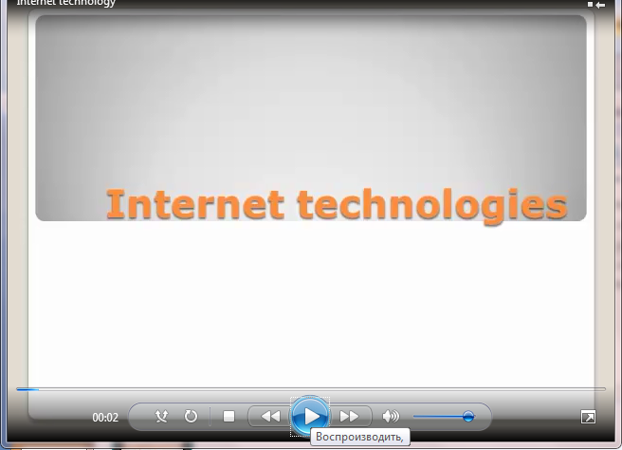
Pic.13 Watch Camtasia Studio Video Clip

2.13 Practical work №13.
INTERNET

Purpose: mastering the skills of working with a browser and Internet Explorer, Mozilla, Chrome, studying the process of searching for information on the Internet, knowing the address of the page on which it is located. To study the features of search engines, methods of their search.

Theoretical materials:
1. Search for information at address.
The World Wide Web Service (WWW) is a single information space consisting of hundreds of millions of interrelated electronic documents.
Individual documents that make up the Web space are called Web pages.
Groups of thematically linked Web pages are called Web sites (sites).
Programs for viewing Web pages are called browsers.
Addressing in the network:
IP address. DNS address.
The IP address consists of four blocks of digits separated by dots. It can look like this: 32.87.56.5
DNS address: http://www.yandex.ru
http - data transfer protocol
www - the server is on WWW
yandex - server name
ru - the server is located in Russia
The part of the address separated by dots is called a domain.
TASK-1
Create a folder on your desktop, and in it a Microsoft Word text document.
In the text document, create the following table:

Site address | Destination | Country
help.belhost.by
www.national-lottery.co.uk
index.all-hotels.in.ua
www.microsoft.com
www.house.gov
acorda.kz
britain.uz
klassica.ru
en.beijing2008.cn

Consider the opening web pages, determine the purpose of the site, determine the state in which this site is made.

2. Using Search Engines.
Currently, there are many online help services to help users find the information they need. These services use the usual principle of searching in unstructured documents - by keywords.
A search system is a complex of programs and powerful computers capable of receiving, analyzing and servicing user requests for searching information on the Internet. Since modern web space is immense, search engines are forced to create their own databases on web pages. An important task of search engines is to constantly maintain the correspondence between the created information base and the materials actually existing on the Web.
To do this, special programs (robots) periodically bypass the existing links and analyze their status. This procedure allows you to delete the disappeared materials and to add new links to the viewed pages.

TASK-2
Create a folder on your desktop, and in it a Microsoft Word text document.
In the text document, create the following table:
20th - 21th century personality
Surname, name | Years of Life | Occupation | Photo
Jeff Raskin
Yuri Gagarin
Marat Zhylanbayev
Bill Gates
Mark Zuckerberg
In order to find information about them, you need to open one of the search engines:
www.yandex.ru
www.rambler.ru
www.aport.ru
www.yahoo.com
www.google.com
In the search field, enter the name and name of the person, click OK.
Wait for the search results.
Among the set of links provided by the search engine, open the most suitable ones and copy the necessary information into the table.

TASK-3. Find the information below about your city (or regional center):
Date of creation -
Area -
Population –

Questions:
What programs browsers do you know?
What is the world wide web?
What is a web site?

CLOUD TECHNOLOGIES

Theoretical materials:

Cloud technology is one big concept that includes many different concepts that provide services. For example, software, infrastructure, platform, data, workplace, etc.
Today, the companies of Google, Amazon, Microsoft, IBM, Sun, and others are considered the “whales” of the cloud computing industry. They provide users with various paid and free services whose name is cloud computing: search engines, online maps, online payments, online games, online virtual worlds, YouTube, Facebook, Twitter, chats, torrents, and more. So, cloud technologies provide almost unlimited possibilities due to their services, from simple storage of information to the provision of complex secure IT infrastructures.

2.1 Сreation of cloud storage Mail.Ru.

!Advice: In order to use the cloud service, you need to create your account - this is an account that stores personal user information to access the site. To create an account it is necessary that the user already had an email address.

To go to the cloud, being on the main Mail.Ru page, you need to click on the "All Projects" tab and select "Cloud".

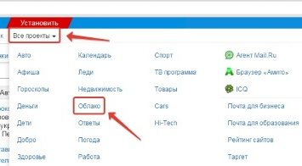
Pic. 1 The main Mail.Ru page, "All Projects" tab

Initially, there are already downloaded pictures and video files that you can delete. You can delete files in several ways. If you need to delete several files at once, check them off and click on the “Delete” button on the top.
!Advice: And such a nuance is that in the Mail.ru cloud there is no basket in which deleted files fall, as on the same Yandex disk. From there we can recover them. From the clouds we remove immediately!
To add files from your computer to the cloud, use the "Download" button in the upper left corner.

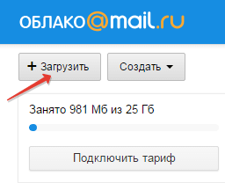
Pic. 2 Download button
You can download via the "Select files on computer" button, or drag them into the download window with the mouse. There is a limit - the size of the uploaded file to 2 GB.

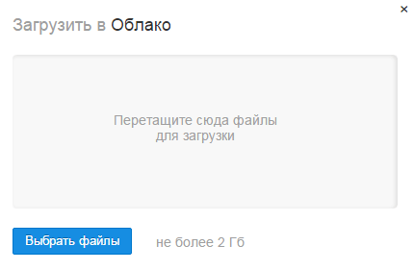
Pic. 3 To add files from your computer to the cloud

Next to the "Download" button we see the "Create" button. It is used to create folders, documents (Word), tables (Excel) or presentations (Power Point) right in the cloud.

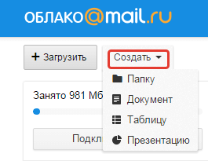
Pic.4 Create" button

If you want to organize files in the cloud, then create special folders for them. To move a file to a folder, select it with a check mark, right-click, select "Move." A window will open in which you can select a folder to move or immediately create a new one.
In general, we can use the right mouse button for different actions on files — delete, move, copy, download, generate a link for other people or send by mail.
To share a file and generate a link to it, first select it with a checkmark, then click on the “Get link” button or use the right mouse button.
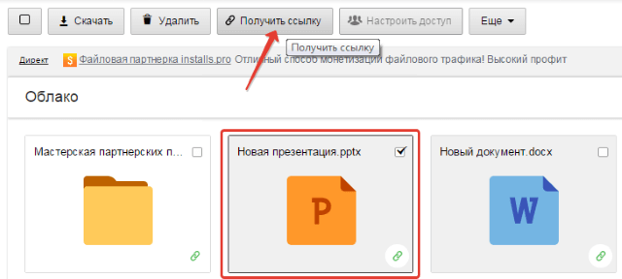
Pic. 5 Share a file and generate a link

A window will open where you can copy the link to this file and share it.

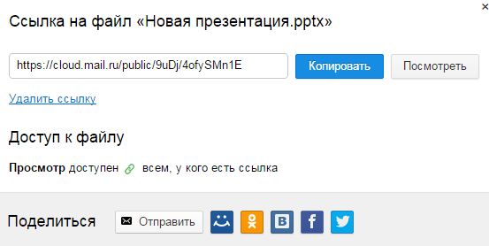
Pic. 6 File Access

If you open access to the file for a while, and then you want to delete this link, then select the desired file with the mouse, press the right button - select the item “Delete link”.
All your files to which you have opened access can also be found in the "Sharing" section.
If a link to a file from the Mail.Ru cloud is shared with you, then you can immediately download it or save it to your cloud. You will be able to specify a folder (in which you want to save this file), or you can create a new folder for it.
Now a few words about setting up access to folders. You can share with any folder with the ability to edit. That is, other users will also be able to add files to this folder.
To set up access to the folder, mark it with a checkmark, click on the “Configure Access” tab.
Access with editing can be opened only for individual participants whom you invite by e-mail.

Task 1
Load your folder in the cloud any file: image, document, audio, video.
Open the file or folder for all of your group.
Send the link to the file (folder) in the audience.
Send the link to the file (folder) to someone by e-mail. File (folder) should be available for viewing.
Install the application cloud service on the smartphone and view your files through it.
Download any file (photo, audio, video) to the cloud via the app on your smartphone. Check to see if your file in a folder on your computer.
Carry out a comparative analysis, the results of which fill Table1

Table 1 - Analysis of the file storage services Dropbox
 | Cloud @mail.ru | Yandex.Disk | Google Drive
Available space (in GB)
The ability to increase free disk space
The maximum file size
Availability of applications for computer
Availability of applications for smartphone
The ability to share links to the file
The ability to create and edit documents directly from the cloud
The ability to co-edit documents in the cloud
Your rating service for 5-point scale

2.2 Google cloud services
Currently, there are many free web hosting services. We will look at Google services. Google Corporation develops and provides many applications and services. The most used are the following Google services: Gmail - free email, Google Calendar - online calendar, Google Docs - online office, Google Maps - a set of maps, Google Sites - free hosting using wiki technology, Google Translate - translator .

2.2.1. Google-site
This site builder uses wiki-technology. Allows you to create a complete e-learning environment.
Page Editor allows you to add information from other Google applications, such as Google Docs, Google Calendar, Picasa albums, YouTube video hosting.
Another important advantage is the ability to work together several users.To construct an electronic environment with the help of convenient tools, you can create training modules and organize interactive interaction of all participants.

2.2.2. Google form
Using Google forms, you can conduct various polls, quizzes, create questionnaires, tests. When you create a form, a Google table is automatically created in which the results of the form are accumulated. The table provides convenient storage and processing of the collected data.

2.2.3. Google spreadsheets
Google Spreadsheets allows you to create online spreadsheets where you can perform:
Import, data conversion and export.
Using formulas.
Creating charts.
Pupils' shared tables on a given topic.

2.2.4. Google Docs. Picture
Service features:
Create online drawings, charts using auto patterns, a text field, insert pictures / photos from a computer disk or from the Internet.
Ability to work together multiple users on one sheet (figure).

2.2.5. Google Drive
Google Drive is a convenient online service that allows you to store various types of files that you can open access to any user. Cloud storage Google Drive has a high level of security and stable operation. Google Drive provides the minimum complexity and amount of time to work with files. Google Drive is notable for the fact that files stored in it can be edited in real time. You will not need to drop and receive your files by mail - all operations on them will be made and saved directly on the disk.

Getting started with Google Drive
Click the small square icon on the Google homepage and select "Drive." You will be provided with 15 GB of free disk space for your files. Increasing the amount will require payment.
Before you open a page that will contain all the documents that you add to Google Drive. It is worth noting that there will also be Forms, Documents and Spreadsheets created in special Google applications, as well as files from the Google Photos section.

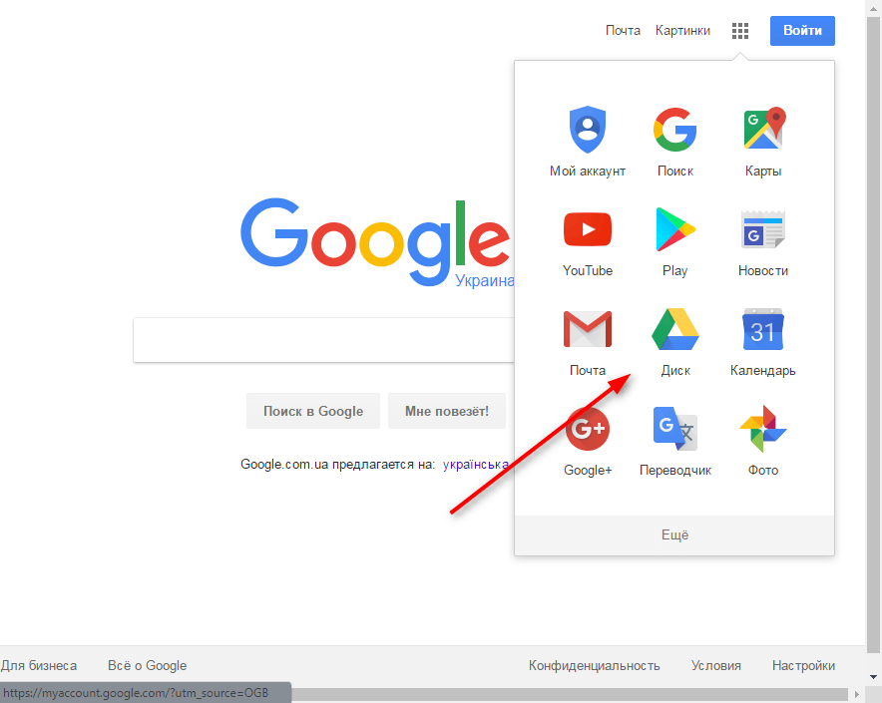
Pic. 7 Google cloud services

To add a file, click Create. You can create a folder structure right on the disk. A new folder is created by clicking on the "Folder" button. Click Upload Files and select the documents you want to add to the disk. With the help of applications from Google, you can immediately create Forms, Tables, Documents, Drawings, or add other applications.

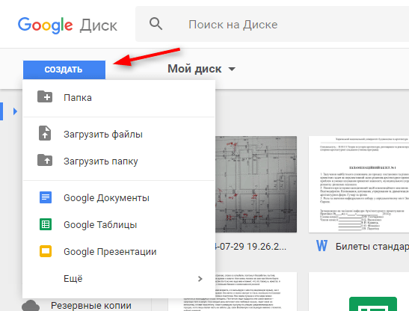
Pic. 8 Add file

Clicking on "Available to me", you will see a list of files of other users to whom you have access. They can also be added to your disk. To do this, select the file and click the "Add to my disk" icon.

Тask 2:
Create your Google Drive
Download any file to Google Drive: image, document, audio, video.
Open someone access to the file
4. Explore the remaining features of Google’s cloud services.

Control questions:
What are your suggestions for the development of services, file storage?
How often do you use the file storage service?
What cloud services do you know?
What are the new ways to use file storage services for yourself what you see?

Pic.9 Associogramm

2.14 Practical lesson №14.

ELECTRONIC GOVERNMENT

Theoretical materials:
Electronic Government - A way to provide information and assistance in a set of public services to citizens, businesses, other branches of the government and public officials, in which the personal interaction between the state and the applicant is minimized and information technology is used as much as possible.
Www.egov.kz portal is one of the major projects of e-government - the mechanism of functioning of government and local authorities, based on widespread use of information technology using the combined information resources of state bodies and mainly oriented to the provision of services to citizens and organizations.Objectives of e-government portal:• simplification of procedures for granting public services to the population on the basis of a single window;• improving the efficiency of delivery of public services;• creation of a single point of access to all information resources of state bodies: an open dialogue with the government, privacy, the establishment of direct and reverse interaction between citizens and public authorities.
The structure of the portal
Electronic services and services, information about public services and useful materials are structured into two main categories - "Citizens" and "Business", which, in turn, are divided into thematic sections.
Task 1. Load the portal of public services of the Republic of Kazakhstan at www.egov.kz

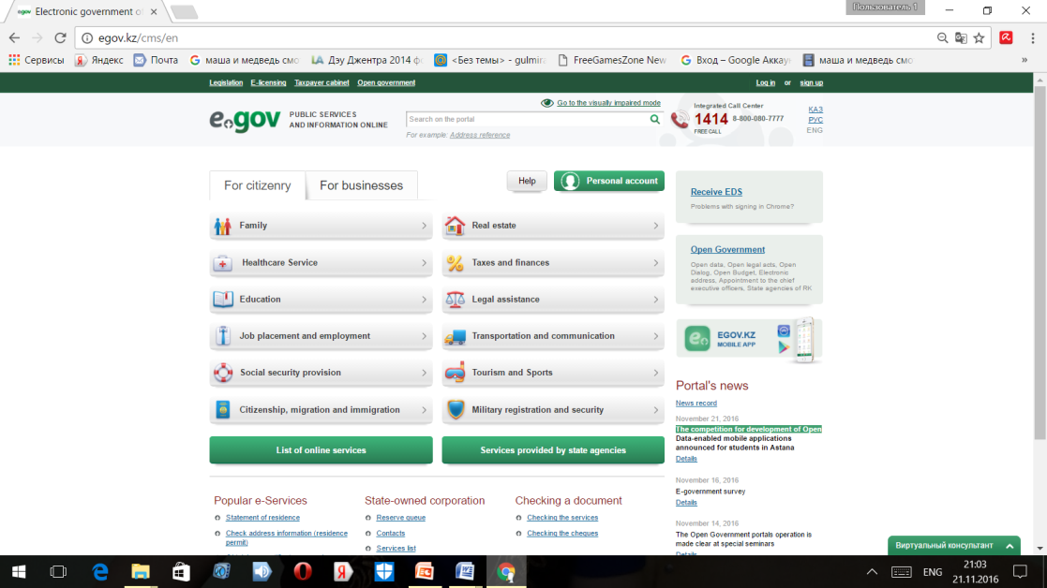
Pic.1First page of site
Complete registration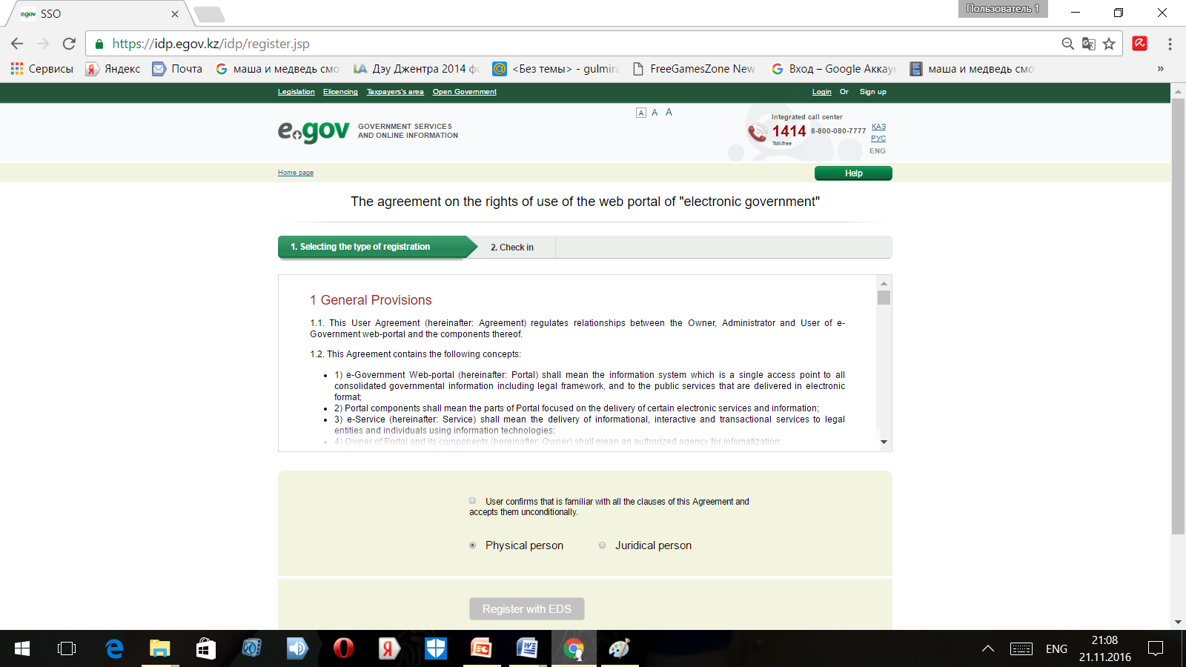
Pic.2 General Provisions
1.3. Learn the basic functions of a single portal of public services www.egov.kz (to access key to e-government and digital signature key)
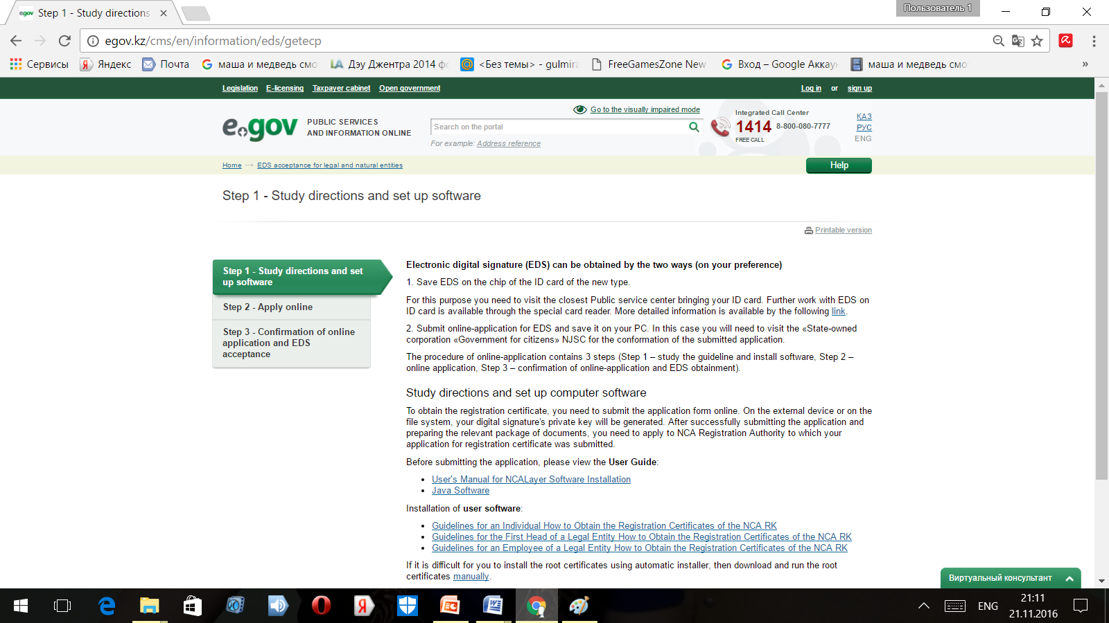
Pic.3 Create digital signature key

1.4. Login to your account on the site www.egov.kz.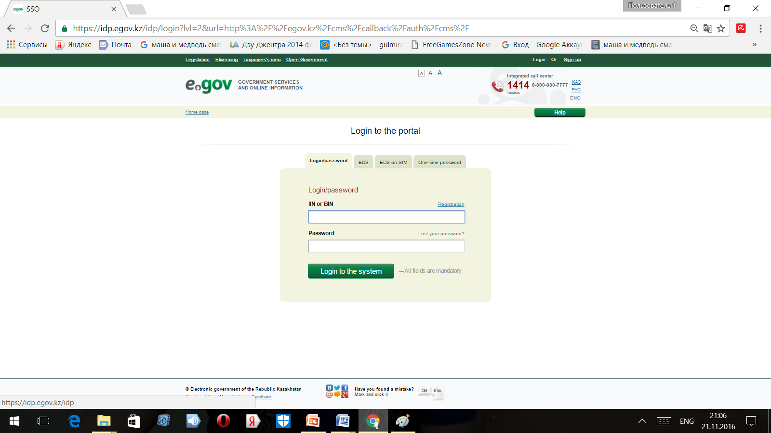Pic.4Enter login and password

Task 2.
2.1 Make a request for the address reference
2.2. Make a request for a certificate of absence of a previous charge of the citizen of Kazakhstan.
2.3. Make a request for passing examination to get a driving license
2.4. Fill in the application for the certificate of tax arrears
Task 3.
1) Print out the necessary forms on the electronical portal that is necessary for a registered individual
2) Making up glossary on the theme.

2.15 Practical work №15.

CREATE A COURSE IN MOODLE FOR DISTANSE EDUCATION

To create a course in the system of distance education PGSPU
http://moodle.pspu.ru/ needed:
1. Register in the system (create an account);
2. Apply with the name of the course and faculty. Request
sent to the email address topolskij@pspu.ru. Text
applications:
Please create a “Name” course for the ______________ faculty.
Assign a teacher (s): full name.
A user who is assigned the role of "Teacher" gets access to
all controls and settings of your course.
To enter the course, click on its name.
In the central block of the page the course content is presented, highlighted
thematic sections of the course, and on the sides - functional and informational
blocks. All basic course controls are on the left in a separate
block - "Settings"
.
Pic.5 Editing

To make any changes to the course page you need to enable
"Edit Mode". In this case, the pages of your course will appear
small icons (pictograms), using which you can change
any of the course elements. Edit mode can be activated by two
ways: through the Settings block or the button in the upper right part of the page.
Please note that edit mode is only available for themes.
users who have teacher rights to the course.

Pic.6 First page

In the edit mode, the course pages will look slightly different:

Pic.7 Edit mode

Clicking the “Finish Editing” button closes accordingly.
this mode.
2. COURSE SETTINGS
Before you start working on your course, you need to check and, when
necessary, edit the course settings set
default site administrator.
To do this, click in the block "Settings" on
left panel. Only the items are complete and are required.
a brief course description. Edit this data if it was not quite
exactly set by admin.

Pic.8 Block "Settings"

Particularly noteworthy is the “Course Description” item. Fill it in
in the following way:
The course is intended for bachelors of the direction ................... Discipline
enters into ...................................... cycle of the curriculum, refers to .... ...............
parts (cipher)
This text is automatically transferred to the main page of the site opposite
Your course.
Do not forget to save the changes ("Save" at the bottom of the page).

Pic.9 Button Save/Cansel

3. PROVIDING ACCESS TO COURSE. CODEWORD
Students enroll for the course automatically after entering
code word, which is given to students of any form during a full-time meeting
learning.
The code word allows access to the course only to those who know.
password. If the field is left blank, then any user can sign up for
course. If a code word is given, then any user, when trying
Sign up for a course will need to enter it.
To set up this method of recording for the course you need in the "Settings" block
in the left pane of the course select a line and in the list that opens
select the course entry methods.
Pic.10Record to the course

On the page that opens, you will see three ways to register for the course. Clickon the gear icon (edit) opposite the line Self
Record (Student):
Pic.11 Selfrecord of student

Fill in the fields: Name of the method (Self recording), Allow
self-recording (Yes), Allow new credits (Yes), Codeword.
The code word can contain Russian, English letters and numbers.
(for example, nir-1213-2014). Try not to choose standard passwords,
since the code word is necessary so that access to the discipline can
Get only your students and no one else.

Pic.12 Page selfrecord of student

Do not forget to save the changes ("Save" at the bottom of the page).
4. DESCRIPTION OF THE COURSE
For courses in the system of distance education PGPP default
Selected format - "Sections by Subject". The whole course is divided into parts - topics.
The upper section of the course does not contain a number and is always displayed on
course page. It is necessary to place in it:
1. Information about the course;
2. Educational and methodical complex of discipline;
3. References to sources of literature from ELS.
Pic.13 About cours

To do this, turn on "Edit Mode" and click on the icon
"gears" in the uppermost section of the course (before the block "Topic 1") -
Edit entry:

Pic.14 Edit entry

Uncheck "Use the default section name" and enter
section title: About the course. Fill out the "Description" field below.
in the following way:
The course is intended for bachelors of the direction ................... Disciplineenters into ...................................... cycle of the curriculum, refers to .... ...............parts (cipher)
Do not forget to save the changes ("Save" at the bottom of the page).
After saving, the course page will look like this:

Pic.15To save the changes

Give the titles of course topics. To do this, click on the edit button.
(gear) about the relevant topic. Uncheck "Use default section name "and enter a topic name. The topic description does notis required.
Depending on the content of the course and the concept of teaching,the teacher may include the most appropriate elements and resourcesprovided by the Moodle system.
For the course page in the system of distant education PGSPU
The following items are required:
- CMD (curriculum, brief course description, including information on teachers, glossary);
- materials of control (laboratory, practical) work;
- placement in the environment of students of the results of assignments;
- lecture materials (short summary / presentation in PowerPoint, in accordance with recommendations on the use of the template in the corporate style PGSPU);
self-study materials, incl. videos, links to ELS;
- tests;
- use the forum.
In fact, creating courses in the Moodle system is a gradual and
selectively adding various resources and elements to the course material.
To add a resource or course item to a topic of the "Edit Mode" course and in the required topic click on the link "Add item or resource "
eleven In the pop-up window you will be presented with descriptions of all the elements and course resources available to you:

Pic.16 Add the new page

Select the desired item or course resource (you can see a brief
description of the resource in the right column) and click "Add."
Attach to the upper section of the course a page with links to sources literature from ELS and the file with the educational-methodical complex .

TEST ASSIGMENTS

Assigment 1.
Coose right answer for questions
1 All of these are synonymous to the word “authenticate” EXCEPT FOR: | a) verify b) authorize c) validate d) confirm
2 What is the logical relationship between the concepts “firewall – security”: | a) general and specific b) cause and effect c) method and purpose d) part and whole
3 What is the logical relationship between the concepts “deny – admit”: | a) general and specific b) contrast c) method and purpose d) part and whole
4 What is the logical relationship between the concepts “filter – firewall”: | a) general and specific b) cause and effect c) equivalence d) part and whole
5 What is the logical relationship between the concepts “character – password”: | a) general and specific b) contrast c) method and purpose d) part and whole
6 Which of these is a correct antonym to the adjective “penetrable”: | a) unpenetrable b) inpenetrable c) impenetrable d) non-penetrable
7 All of these mean “cause to become vulnerable or function less effectively” EXCEPT FOR: | a) compromise b) secure c) penetrate d) expose
8 Mark the odd word: | a) compromise b) corrupt c) disrupt d) detect
9 Official recognition of sb as possessing certain qualifications or meeting certain standards is referred to as ___. | a) authentification b) certification c) authorization d) verification
10 Mark the odd word: | a) cipher b) code c) encrypt d) decrypt
11 Which of these is antonymous to “confidential”: | a) sensitive b) public c) classified d) proprietary
12 All of these collocate with the adjective “dedicated” EXCEPT FOR: | a) network b) channel c) link d) line
13 Choose the correct preposition: While studying abroad one gets exposed ___ the risks of cross-cultural misunderstanding. | a) for b) to c) at d) by
14 Hackers try to ___ firewalls. | a) install b) construct c) bypass d) set up
15 All of these are synonymous to the verb “expose” EXCEPT FOR: | a) endanger b) imperil c) peril d) jeopardize
16 The project is doomed ___ failure | a) for b) to c) – d) from
17 One can deny all of these EXCEPT FOR: | a) sb’s right to sth b) access b) a service c) some evidence d) an invitation
18 When scanning images ___ the computer, you digitize them | a) on b) in c) into d) to
19 Information categorized as officially secret, access to which requires authorization, is referred to as ___. | a) confidential b) classified c) sensitive d) encrypted
20 Try not to intrude ___ people’s privacy in social networks. | a) — b) on c) at d) to

Assigment 2.
Web 2.0. Basic terminology. Match these notions and definitions: /7/

notions |  | definitions
1 | Web 2.0 | a | Audiofile that can be accessed through a website, syndication or RSS feed
2 | Blog | b | A webside used for individuals or companies to share opinions or post news
3 | Podcast | c | Site containing the arrey of vidios
4 | RSS feed | d | Conseption or methodics of the next generation of Internet technologies and capabilities used to share and create content in new ways
5 | Webinar | e | A conference that is broadcast live over the internet
6 | Social networking | f | Really Simple Syndication that makes easily to subscribe to new content from the internet
7 | Colloborative | g | Online service which allows users to organize the sites and share them with others
8 | Wiki | h | A website that allows any user to contribute, edit, or change content
9 | Social bookmarcs | i | Descriptive keywords that help users categorize and find sites they bookmark/collection of tags, biogs
10 | Tag/tag cloud | j | Adjective to describe the contribution of each person into the work
11 | Youtube | k | A networking used to connect people or communities with each other

Assigment 3. Add true names for pictures

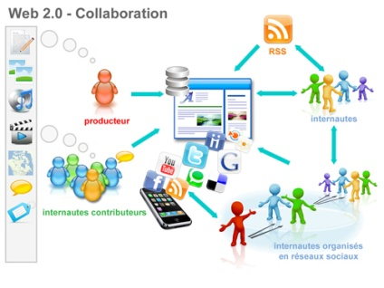












Assigment 4. Solve the tests
1. Which among the following sentences is true?
a) copyright is a form of legal protection**
b) copyright is concerned with the protection of ideas
c) copyright and plagiarism refer to the same concept
2. Which among the following sentences is true?
a) the use of Creative Commons license is recommended for software
b) creative Commons licenses are revocable.
c) a Creative Commons license is used when an author wants to give people the right to share, use, and build upon a work that they have created **
3. In order to limit Google results for a specific website this keyword must be used:
a) website:xxxx.com
b) site:xxxx.com **
c) it is not possible to limit the search to a single website
4. Wolfram Demonstration requires:
a) a deep knowledge of mathematica programming language
b) powerful computer with expensive graphics card
c) CDF player to use simulations **
5. How can we define a “simulation”?
a) Simulations are imitations of operating systems through time, via computers**
b) It is experimental device in small virtual laboratories
c) It is a workshop controlled remotely
6. Which among the following tool is not a virtual laboratory?
a) simulation
b) moоdle**
c) network applets
7. What does the right or condition “no derivative works” mean?
a) You must acknowledge both the author and the publisher.
b) You must use “as is” and not make changes.**
c) You cannot sell the resource and make money from the sale.
8. Which licences do NOT allow “use and/or sharing commercially”?
a) CC BY-ND
b) CC BY-SA
c) CC BY-NC-ND**
9. How can one use smartphone for high-performance computing in the laboratory.
a) 1- the remote use of cloud servers. 2 - smartphone as a mediator between the user and the computer / server. 3 - Use adapted calculation algorithms on the smartphone (for example neural networks tailored to address specific problems)**
b) Connect multiple smartphones in a cluster to further use the total processing power of all connected devices
c) The use of NFC technology for high-speed data exchange with a server.

10. What is mobile learning? Choose the precise formulation.
a) Is flexible learning, implying the presence of a large number of sources, the maximum diversity of media (audio, video, graphics), the ability to quickly and easily adjusted to the level and needs of the listener by using mobile devices.**
b) A flexible learning, suggesting the presence of audio that can build a learning path
c) A flexible training based on smartphones, suggesting the presence of video effects and animations that can adapt to the level of knowledge of the audience and make decisions

This set of Cloud Computing Multiple Choice Questions & Answers (MCQs) focuses on “Introduction to Cloud Computing”.
11. _________ computing refers to applications and services that run on a distributed network using virtualized resources.
a) Distributed
b) Cloud
c) Soft
d) Parallel
View Answer
Answer:b
Explanation:Cloud Computing applications are accessed by common Internet protocols and networking standards.
12. Point out the wrong statement :
a) The massive scale of cloud computing systems was enabled by the popularization of the Internet
b) Soft computing represents a real paradigm shift in the way in which systems are deployed
c) Cloud computing makes the long-held dream of utility computing possible with a pay-as-you-go, infinitely scalable, universally available system
d) All of the mentioned
View Answer
Answer:b
Explanation:Cloud Computing is distinguished by the notion that resources are virtual and limitless and that details of the physical systems on which software runs are abstracted from the user.
13. ________ as a utility is a dream that dates from the beginning of the computing industry itself.
a) Model
b) Computing
c) Software
d) All of the mentione
View Answer
Answer:b
Explanation:Cloud computing takes the technology, services, and applications that are similar to those on the Internet and turns them into a self-service utility.
14. Which of the following is essential concept related to Cloud ?
a) Reliability
b) Productivity
c) Abstraction
d) All of the mentioned
View Answer
Answer:c
Explanation:Cloud computing abstracts the details of system implementation from users and developers.
15. Point out the wrong statement :
a) All applications benefit from deployment in the cloud
b) With cloud computing, you can start very small and become big very fast
c) Cloud computing is revolutionary, even if the technology it is built on is evolutionary
d) None of the mentioned
View Answer
Answer:a
Explanation:Issues with latency, transaction control, and in particular security and regulatory compliance are of particular concern.
advertisements
16. Which of the following cloud concept is related to pooling and sharing of resources ?
a) Polymorphism
b) Abstraction
c) Virtualization
d) None of the mentioned
View Answer
Answer:c
Explanation:Applications run on physical systems that aren’t specified, data is stored in locations that are unknown, administration of systems is outsourced to others, and access by users is ubiquitous.
17. ________ has many of the characteristics of what is now being called cloud computing.
a) Internet
b) Softwares
c) Web Service
d) All of the mentioned
View Answer
Answer:a
Explanation:The Internet offers abstraction, runs using the same set of protocols and standards, and uses the same applications and operating systems.
18. Which of the following can be identified as cloud ?
a) Web Applications
b) Intranet
c) Hadoop
d) All of the mentioned
View Answer
Answer:c
Explanation:When an intranet becomes large enough that a diagram no longer wishes to differentiate between individual physical systems, the intranet too becomes identified as a cloud.
19. Cloud computing is an abstraction based on the notion of pooling physical resources and presenting them as a ________ resource.
a) real
b) virtual
c) cloud
d) None of the mentioned

ACTIVITIES

Activity 1.
Cyberbullying Crossword Puzzle
Sameer Hinduja, Ph.D. and Justin W. Patchin, Ph.D.
Cyberbullying Crossword Puzzle
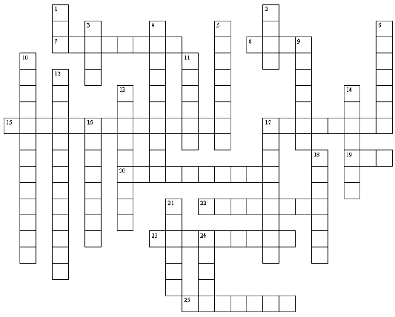

DOWN
1. Short for “World Wide Web” or pages linked together via
the Internet.
2. Unsolicited electronic mail sent from someone you do
not know.
3. Interactive Web journal or diary, the contents of which
are posted online and then viewable by some or all
individuals.
4. An intermediary Web site that hides or disguises the IP
address associated with the Internet user.
5. An electronic device that stores and processes
information and facilitates electronic communication
when connected to a network.
6. Two or more computers connected so that they can
communicate with each other.
9. The most popular social networking Web site.
10. An extreme form of bullying where physical assaults
are recorded on mobile phones or digital cameras and the
recordings are distributed to others.
11. A file on a computer that records user information
when visiting a Web site.
12. Intentional and repeated harm inflicted through the
use of computers, cell phones, and other electronic
devices.
13. A wireless handheld device that allows for telephone
communications.
14. A user created Web page on a social networking Web
site.
16. The denial of access to particular parts of the Internet.
17. The act of restricting access to certain Web sites
(usually using software programs).
18. Sending short messages via cell phone.
21. Making a statement or taking an action that indicates
harm to another.
24. Allows Internet users to send and receive electronic
text to and from other Internet users.
ACROSS
7. Repeated and deliberate harassment directed by one in
a position of power toward one or more.
8. Physical or emotional injury to someone.
15. Suicide stemming directly or indirectly from
cyberbullying victimization.
17. The second‐most popular social networking Web site.
19. Acronym for the company that provides an Internet
connection to individuals or companies.
20. Unsolicited words or actions intended to annoy, alarm,
or abuse another individual.
22. A worldwide network of computers communicating
with each other via phone lines, satellite links, wireless
networks, and cable systems.
23. The act of requesting another person to enter your
social network
25. Sending angry, rude, or obscene messages directed at a
person or persons privately or via an online group

OPTIONAL WORD BANK
ANONYMIZER  BLOCKING  BLOG  BULLYING  CELLPHONE  COMPUTER  COOKIE  CYBERBULLICIDE  CYBERBULLYING  EMAIL  FACEBOOK  FILTERING  FLAMING | FRIENDING  HAPPYSLAPPING  HARASSMENT  HARM  INTERNET  ISP  MYSPACE  NETWORK  PROFILE  SPAM  TEXTING  THREAT  WEB

Activity 2.
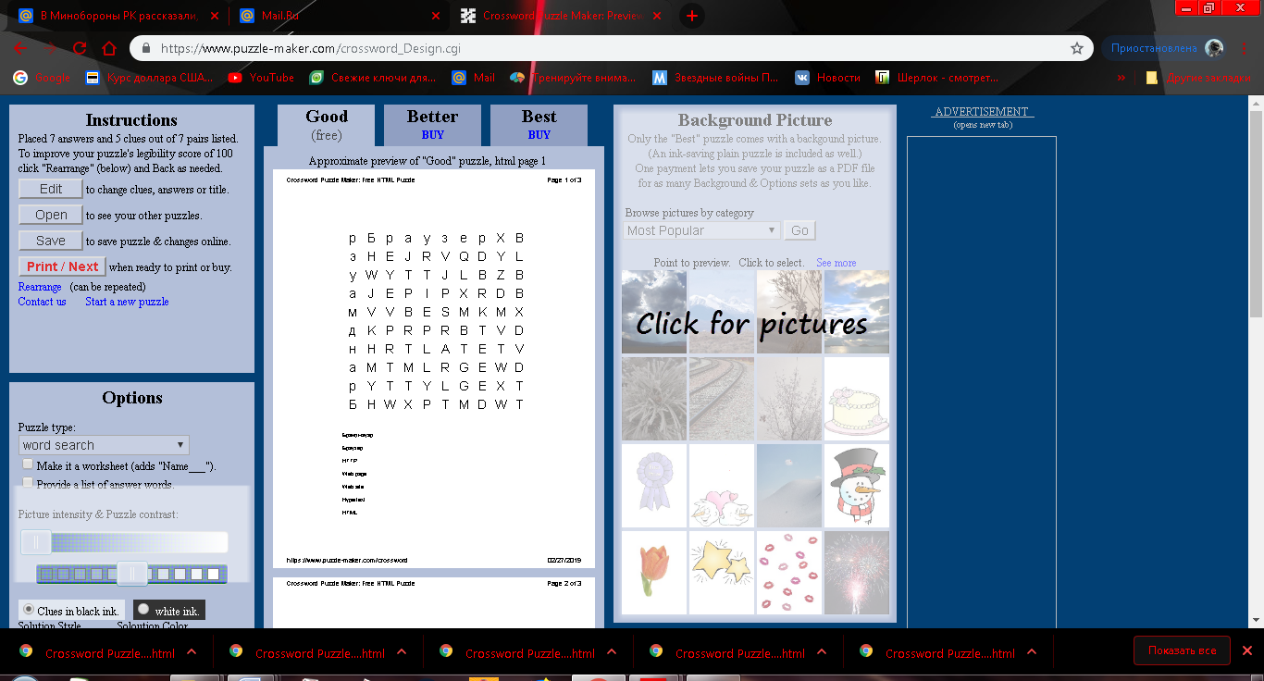

Activity 3. Solve this crossword

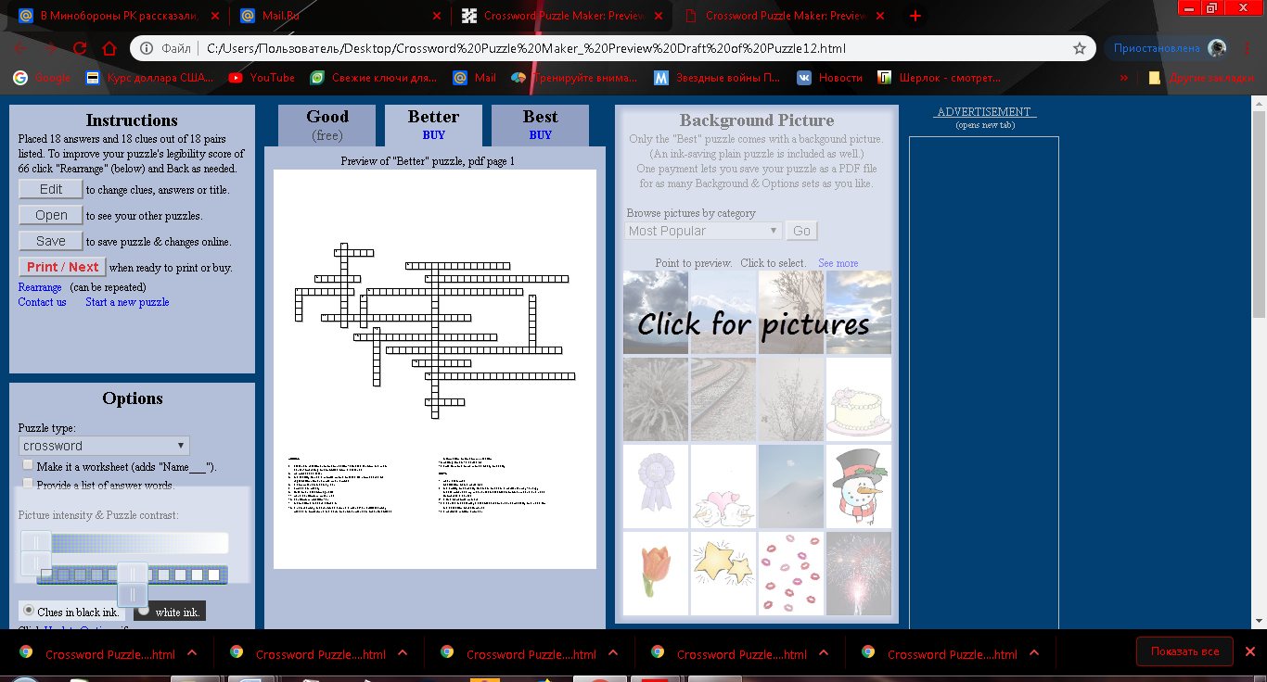

ACROSS: 2. distant in relationship or connection; situated far from the maincenter; operating or controlled from a distance 3.be processed later5the facility to use a mobile phone outside its normal area ofregistration, for example when abroad 6.a computer so that they can 7.spread sth widely 8.fluid or an electromagnetic11.wave equilibrium which has13.equilibrium position; an14.instructions that are stored in15.a natural body that revolves around a planet; an artificial bodyplaced in orbit round the earth or another planet in order to collectinformation or for communication1 6.waiting for sth; a series of 17.able to move or be moved freely or easily
DOWN1been disturbed 4.oscillation of the parts of a7.the ability or capacity to do sth or act in a particular way; energythat is produced by mechanical, electrical, or other means and usedto operate a device9.a line of people who are10.a device that displays electrical resonance, especially one used forthe detection of radio waves12.a periodic motion about an

Activity 4.

Match the given terms with their definitions:
1. back door | A. disclose confidential information
2. divulge | B. a feature or defect of a computer system that allows secret unauthorized access to data
3. deny | C. sth categorized as officially secret, access to which requires authorization
4. classified | D. internal consistency or lack of corruption in electronic data
5. integrity | E. refuse to admit the truth or existence of sth
6. threat | F. owned by an individual or a company, which needs to be licensed from the owner before it can be used
7. proprietary | G. a person or thing likely to cause damage or danger,

Activity 5. Match the given terms with their definitions:
1. cellular | A. a technology that allows high-speed transmission of text, audio, and video, usually over standard telephone lines; a form of broadband transmission
2. blackout | B. a natural body that revolves around a planet; an artificial body placed in orbit round the earth or another planet in order to collect information or for communication
3. carrier | C. the world's largest association of technical professionals
4. diffuse | D. relating to a system that uses radio waves instead of wires to send telephone signals
5. DSL | E. a mechanism or device by which something is conveyed or conducted; a company that provides facilities for conveying telecommunications messages
6. IEEE | F. spread over a wide area or between a large number of people
7. satellite | G. a period when lights are off because of an electrical power failure

Activity 6. Solve tests

1 What is the logical relationship between the concepts “earthquake - vibration”: | a) general and specific b) cause and effect c) method and purpose d) part and whole
2 What is the logical relationship between the concepts “diffusion – dispersion”: | a) general and specific b) cause and effect c) method and purpose d) equivalence
3 All of these are synonymous to the word “beam” EXCEPT FOR: | a) ray of light b) low c) resonator d) radiation
4 What is the logical relationship between the concepts “mobile communication standard – 3G”: | a) general and specific b) cause and effect c) equivalence d) part and whole
5 A mechanism or device by which something is conveyed or conducted is known as a___: | a) carrier b) band d) DSL d) LTE
6 A standard for wireless communication of high-speed data for mobile phones and data terminals is known as ___ | a) LTE b) 2G d) ADSL d) IEEE
7 Digital subscriber line is a family of technologies that are used to transmit digital data ______ telephone lines | a) forward b) over c) via d) through
8 Keeping _____ the communication standards is rather a challenging task for professionals. | a) up b) for c) to d) towards
9 ______ is a device that enables digital machines to monitor a physical quantity of the analog world, such as temperature, humidity, or pressure, to provide data. | a) resonator b) sensor c) satellite d) sonde
10 Mark the odd word: | a) detect b) neglect c) ignore d) conceal
11 All of these are synonyms EXCEPT FOR: | a) distort b) alter c) pervert d) preserve
12 All of these are antonyms to the word “landline” EXCEPT FOR: | a) satellite connection b) cellular connection c) WI-Fi d) telephone connection
13 Mark the odd word: | a) detector b) detection c) detectably d) detective
14 LTE, 3G, 4G are examples of: | a) standard for satellite connection b) standard for radio connection c) standard for wireless communication d) standard for cellular connection
15 Mark the odd word: | a) transitory b) transit c) transitional d) transitionary
16 All of these collocate with the noun “energy” EXCEPT FOR: | a) alternate b) nuclear c) computer d) solar
17 A device providing specific information on the state or condition of something; a thing that shows the state or level of something is known as a(n)___: | a) indicator b) pointer c) communicator d) connector

REFERENCES

1. June J. Parsons and Dan Oja, New Perspectives on Computer Concepts 16th Edition - Comprehensive, Thomson Course Technology, a division of Thomson Learning, Inc Cambridge, MA, COPYRIGHT © 2014.
2. Lorenzo Cantoni (University of Lugano, Switzerland) James A. Danowski (University of Illinois at Chicago, IL, USA) Communication and Technology, 576 pages.
3. Craig Van Slyke Information Communication Technologies: Concepts, Methodologies, Tools, and Applications (6 Volumes). ISBN13: 9781599049496, 2008, Pages: 4288
4. Utelbaeva A. K., Utelbaeva A.K. Study guide for lectures on discipline “Computer science”, Shimkent 2008, 84 pages.
5. Акбаева Г.Н., Смагулова Г.Т., Болатбекова А.К. Профессионально-ориентированный английский язык для педагогических специальностей. – Караганда: Изд-во КарГУ, 2013–154 с.
6. Англо-русско-казахский словарь компьютерных и Интернет-терминов / Авт.-сост. Д.Б. Алибиев., Э. В. Нестерик, А. Т. Жумашева., А. Т. Махметова, С. Ж. Алимкулова. – Караганда: Изд-во КарГУ, 2013. – 138 с.
7. Essential Skills for Word Processing: Microsoft Word 2007, TR Leger Adult Literacy and Employment Preparation Program
8. Aitbenova A.A. Laboratory work on computer science: educational-methodical manual for students of higher educational institutions. -Kostanay: KGPI, 2014. -220 p.
9. Santiago Remacha Esteras; Infotech English for computer users; page of 172;
10. Antonio Cartelli and Marco Palma; Enciclopedia of information communication technology; Page of 883; Copyright © 2009 by IGI Global.
11. Harry Henderson. Encyclopedia of computer science and technology. Copyright © 2009, 2004, 2003 by Harry Henderson 593 р.
12. June J. Parsons, New Perspectives on Computer Concepts 18th Edition—Comprehensive, Thomson Course Technology, a division of Thomson Learning, Inc Cambridge, MA, COPYRIGHT © 2016; ISBN-10: 1-4239-0610-1, ISBN-13: 978-1-4239-0610-0.
13. Reema Thareja Fundamentals of Computers. – Oxford University press: Oxford, 2014. - 288p
14. George Beekman. Computer Confluence: Exploring Tomorrow's Technology. ISBN 0130661880, 9780130661883. Prentice Hall, 2003
15. Симонович С.В. и др. Информатика. Базовый курс: учебное пособие для высших технических учебных заведений. – СПб.: Питер, 2011. – 639 с.
16.Thomas M. Connolly, et al. Database Systems: A practical approach to Design, Implementation, and Management. 4th Edition ISBN: 0321210255 Addison-Wesley, 2004
17.H. L. Capron. Computers: Tools for an Information Age. Addison-Wesley, 1998.
18. Roqers Y., H. Sharp, J. Preece. Interaction design beyond human computer interaction - Third Edition.- Italy: WILEY & Sons Ltd, 2011.- 585 р.
19. Ducket, J. Beginning Web Programming with HTML, XHTML, and CSS: 2th ed. / Jon Ducket.- U.S.A: Wiley Publishing. Inc, 2008.- 739с. ISBN 978-1-0-470-25931-3.
20. Stephen P Borgatti, Martin G. Everett, Jeffrey C. Johnson Analyzing Social Networks Paperback, 2013
21. Уша Рани Вьясулу Редди. Серия учебников по ИКТР для молодежи. Учебник 1: Введение в ИКТ для развития. UN-APCICT/ESCAP 2011
22. Дейтел Х. М., Дейтел П. Дж., Чофнес Д. Р. Операционные системы. Часть 1. Основы и принципы. – М.: Бином-Пресс, 2011. – 677 c.
23. Ярочкин В.И. Информационная безопасность: Учебник для вузов. – М.: Акад. Проект, 2008. – 544 c.
24. Голицына О.Л. Базы данных: Учебное пособие. – М.: Форум, 2012. – 400 c.
25. Keith Worden, W.A. Bullough, J. Haywood. Smart Technologies. World Scientific Pub Co Inc (April 14, 2003)
26. Introduction to ICT: учеб.-метод. Пособие по ИКТ на англ. языке / К.Т. Тобылов, Г.Б. Даулетбаева, В.В. Данилова. - Костанай: КГПИ, 2017. - 160 с.
27. R. Shirey, Internet security glossary, GTE/BBN Technologies, May 2000. [Online]. Available: https://www.ietf.org/rfc/rfc2828.txt [Accessed 15 Oct. 2015]
28. British National Corpus. [Online] Available: http://www.natcorp.ox.ac.uk/ [Accessed 15 Oct. 2015]
29. Oxford dictionaries. Oxford University Press. [Online]. Available: http://www.oxforddictionaries.com/definition/english/cipher?q=cypher [Accessed: 16 Oct. 2015]
30. A glossary of common cybersecurity terminology, NICCS. [Online]. Available: http://niccs.us-cert.gov/glossary [Accessed: 15 Oct. 2015]
31. Англо-русский словарь по телекоммуникациям. – «РУССО». – Александров А.В. – 2010.
32. Telecom ABC. [Online]. Available: http://www.telecomabc.com [Accessed: 19 Oct. 2015]
33. Computer hope. Free computer help and information. [Online]. Available: http://www.computerhope.com/jargon.htm [Accessed: 19 Oct. 2015]
34. Oxford dictionaries. Oxford University press. [Online]. Available: http://www.oxforddictionaries.com/definition/english [Accessed: 19 Oct. 2015]

Web Resources:
http://www.microsoft.com/Rus/Msdnaa/Curricula/
http://www.computer-museum.ru
http://inf.1september.ru
http://comp-science.narod.ru
http://www.intuit.ru
http://marklv.narod.ru/inf/
http://infoschool.narod.ru
http://www.syrtsovasv.narod.ru
http://www.phis.org.ru/informatika/
http://www.rusedu.info
http://iit.metodist.ru
http://book.kbsu.ru
http://school87.kubannet.ru/info/
http://www.intuit.ru/studies/courses/3735/977/lecture/14671
http://www.fgcu.edu/support/office 2007
http: //refleader.ru/jgeujgrnayfsyfs.html
http://ru.wikipedia.org/wiki/
http://ru.wikipedia.org/wiki/
http://www.intuit.ru/studies/courses/673/529/lecture/
http://www.openbookproject.net/courses/intro2ict/hardware/internal.html

