Костанайский государственный педагогический институт
Факультет иностранных языков
Кафедра иностранных языков

Данилова Виктория Валерьевна
Белоусова Ирина Юрьевна

Theory and Methods of
Upbringing Activity


Учебно-методическое пособие

Костанай, 2016 г.
УДК 811.111 (075.8)
ББК 81.2 Англ-923
Д 18

Авторы:
Данилова Виктория Валерьевна,
к.п.н., магистр педагогики и психологии, старший преподаватель кафедры иностранных языков факультета иностранных языков КГПИ

Белоусова Ирина Юрьевна,
учитель английского языка, социальный педагог ГУ «Средняя школа № 122 отдела образования акимата города Костаная»

Рецензенты:
Дорошок Е.Л., к.филос.н., доцент ВАК, декан факультета иностранных языков КГПИ

Котлярова Т.Я., к.фил.н., профессор кафедры филологии КФ ФГБОУ ВПО «Челябинский государственный университет»

Д18 | Данилова В.В.  Theory and Methods of Upbringing Activity: учебно-методическое пособие по воспитательной деятельности на английском языке / В.В. Данилова, И.Ю. Белоусова. - Костанай: КГПИ, 2016. – 58 с.

ISBN 978-601-7839-28-4

Учебно-методическое пособие по воспитательной деятельности предназначено для студентов факультета иностранных языков II и III курсов, также студентов полиязычных групп с целью формирования теоретических и практических основ планирования, организации и диагностирования воспитательной деятельности в современной школе. Данное пособие может быть применено в старших классах школ в рамках профилирующей траектории гуманитарного цикла.
Пособие состоит из двух разделов: теоретический и практико-ориентированный блоки. Теоретический блок представлен в виде опорных схем и отражает основные моменты теории воспитательной деятельности. Практический блок состоит из заданий и упражнений для формирования компетенций в сфере воспитательной деятельности.
УДК 811.111 (075.8)
ББК 81.2 Англ-923

Рекомендовано Ученым Советом Костанайского государственного педагогического института.

ISBN 978-601-7839-28-4
© Костанайский государственный
педагогический институт, 2016
Contents

INTRODUCTION 4
I Theoretical aspects of upbringing activity 6
Module 1. Methodological base of the upbringing process 7
Module 2. Facilitating the upbringing process 13
Module 3. Technological base of the upbringing process 15
II. Practical Module 22
Module 1. Methodological base of the upbringing process 23
Topic 1. Upbringing process as the integral part of pedagogical process 23
Topic 2. Modern Theories of Upbringing 25
Topic 3. The Content of Upbringing at school 27
Module 2. Facilitating the upbringing process 28
Topic 1. Supervising instructor at school: his functions, rights, obligations 28
Topic 2. Methods of Upbringing activity 30
Module 3. Technological base of the upbringing process 32
Topic 1. Case-Study Method. Ways of solving cases 32
Topic 2. Methods of planning traditional class hour 35
Topic 3. Methods of planning debates 37
Topic 4. Methods of planning a role play 38
Topic 5. Methods of planning the guest show 40
Topic 6. Methods of planning trainings 42
Topic 7. Monitoring of the upbringing activity 44
CONCLUSION 46
Mid-term test 1 46
Mid-term test 2 49
Questions for final control (TMUA) 51
Appendix 53
References: 57

Introduction

Modernization of education results in overall changing of the content of subjects to be taught turning into participant and competence-based one. The given manual is aimed at forming readiness of future teachers for upbringing activity in modern schools.
The readiness is comprised by theoretical and practical aspects and leads to effective collaboration in the system of ‘student-teacher-pupil’.
Upbringing activity cannot be parted from participation. Students are to be ready to handle with difficulties in reality that can occur while their training in HEIs (including factors from inside and outside of the educational process).
This manual presents the attempt of authors to illustrate basic factors influencing the participative readiness of future teachers for upbringing activity based on collaboration.
Upbringing activity was and is still the object of research of modern scientists (A.F. Daiker, A.Yu. Romanenko, D.V. Shalimova, V.L. Strokina, T.M. Tolkacheva, etc.). The issue on the forming of readiness for upbringing activity has been recently raised in modern foreign researches.
But foreign representation of the term ‘upbringing activity’ is connected with social work (Mario Jacomino, Jo Ann M. Bamdas, Kathryn Keller, Elwood Hamlin, Michele Hawkins, Shirley Gordon, Joseph G. Ouslander) or social activity (Lee-Fay Low, Jessica Rose Baker, Fleur Harrison, Yun-Hee Jeon, Maggie Haertsch, Cameron Camp, Margaret Skropeta).
The term ‘upbringing’ has been mainly used by post-soviet researchers and is associated with the more specific aspect of social work that was used to be mentioned in researches abroad.
Thus, the manual is dedicated to the problem of upbringing activity and the ways of assistance to future teachers in the field of upbringing in schools.
Theoretical module deals with key moments in the theory of upbringing and is presented in graphical form so that the process of acquiring the information could be sufficient.
Practical module is comprised by practical assignments aimed at developing skills of planning, organizing and diagnosing of upbringing activity in modern schools.
Appendix contains extra tasks for consolidating knowledge of students, as well as the content list of the items included into the Folder on Upbringing Activity.

I Theoretical aspects of upbringing activity

Theoretical aspects of upbringing activity are comprised by three main Modules (Methodological base of the upbringing process, Facilitating the upbringing process and Technological base of the upbringing process). Thematic calendar for the discipline is presented below (see Table 1).
Table 1
Thematic calendar for the discipline
“Theory and Methods of Upbringing Activity”
Week | Theme | Lec-ture | Semi-nar | SWST | IWS
Module 1. Methodological base of the upbringing process

 | Upbringing process as the integral part of pedagogical process | 1 | 1 | 1 | 3
 | Modern Theories of Upbringing | 2 | 2 | 2 | 6
 | The Content of Upbringing at school | 2 | 2 | 2 | 6
Module 2. Facilitating the upbringing process

 | Supervising instructor at school: his functions, rights, obligations | 1 | 1 | 1 | 3
 | Methods of Upbringing activity | 2 | 2 | 2 | 6
Module 3. Technological base of the upbringing process

 | Case-Study Method. Ways of solving cases | 1 | 1 | 1 | 3
 | Methods of planning traditional class hour | 1 | 1 | 1 | 3
 | Methods of planning debates | 1 | 1 | 1 | 3
 | Methods of planning a role play | 1 | 1 | 1 | 3
 | Methods of planning the guest show | 1 | 1 | 1 | 3
 | Methods of planning trainings | 1 | 1 | 1 | 3
 | Monitoring of the upbringing activity | 1 | 1 | 1 | 3
 | Total | 15 | 15 | 15 | 45

Special characters:
SWST – СРОП (Self-Work of the Student with the Teacher)
IWS – СРС (Individual Work of the Student)

Each Module has the graphical representation for the simplifying the incoming information and making students develop their critical and creative thinking. It must be stated that the use of these picture-based representations must be accompanied by solid theoretical background gained from various sources and must not be restricted to the given ones.

Module 1. Methodological base of the upbringing process
Topic 1. Upbringing process as the integral part of pedagogical process

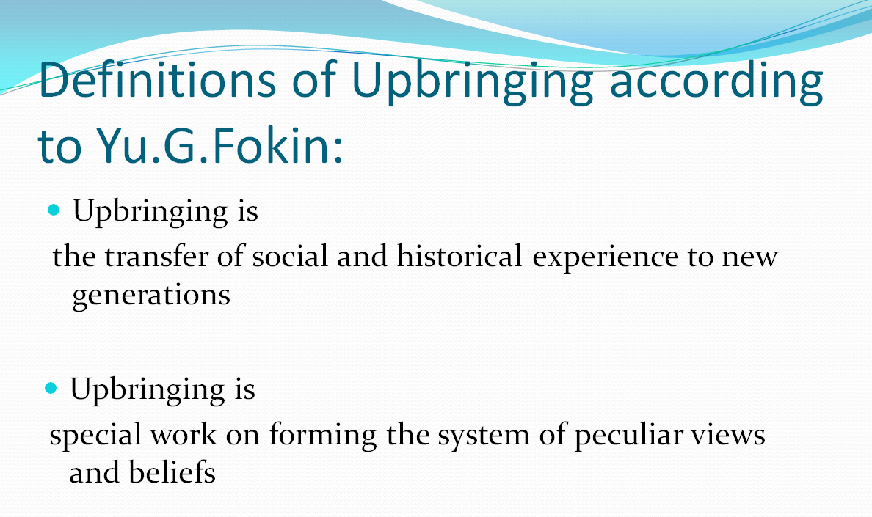

Social activity
Social work

Upbringing activity
Upbringing work

FUNCTIONS OF UPBRINGING

Main Upbringing Objectives: Upbringing System is…
The group of components of social reality providing spiritual, moral and creative development of the personality.

L.I.Novikova, V.A.Karakovsky, A.M.Sidorkin, etc.

- Humanistic development of the child.
- Forming patriotic feelings.
- Developing labour and life skills
- Forming appropriate behaviour
- Forming healthy life style
- Developing emotional sphere of the child
- Bringing up aesthetic feelings
- Forming eco-culture of the child

Components of Upbringing System (L.I. Novikova, N.L. Selivanova)

Communication
Organization
Management
Content

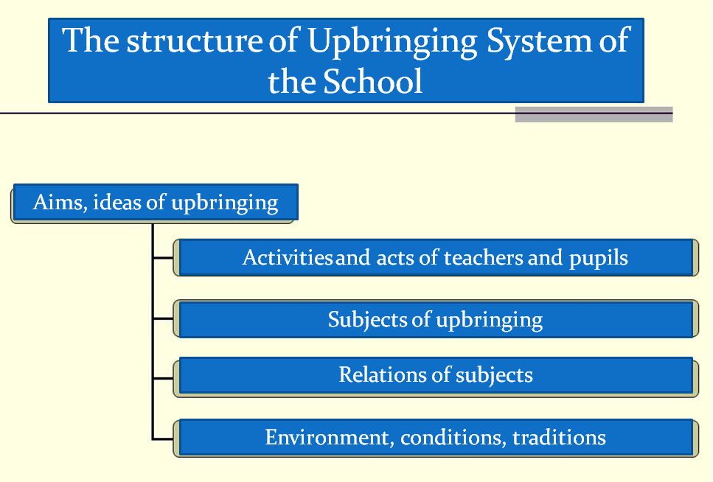

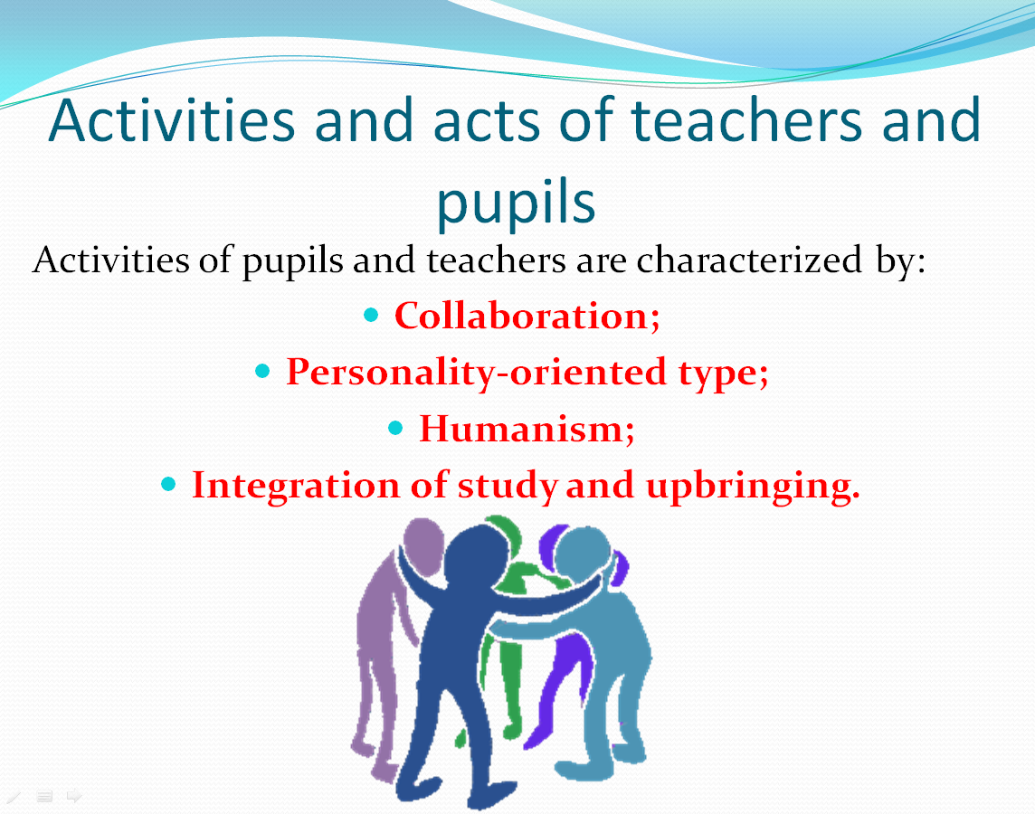
Subjects of Upbringing System
Collective of pupils
Teachers
Pupils

Relations of Subjects of Upbringing
analysing
support
organising
planning

…
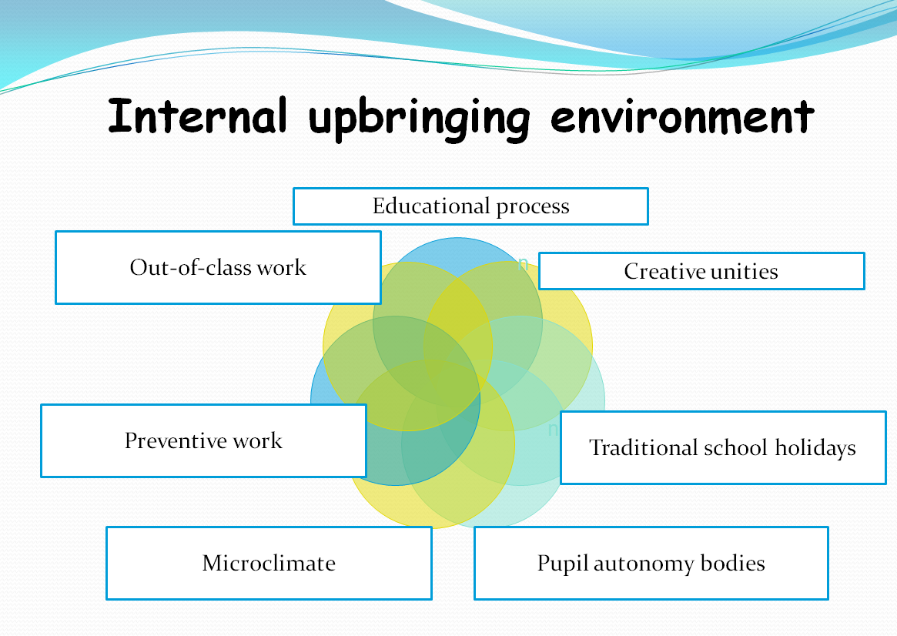
Stages of the Development of the Upbringing System

Motivating force of the upbringing process. Dialectics
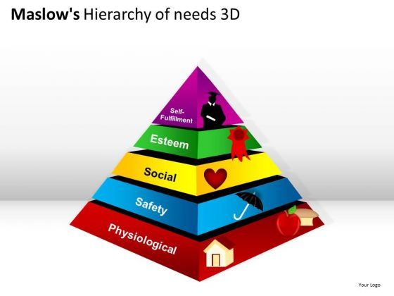

Dialectics is the study of development based on contradictions in upbringing process

Topic 2. Modern Theories of Upbringing
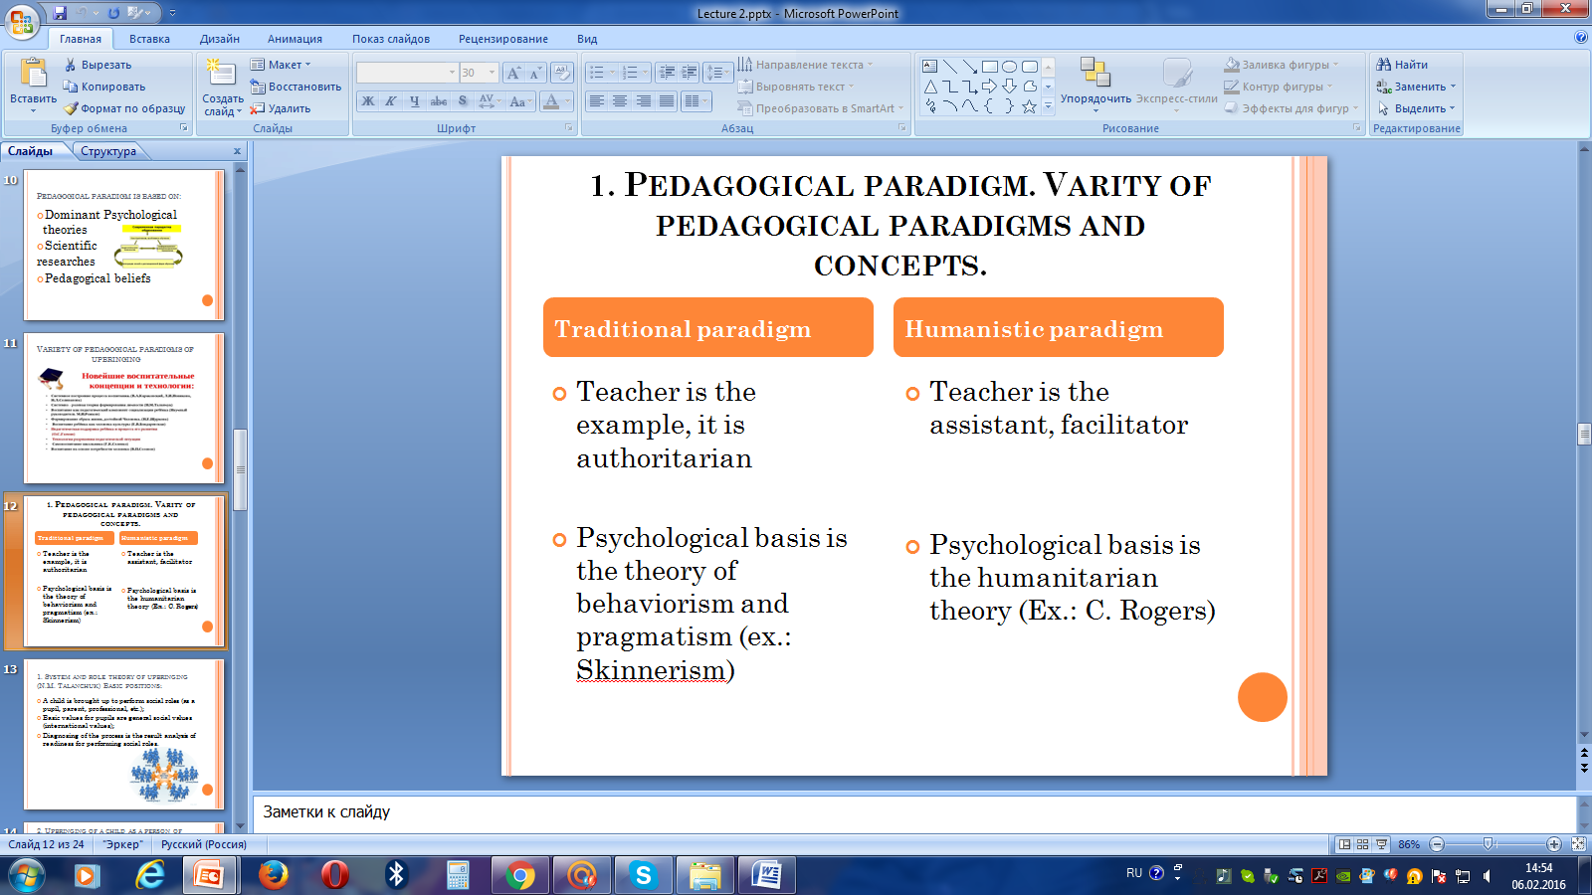

Basic theories of Upbringing
Theory of upbringing of the person of culture
(E.V. Bondarevskaya)

Theory of Pedagogical assistance to the child (O.S.Gasman)

Theory of upbringing based on roles performing
(N.M. Talanchuk)

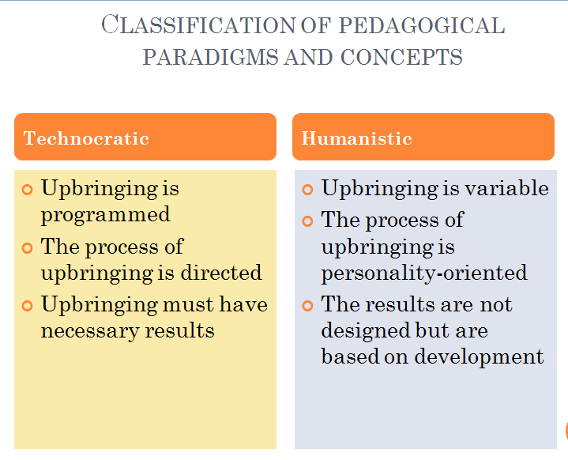

Topic 3. The Content of Upbringing at school
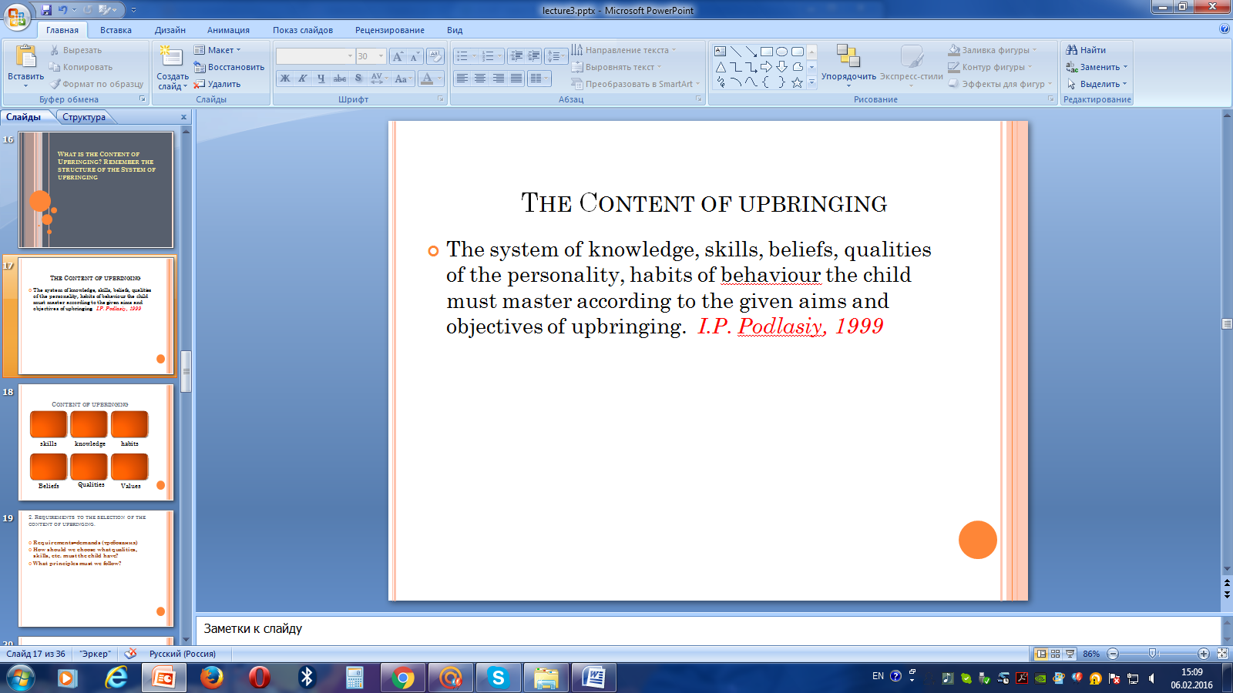

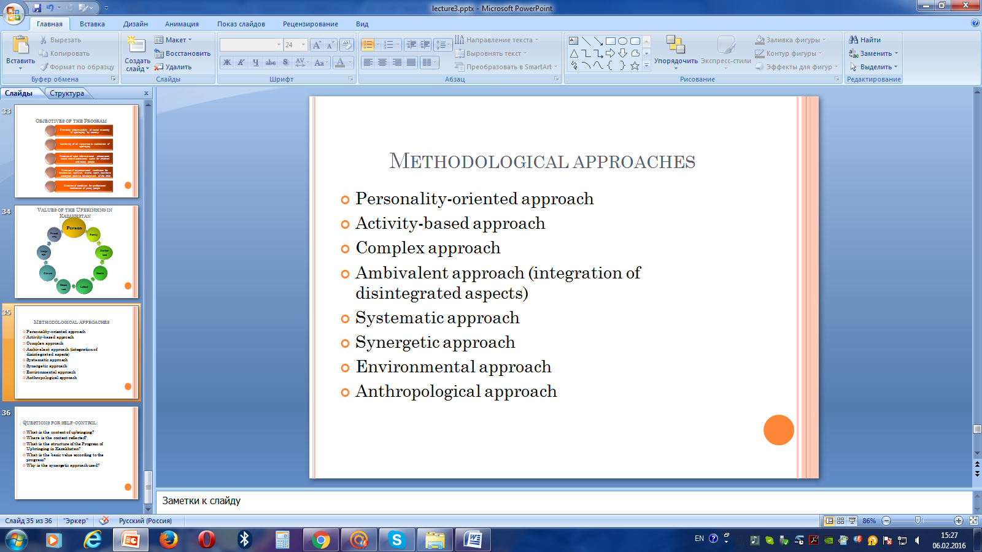
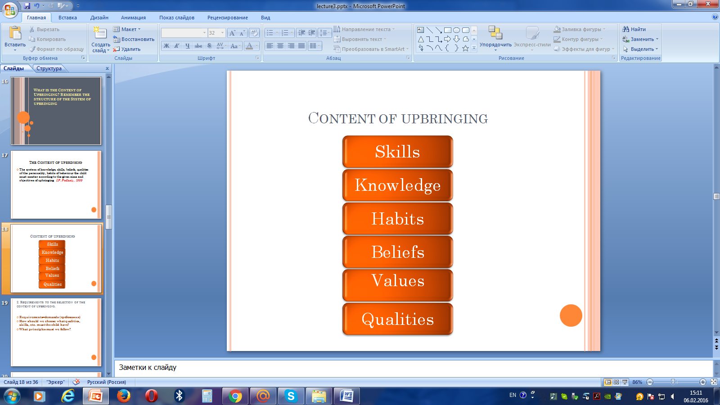

Realism of the aims of upbringing

Student-centered direction of the Upbringing System
Collaboration of children and grown-ups

Self-identification of children in community
Voluntariness
(Forceless upbringing)

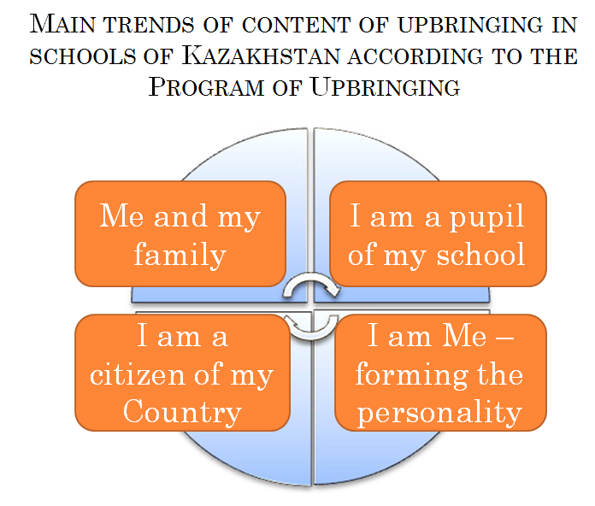
Person

Family
Friend-ship

Values
Langua-ge
Mother-land
of
Upbringing
in
Health
Kazakhstan
Culture

Labour
Educa-tion

Module 2. Facilitating the upbringing process
Topic 1. Supervising instructor at school: his functions, rights, obligations
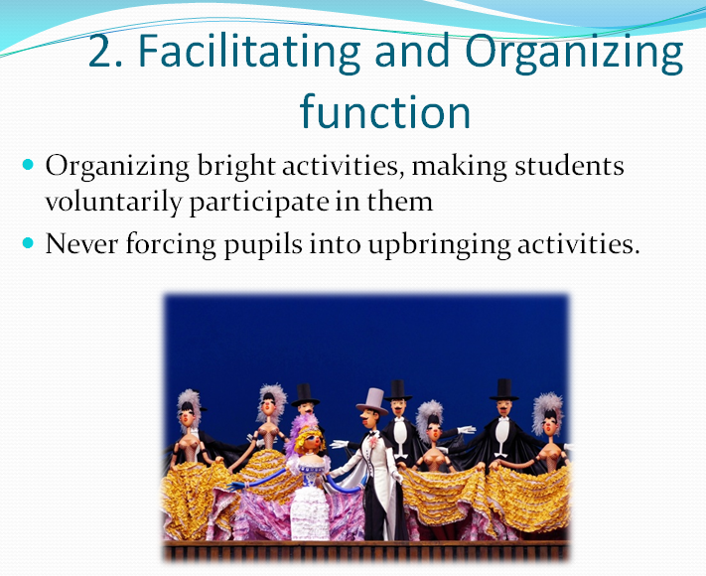
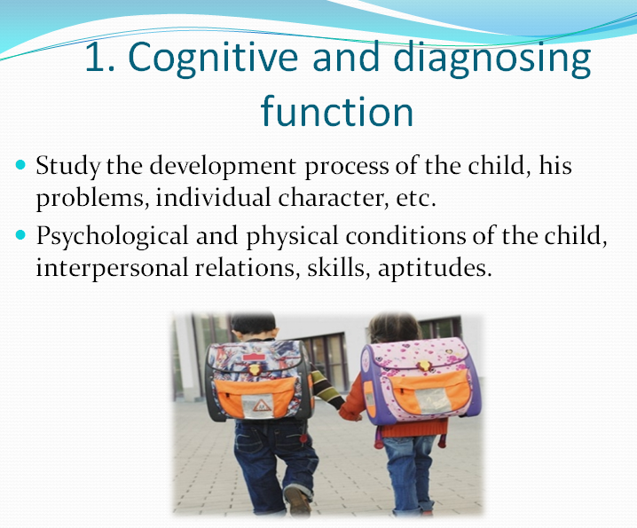

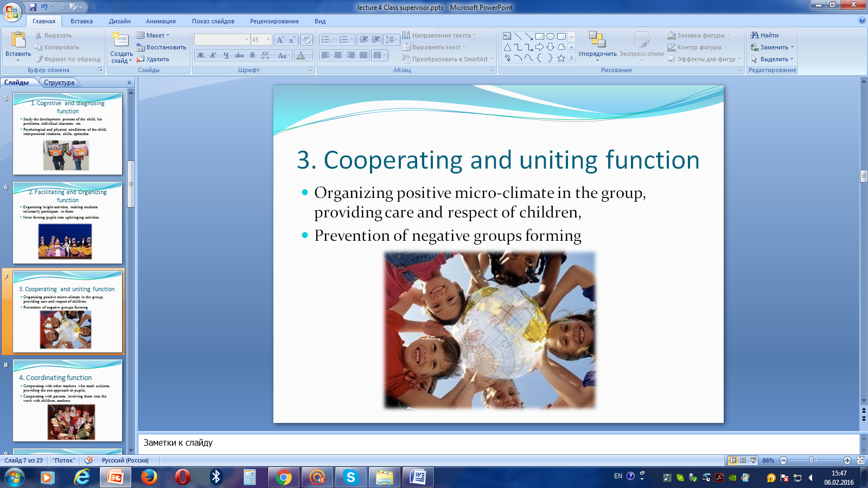
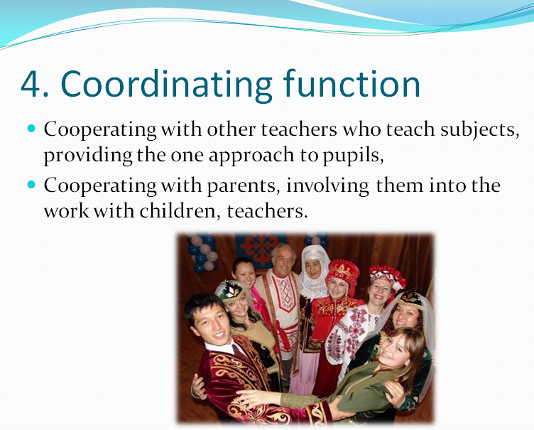

Objectives of the SI
Observation  of pupils | Discussing the rules of behavior with children | Organizing class meetings
Involving of pupils into extra-curricular activities | Organizing social useful labour | Providing support to children associations, clubs
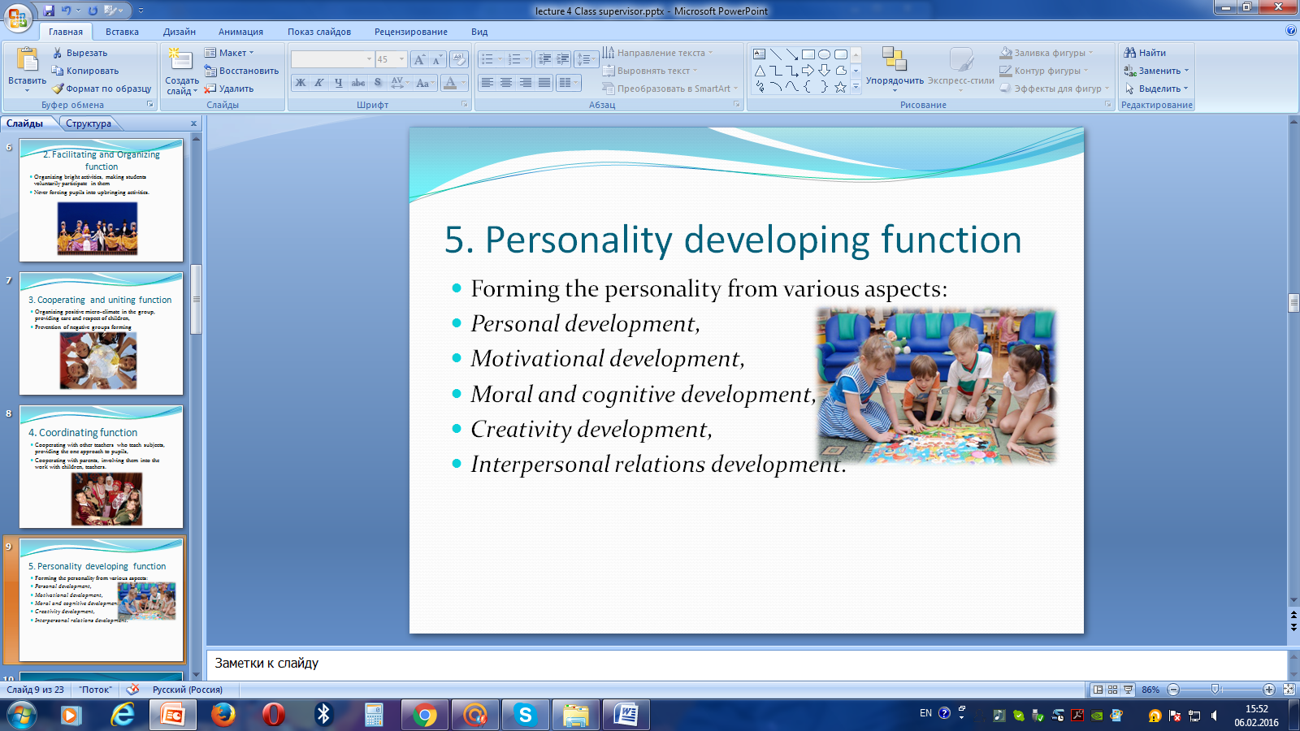

Topic 2. Methods of planning of Upbringing activity
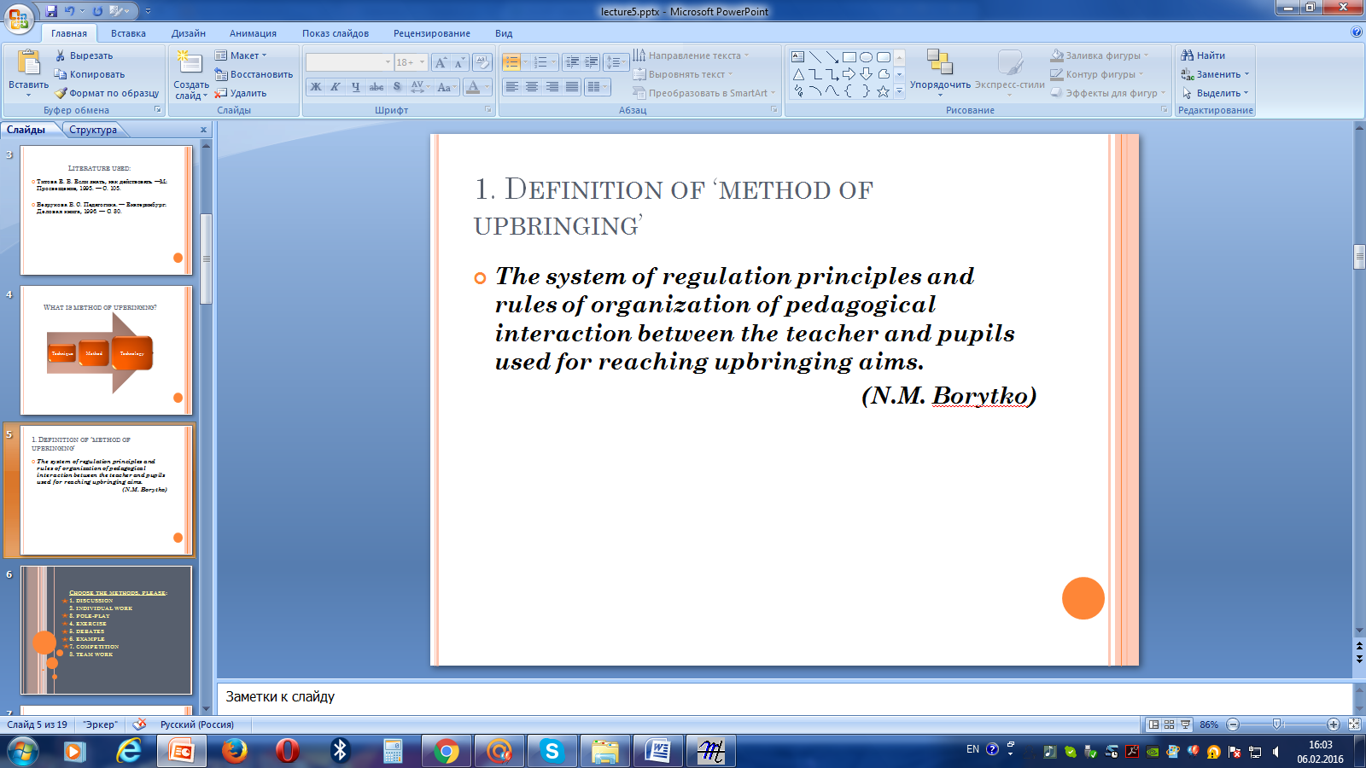

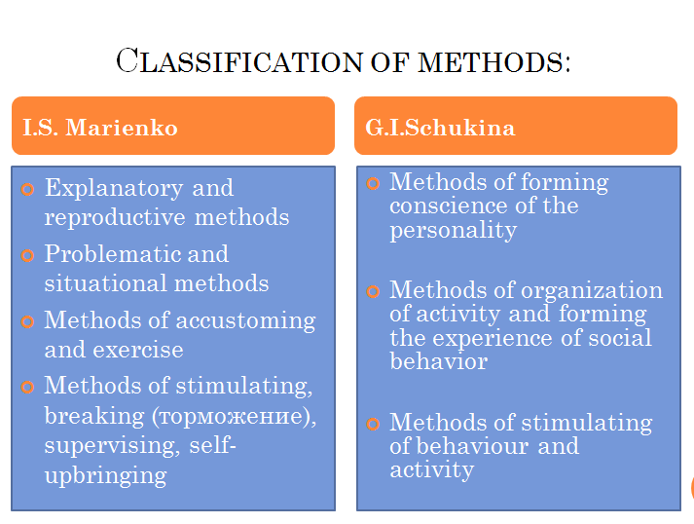

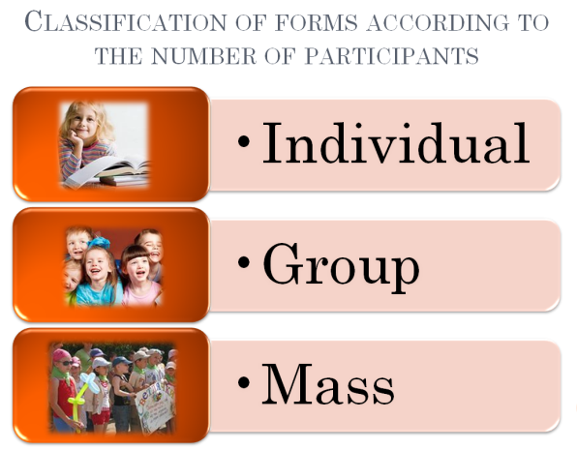

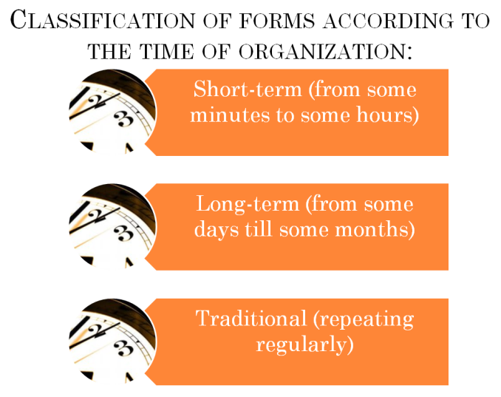
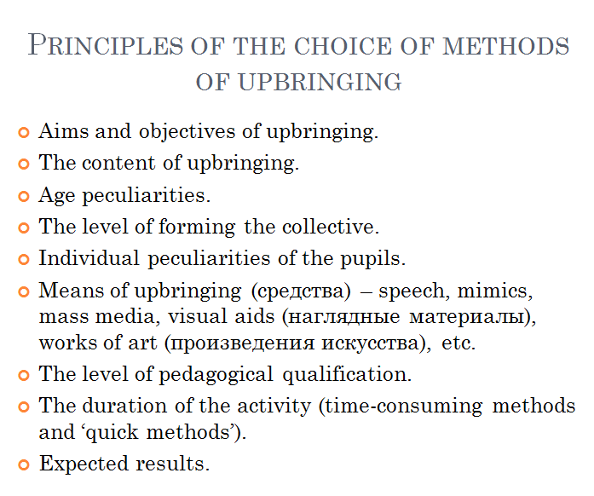

The form of upbringing activity is material side of the set of methods and activities

Module 3. Technological base of the upbringing process
Topic 1. Case-Study Method. Ways of solving cases
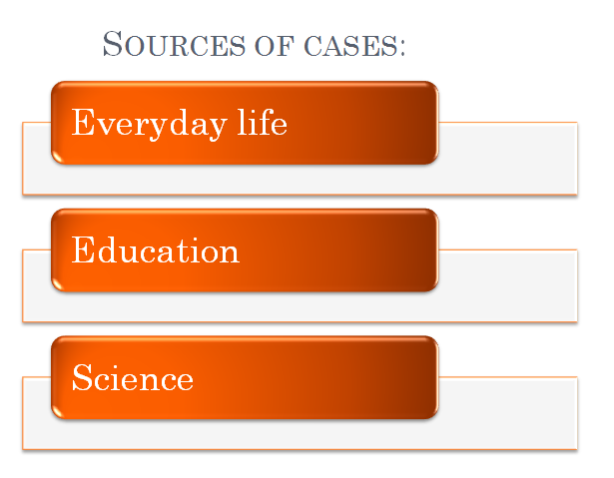
Case is the situation having stable formal content and requiring the analysis and argumentative decision

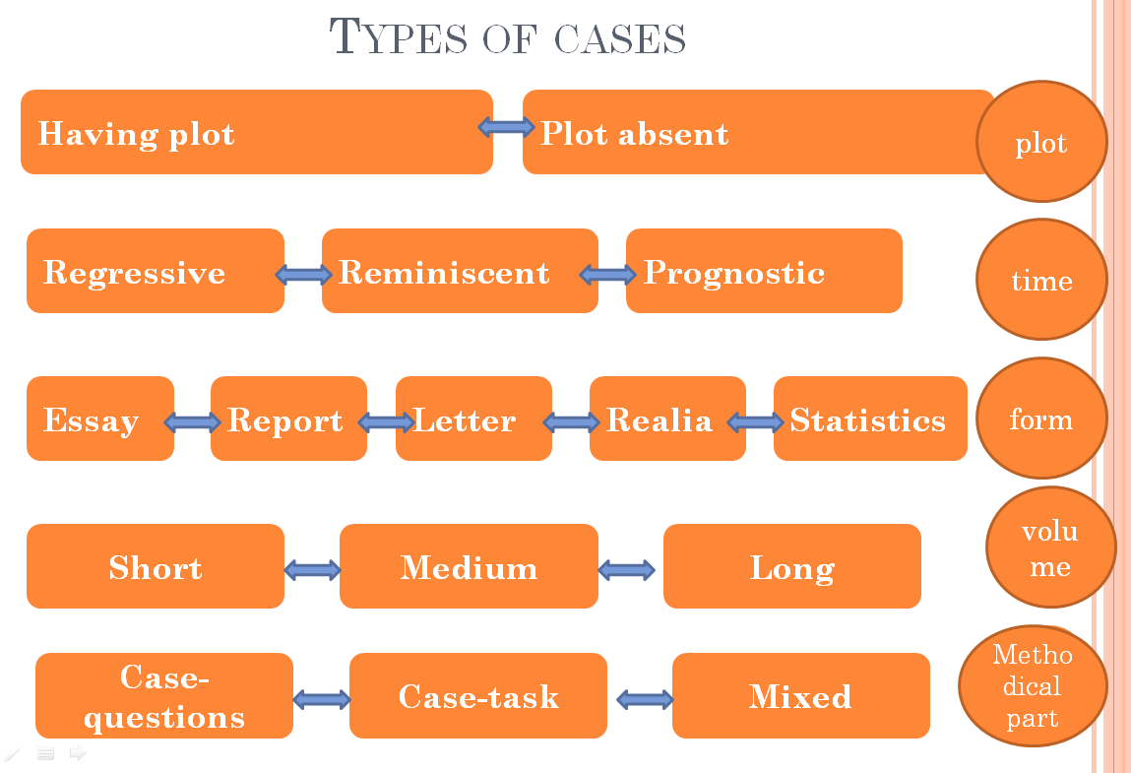

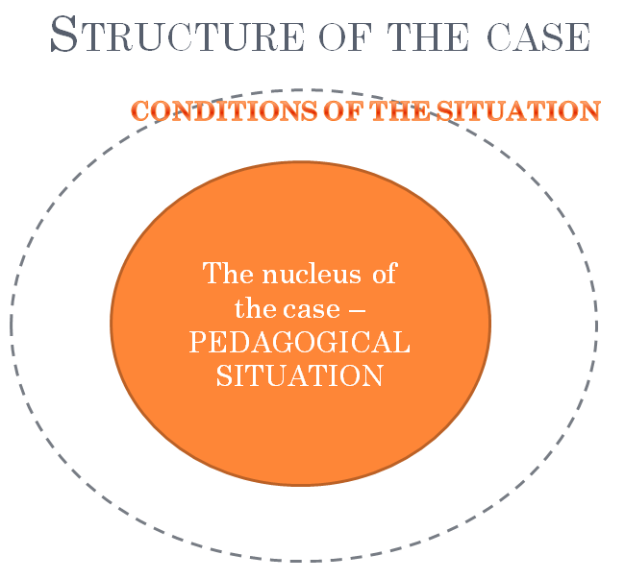
Algorithm of solving cases

Analysing details of the case

Formulating the aim and objectives

Finding various options

Choosing the best option

Diagnosing

Topic 2. Methods of planning traditional class hour
Class hour is a form of CCD (Collective creative deed) which is based on upbringing in collective and through collective
(E.N. Stepanov)

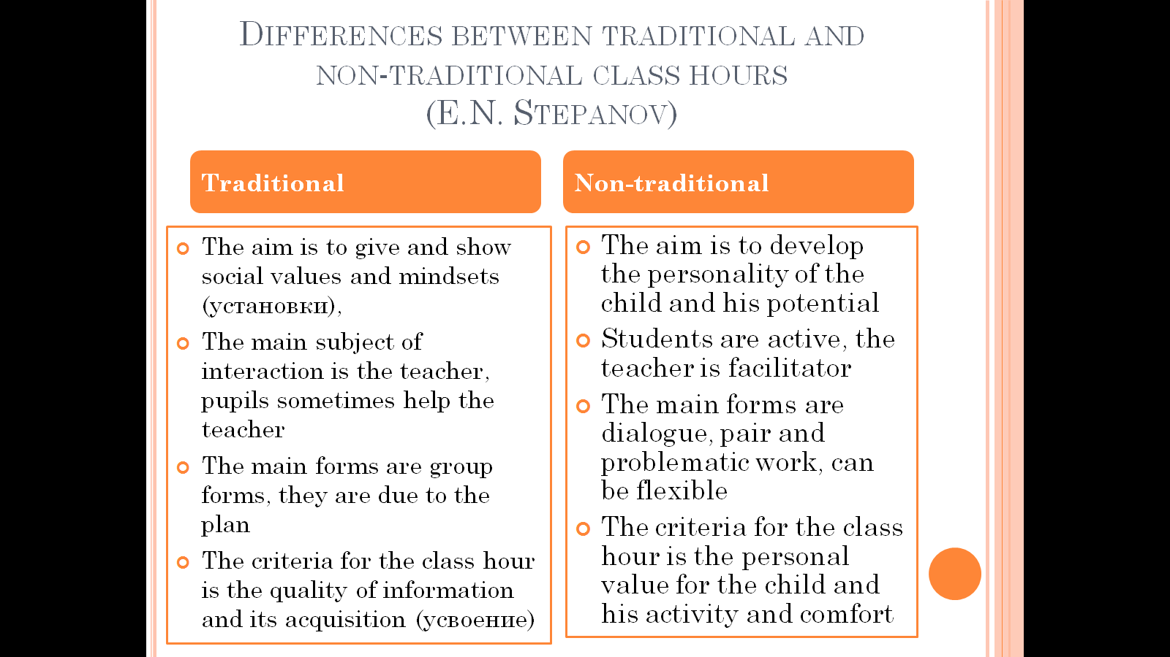

Algorithm of methodic of the class hour by L.I. Malenkova

Choosing forms/topic

Setting aims

Creating psychological background

Realisation

Analysis

Preliminary readiness

Topic 3. Methods of planning debates
Debate is a form of teaching communication aimed at self-work of pupils with literature, forming skills of leading discussion and protecting own viewpoints with respect to the opposite ones.
(E.O. Galitskikh)

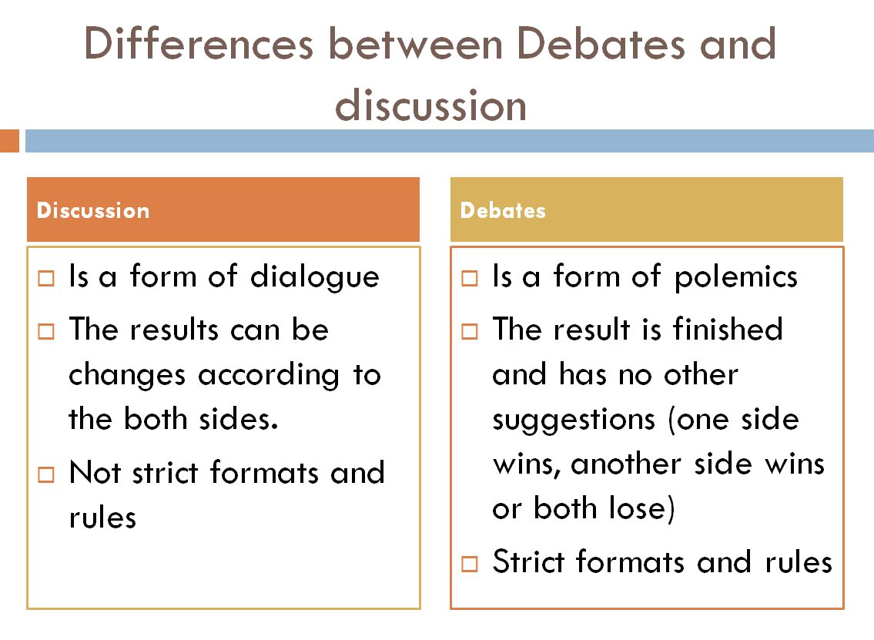

Functions of debates

Developing
Upbringing
Socialization

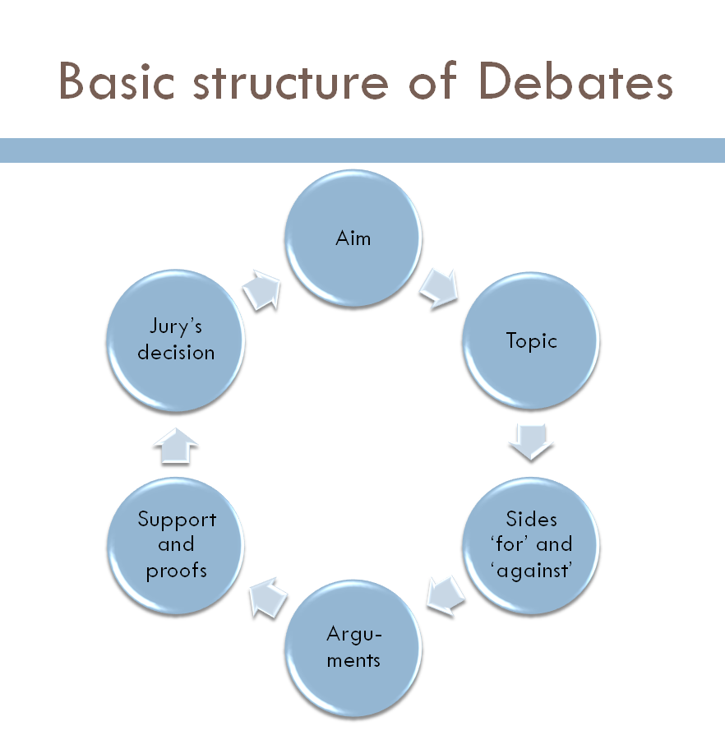
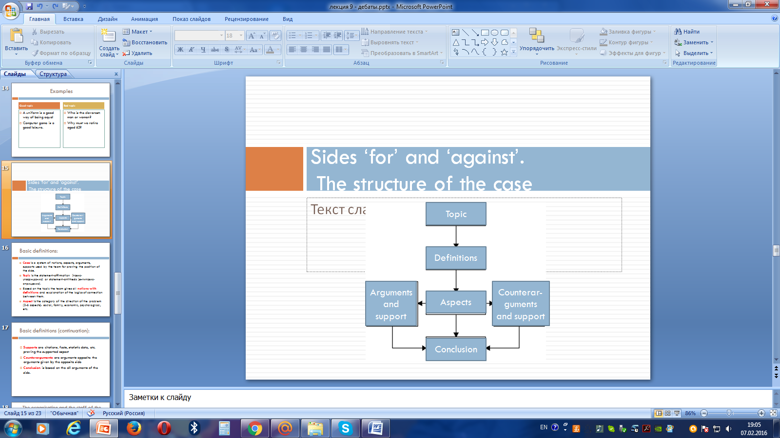

Topic 4. Methods of planning a role play
The role play is a less technologically elaborate form of simulations based on imitation of the social behavior
(Adam Blatner)

Functions of a role play

Educating
Educating
Compensational
Motivational

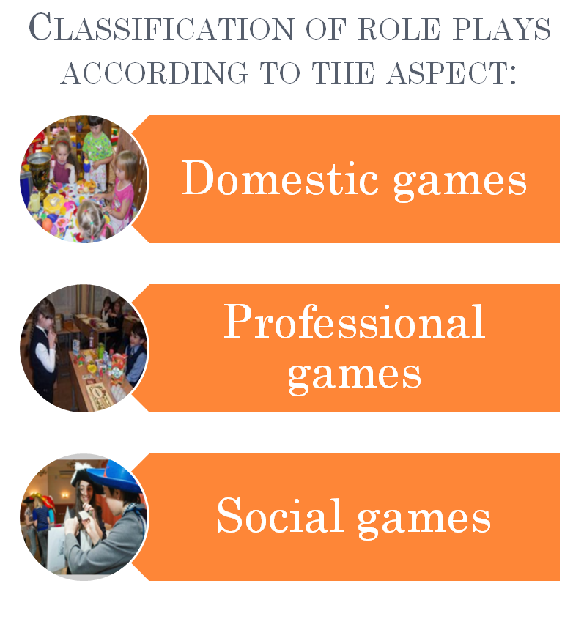
Structure of the role play

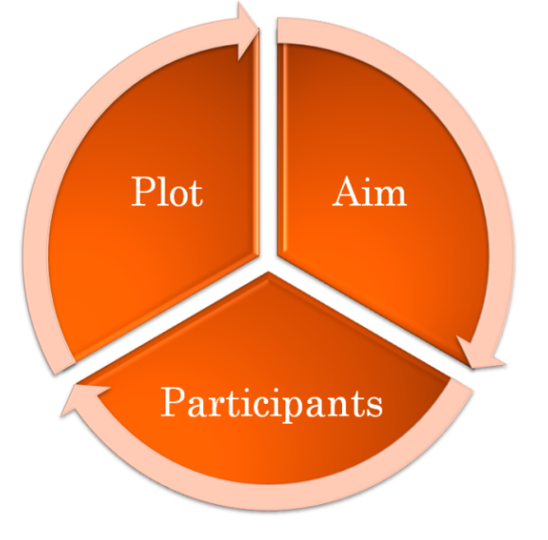

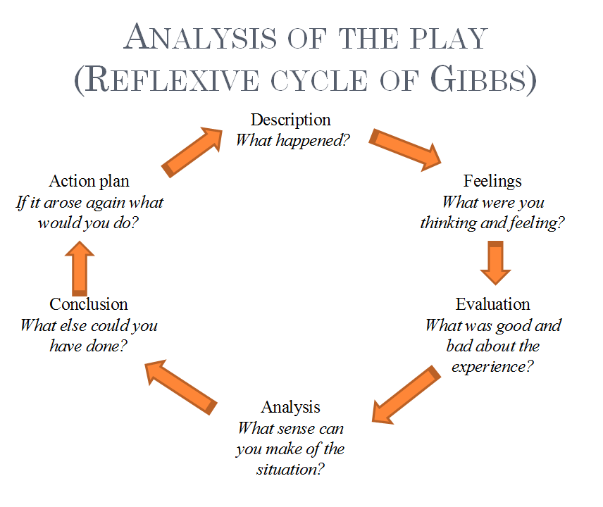

Topic 5. Methods of planning the guest show
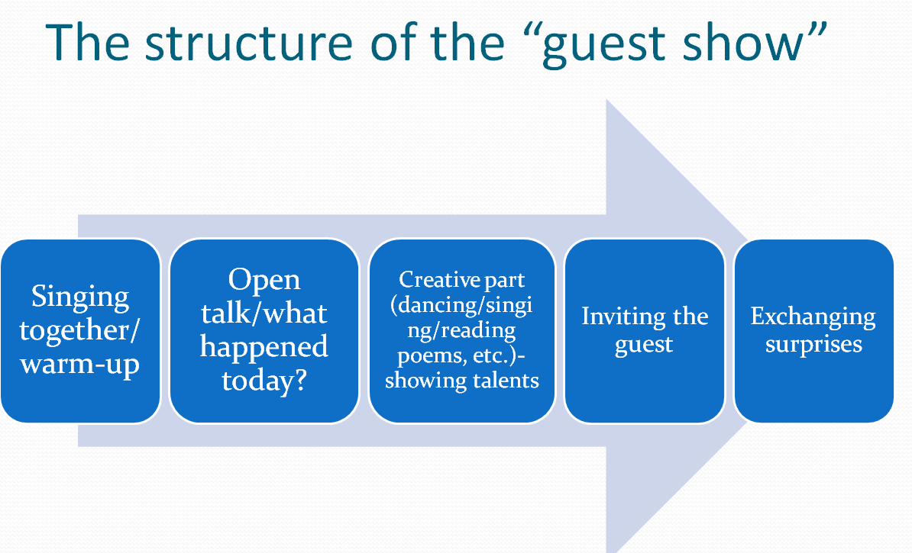

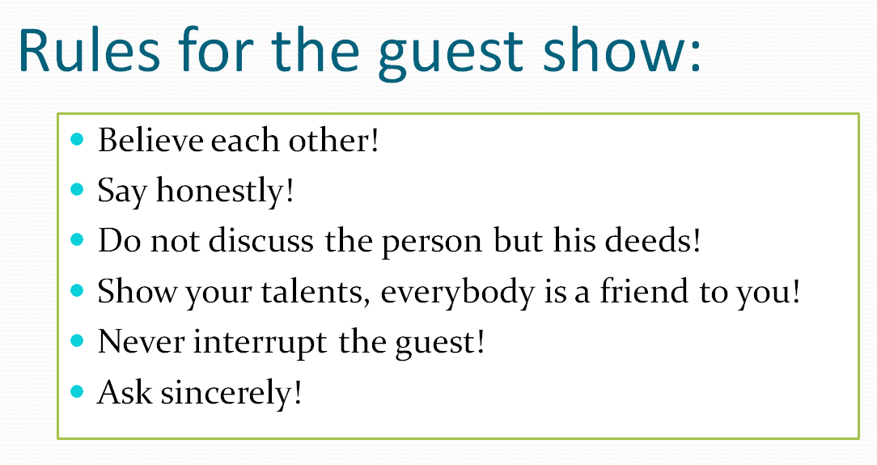

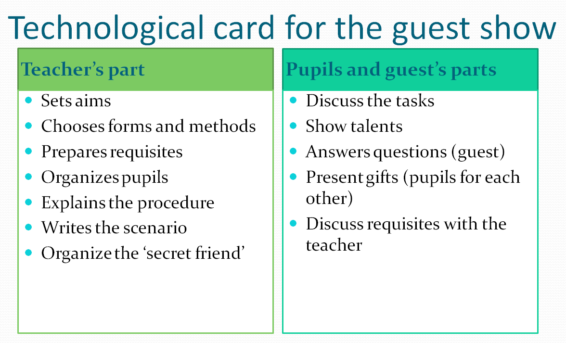

Topic 6. Methods of planning trainings
Training is a method of active upbringing of social behaviour and skills used for reaching upbringing aims.

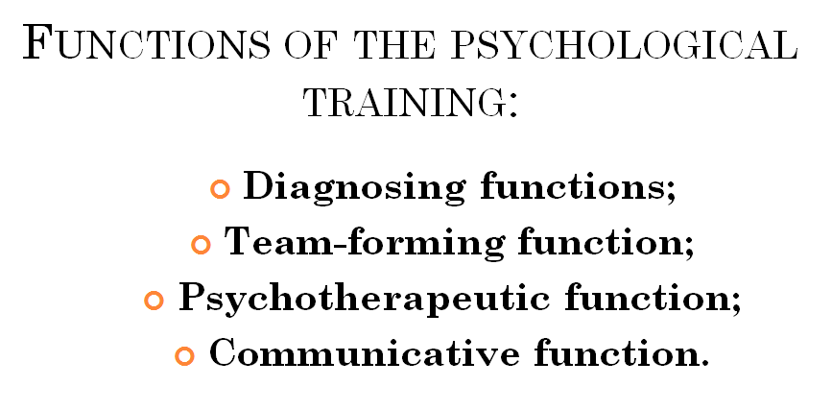
Principles of training

Volunteering

Activeness

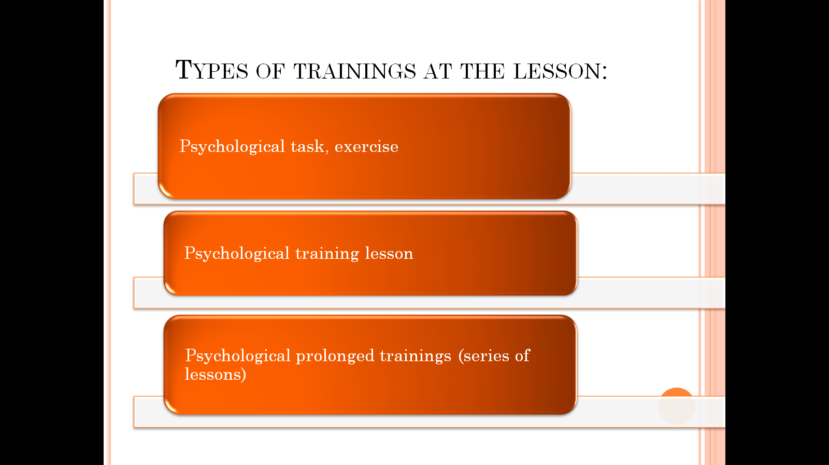
Concentration on current events

Psychological task, exercise
Openness

Personification of the utterances
Psychological training lesson

Confidentiality

Psychological prolonged trainings

The structure of the lesson
(J. Harmer)

Topic 7. Monitoring of the upbringing activity
Monitoring is the system of methods that measure the upbringing activity

Pedagogical diagnosis is the type of pedagogical activity of interaction of pupils and teachers aimed at study and changing of the pupil.

Objectives of monitoring
- Getting information about upbringing activity in time
- Analyzing the information, find alterations from the aim
- Correcting the upbringing process to make it more effective

Methods of Monitoring
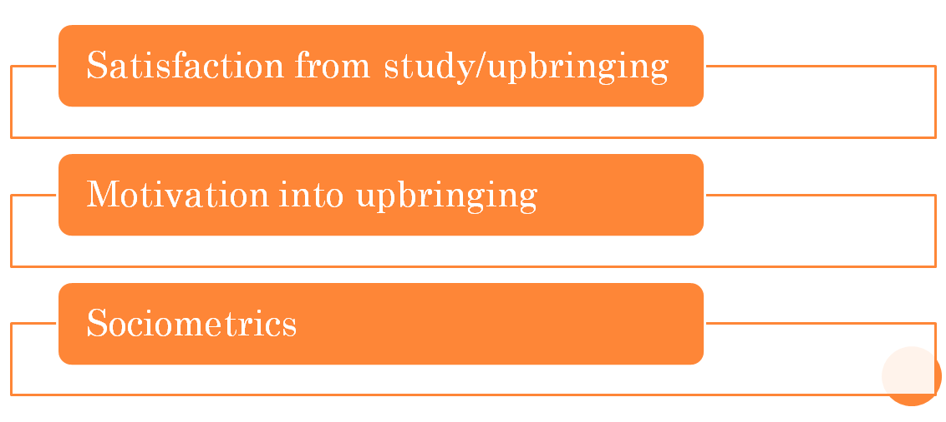

Principles of Monitoring:

- Strategic direction of monitoring;
- Orientation to the results of upbringing;
- No differences between words and deeds;
- Timing of upbringing activity;
- Simplicity and economic character of monitoring;
- Systematicity of monitoring.

II. Practical Module

This Module presents the practical assignments aimed at developing practical skills of students in the sphere of analyzing, applying and systematizing the gained theoretical issues stated above.
This Module is focused on:
- Independent work of a student;
- Self-evaluation and peer assessment;
- Solving practical cases;
- Planning, organizing and analyzing various upbringing activities;
- Consolidation of theoretical knowledge while ding practical tasks.
Practical Module is based on the integration of the theoretical issues and experimental, empiric researches.
The main recommendation for the use of various exercises concerns the following:
- Every task performance must be properly justified by the teacher;
- Definitions of the studied Modules must contain the exact citation and reference;
- Tasks aimed at real planning, organizing and analyzing upbringing pedagogical events can be performed on the basis of tandem method or peer micro teaching.
- Writing Blogs for upbringing activity must be monitored by the teacher at every step of realization due to existing transformation into undesirable social chat excluding the purpose of the Blogs of such types;
- Tasks for carrying out analysis of upbringing events can be done individually, in pairs or group.
As a result of taking this course the student is supposed to:
- Have stable consolidated knowledge on the Theory of Upbringing activity;
- Master various techniques and methods for organizing Upbringing activity at school;
- Have basic skills for analyzing upbringing events and cases;
- Undergo possible changes while students’ internship.
Information below has been structured in accordance with the requirements of the Syllabus and can be considered flexible providing various methods of class organizing.
Final assessment of the discipline is comprised by the face-to-face examination (two theoretical questions accompanied by one practical assignment).

Module 1. Methodological base of the upbringing process

Topic 1. Upbringing process as the integral part of pedagogical process

- What is upbringing? Fill in the mind map:

Upbringing

- Test yourself! How much do you know about upbringing process?
- Upbringing is:
- The transfer of social and historical experience to new generations;
- The system of study and development;
- The result of teaching and study;
- The quantity of changes in personality.
- Upbringing process is characterized by:
- Stability;
- Spontaneous changeability;
- Objectivity;
- Dynamism.
- Upbringing process at school includes…
- Planning, organizing and monitoring;
- Planning, organizing, realizing and monitoring;
- Planning, organizing, realizing, monitoring and analyzing;
- Synthesizing, organizing, realizing, monitoring and diagnosing.
- The goal of upbringing activity of a teacher in a narrow meaning is to:
- Bring up necessary skills and qualities;
- Form necessary knowledge;
- Develop psychic of a pupil;
- Form new methods of taking solutions.
- Minimal unit of upbringing is :
- Upbringing lesson;
- Upbringing situation;
- Upbringing objective;
- Upbringing goal.

- Choose the best representation of the place of upbringing in development of the personality. Explain your choice.
education

education

upbringing

upbring-ing


A B.
upbringing

upbringing

education

education

C. D.
- Checklist. Please, do the checklist.
Upbringing activity. Checklist
Dear student! Please, evaluate the importance of components of upbringing activity from your view point! The grades are from 0(not important) to 9 (the most important)
Remark: abbreviation UA stands for Upbringing activity
Components (your ideal view) | Not important Important
Components (your ideal view) | 0 | 1 | 2 | 3 | 4 | 5 | 6 | 7 | 8 | 9
Upbringing activity at school
Presence of interest of a teacher to UA
The presence of motives to bring up pupils
The presence of direction of the personality to bring up pupils
The presence of skills and knowledge of UA
Self-evaluation | Not developed/absent Developed/present
Self-evaluation | 0 | 1 | 2 | 3 | 4 | 5 | 6 | 7 | 8 | 9
My positive motivation to perform upbringing activity at school
The presence of the interest to plan upbringing activity together with pupils
The presence of a direction to realize upbringing activity together with pupils
Upbringing skills
Knowledge of upbringing

- From this moment your are going to pick up new concepts and notions. Be ready to write them down and find definition and the source of it. Fill in the table:
# | The notion | The definition | The source
1 | Upbringing process
2. | Dialectics
3. | Motivating force of upbringing
4. | Upbringing objective
5. | Upbringing aim

Topic 2. Modern Theories of Upbringing

- Be ready to present a short report to the following topics (3-5 minutes):
- The meaning of upbringing in humanistic concept, its main positions, aims and objectives.
- Individual and anthropocentric approach as methodological base for humanistic concept of upbringing.
- Characteristics of humanistic authorial upbringing systems (E.V. Bondarevskaya, N.E. Schurkova, O.S. Gasman).

- Read the essay of the person about upbringing. Agree or disagree with his viewpoint.
P. Pirimov.
What is ideal upbringing?
In an ideal childhood, we would have been nurtured by the presence of a person who was completely aware of us, who took us seriously, who admired and followed us.
Life has proceeded, of course, on a less than ideal basis for generation after generation. A man who was beaten by his father as a teenager, who intends to beat his own children, is proposing that is it good to break a child’s spirit.
Without a qualm, he feels it necessary for a child to live in fear of severe punishment. The word “respect” for him basically means “terror.” This sort of untruth gets passed on because one generation fails to solve the problem of the false self and then has no choice but to pass the problem on.
Broken spirits do not see anything wrong in breaking the spirits of their children.
The ideal parent would serve as a sensitive extension of the child’s psyche. As father and mother mirrored the child’s feelings, he would see the reflection coming back to him, and conforming to it, he would be shaped by both his own psyche and theirs.
A cry of rage would meet, for example, with an understanding look that said, “I know why you are angry,” and dissolve. It is our checked feelings, the ones that our parents labeled “bad” in their eyes, that cause so much hidden conflict later.
Without this sensitive, loving interaction, which must begin from birth, we walk through the rest of our lives wounded, unable to accept ourselves but never fully knowing why.
The image of “dying to your father and mother,” does not mean running away or turning your back on them. Rather, it means taking on their role yourself, developing inside your own heart the give-and-take of awareness that fashions a complete person out of the raw material of existence.

- Do you agree that children mirror the feelings of parents?
- What Concept of upbringing has been described here? What are the main problems are viewed?
- What are the moments you totally agree with? Disagree? Explain why.

Moments of the essay I agree with | Reasons

- Write your own essay on the following topics (choose ONE):
  - Ideal upbringing for me.
  - As a teacher I will bring up my pupils this way…
  - The teacher from my memory who could bring up me most.
  - The role of parents and school in humanistic upbringing.
  - How to make family and school collaborate when upbringing a child?

- Fill in the table below:
# | The notion | The definition | The source
1 | Upbringing concept
2. | Humanistic concept of upbringing
3. | Technocratic concept of upbringing

Topic 3. The Content of Upbringing at school

- Be ready to discuss the following:
- Historical outline on the upbringing system and content of upbringing of the school as a phenomenon of reality:
- School of V.A. Karakovsky.
- The school of the Dialogue of cultures
- Adaptive school
- The technology of the author school of self-identification of A.N. Tubelskoy
- «Pedagogy of success» as upbringing system
- The importance of content of upbringing and its change due to political, social and philosophic aspects.

- Make up a test concerning the Topic of content of upbringing and consisting of 5 descriptors. The number of test tasks is 5. Example:
    - Upbringing is:
- The transfer of social and historical experience to new generations;
- The system of study and development;
- The result of teaching and study;
- The quantity of changes in personality.
- The skill of individualization

- Make up a crossword/scanword/rebus on the topic of “Content of Upbringing” or any other creative task. Do not include the answers to them.

- Read the “Strategy-2050” concerning upbringing and social environment. Identify the types of upbringing reflected in it.

- Analyse one of the following Programs/documents and fill in the table below:
- «Аtameken»,
- «Elim-ai»,
- «Kausar-Bulak»,
- «Zhasyl El»

Aims and objectives of the program | Content of the program  (main parts) | Type of upbringing reflected in the program

Module 2. Facilitating the upbringing process

Topic 1. Supervising instructor at school:

his functions, rights, obligations
- Be ready to discuss the following:
- Professiogram of the modern class supervisor.
- Functions and obligations of the class supervisor.
- Documentation of the class supervisor.
- Plan of upbringing work. Types of plans
- Class register. Its structure
- The diary and its role in upbringing
- Personal record. The content of personal record (личное дело)
- Medical card
- Pupil’s portfolio. Types of portfolios
- Make up a cluster illustrating the examples of activities/work that can take place in the interrelations of the class supervisor with:
- School psychologist
- Social worker of the school
School psychologist
- Medical staff
- Administration of the school
Medical staff
Class Supervisor / Supervising Instructor

Administration of the school
Social worker of the school

- Give the definitions (glossary):
- class supervisor –
- psychologist –
- social worker –
- medical worker –
- Choose the picture that best represents the ideal Class Supervisor. Why have you chosen it?
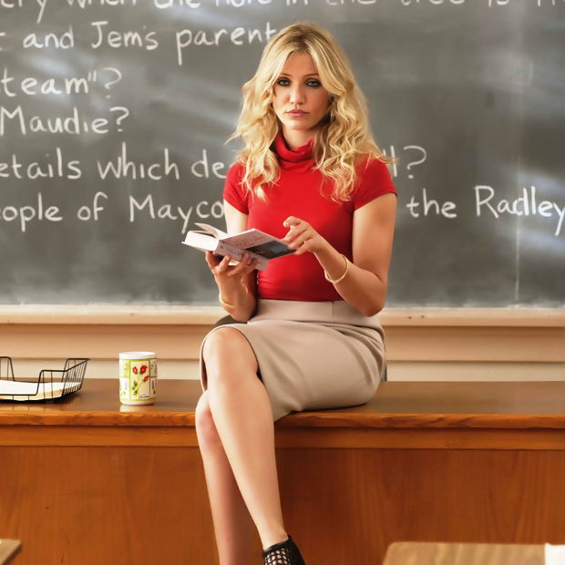


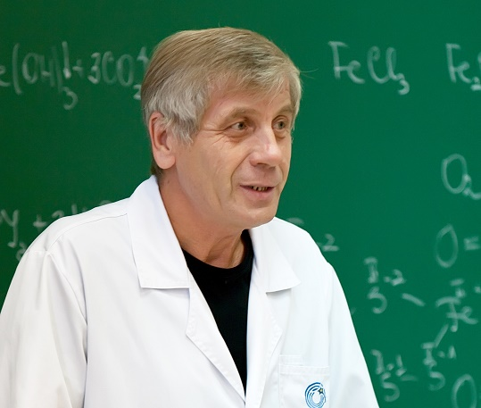


- Create the Portrait of the Ideal Class Supervisor (100-150 words).
- Make up a complex professiogram of the Class Supervisor.
Find the examples of existing professiograms.
Put the professiogram into the Folder of Upbringing work (see Scheme 1 below).

Scheme 1. Scheme of the Professiogram (sample)
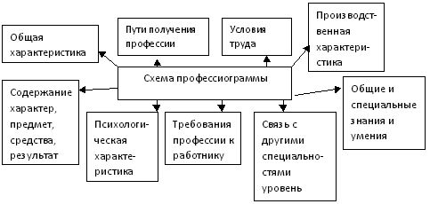
Psychologi-cal characteris-tics
Require-ments to the worker
Connection to other professions
General characteristics
Content, results of the work
General and specific knowledge
Processing characteris-tics
Labour conditions
Ways of gaining profession Professiogram
Scheme of the Professiogram

Topic 2. Methods of Upbringing activity

- Be ready to discuss the following:

- Definition of the term “method of upbringing”.
- Classifications of methods of upbringing.
- Principles of choice of methods of upbringing.
- Techniques and forms of upbringing.

- Write out 3 definitions of the “method of upbringing”(glossary):
# | Definition of the term “method of upbringing” | Author | The source
1
2
3

- Make up a plan for upbringing work for the term/semester. Fill in the table below (the example for 6th class, you may take any class!):
Class | 6
Date | 01.09.2015 | 05.09.2015
Type of upbringing | Intellectual
The name of the activity | The Day of Knowledge
Methods | Talk
Form | Concert
Responsible people | Teacher
Participants | Class, parents, active teacher,  the head

- Fill in the table below:
Groups of methods | Author | The name of the source
- Read the work of A.S. Makarenko “Methodology of organizing of upbringing process” («Методика организации воспитательного процесса») and identify the methods used there.
- Match the following, please.
The saying | Method
‘To respect’ means to understand the person | Instructing
Today we will see who is the bravest person in the group! | Example
You are to do the duty on time every Saturday | Upbringing situation
Today you behaved well! Good job! | Explanation
The great person who sacrificed himself for children is J. Korchak | Reward
Imagine that you are this poor boy, what would you do? | Competition
- Explain the meaning of the following methods, give some sayings illustrating them.
- Lecture
- Punishment
- Duty
- Accustoming
- Debates
- Clarification
- Answer the questions:
- How should we choose the methods?
- What method would you choose for forming the child’s behavior of:
- Washing hands before eating;
- Saying ‘hello’ to neighbors;
- Not kicking the cat;
- Not interrupting the teacher?

Module 3. Technological base of the upbringing process

Topic 1. Case-Study Method. Ways of solving cases

- Be ready to discuss the following:
- Types of cases
- The structure of cases
- Functions of cases
- Algorithm of solving cases.

- Blogging. Follow the algorithm below:
- Register on the site: www.mypage.ru
- Create your own blog - case. For that you should remember any situation happened to you this week. Describe any conflicts/problematic cases that you were involved into.
A. Describe the conflict/problem.
В.Describe behaviour of the participants of the conflict/case (without any real names!)
C. Describe the reaction of participants on the problem/case.
D. Attach any questions for enclosing further commentary of your case.
- After you created a blog, you should comment on every blog of your groupmates (see Pic.1).
Example.
A Blog content (sample):
Yesterday the teacher (a young specialist, 22 years old, teaching biology) was angry because of my not doing the home task (I am a student of the 2nd course, I study well). I explained that it was not my fault – the Internet did not work. But the teacher said it was not a good excuse due to having libraries in the city. So, I was upset and angry, too. I had other work to be done (the parents came to me and I helped them, but I didn’t tell it to the teacher! It wouldn’t work)! Was I right?

Commentaries (sample):
- Yes, I think, the teacher made a mistake. You had a chance for helping your parents. So, you should have told about your problems and explained that you would be ready the next time.
- No, I don’t think it is a good excuse… In any case, you had to be ready, even if you had other work to do.
- I cannot say I support any of this two people…

Pic. 1 – The content of the blog by the student


- Analyse the following case. Identify the core and the periphery of the case. Answer the questions. Fill in the table below:
# | Stage | Description of given facts
1. | Conditions analysis  Formulating the concepts (upbringing, study, communication theories)
2. | Identifying the source of the conflict (subject and object of upbringing, contradiction, stage of the group development, individual personality peculiarities)
3. | Goal setting (operational, tactic, strategic)
4. | Presentation of errors used in the situation
5. | Possible development of the situation
The teacher conducts the lesson of Biology in the 8th grade. It is a new and rather depressing topic. The class is listening to her/him attentively. Suddenly the door opens and the teacher sees one of his/her pupils of this class who enters the door with words “Go on, please, I’m late. It’s fine” and sits calmly. The teacher doesn’t reply anything and continues the explanation.
- Analyze the environment. Give brief psychological portrait of the pupil of the 10th grade.
- Were you late being a pupil, student? Remember the reactions of teachers.
Ask your partner. Describe your feelings when the teacher was angry/indifferent/mocking/disappointed/ironic/funny, etc.
Fill in the chart below:

- Why did the teacher keep silent when heard impudent words of the pupil? Was she/he right? What method(s) should she have applied? Why?
- Must the teacher speak to the pupil right now? After the lesson? In presence of the head of the school? Parents?
- Act out a possible talk of a teacher with the pupil after the lesson.
- Present a scheme of a talk (a draft) with pupil’s parents.
- Give pros and cons concerning reporting to a head of a school.
- Choose the best way out of the situation/case.
- Write the list of possible decisions beginning with the best one from your view point/the point of your partner/group/class.

- Read the following cases and ask possible questions concerning these cases (see ex. 3 above). Analyse the cases and answer your questions (pair or group work):
- Early morning. Spring. The birds have just woken up. The first lesson is the lesson of English. Children of the 5th form are yawning. Some of the pupils are almost sleeping. Monotonous rhythm of the lesson has been interrupted by the sudden outcry of Gleb who has seen the chick fall down from the nest outside the window. All the class stood up asking for the help for a poor chick. You…
- Temirlan is a very curious pupil of the 5th form. He knows the subject well. But he is utmost impatient when somebody doesn’t know the answer. He raises his hand and bothers the rest of the pupils. You praise him and consider him to be an example of the perfect pupil. Is he really a good example?

Topic 2. Methods of planning traditional class hour

- Be ready to discuss the following:
- Definitions of the class hour
- Types of class hours
- Analysis of class hour
- The role of the teacher in traditional and non-traditional class hours.

- Make analysis of CCD. Use the book by М.Е. Sysoyeva “Pedagogical internship” («Педагогическая практика»). Make notes on the “Scheme of analyzing CCD – Collective Creative Deed” («Схема анализа КТД») pp. 71-72. Techniques of CCD.

- Make up your own scheme of CCD. See a sample below:
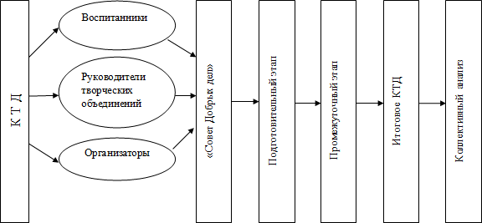
Overall analysis
Final CCD
Intermediate stage
Preliminary stage
The unity of good deeds
CCD
Pupils
Facilitators
Leaders of creative associations

- Organize a Class hour – 2 people. You are to prepare all the stages of it (preparing till analysis). You will see the example of the technological card of it below.
Topic: _______________
Date:_______________
Class:________________
Aim:_________________
Objectives:1)_______________; 2)________________; 3)_____________.
The direction of the Upbringing process:__________________
Form of the Upbringing activity:_________________
Methods:_______________
Means:______________
Aids:______________
Resources:_______________

Stages | Teacher’s activity | Pupils’ activity | Forms, techniques, methods used | Formation of study actions
Preparatory
Main
Final (reflection)

Analysis of the Class Hour (sample):
- Plan-based analysis
- Analysis of the structure of the plan,
- Correctness of the aim,
- Predominance of teacher’s or pupils’ activity,
- The choice of means and aids,
- Relevance of topics according to age of pupils, their temperament, etc.
- Procedure analysis
- Effectiveness of the event,
- Psychological climate,
- Reaction of students and their attention,
- Development of cognitive sphere,
- Orientation of modes (visual, kinesthetic, auditory),
- The account of upbringing aspects of the event.

Topic 3. Methods of planning debates

- Be ready to discuss the following:
- Definition of Debates
- Functions of Debates
- Technology of conducting Debates
- Choosing topics for Debates

- Answer the questions:
- What are the main purposes of the Debates?
- What age of pupils is recommended to play Debates? Why?
- What are the main components of a good game called Debates?
- Who can perform the role of jury at Debates? Why?

- List the differences between Debates and Discussion:
Debates | Discussion
1 | 1
2 | 2

- Formulate the rules for choosing a Topic for Debates:
Ex: A Topic must be well formulated and have no double meaning.

- Analyse the following Topics (good or bad formulated Topics). Explain your decision.
- A uniform is a good way of being equal
- Computer game is a good leisure.
- Who is the cleverest: man or women?
- Why must we retire aged 63?
- All students must wear only black and white colours.
- TV or Laptop?
- Face-to-face communication or chatting online?
- Problems of the use of WhatsApp Messenger.
- A pet at home is always happiness.
- Pupils must choose subjects to be studied at school.

- Explain the organization of the procedure of Debates:
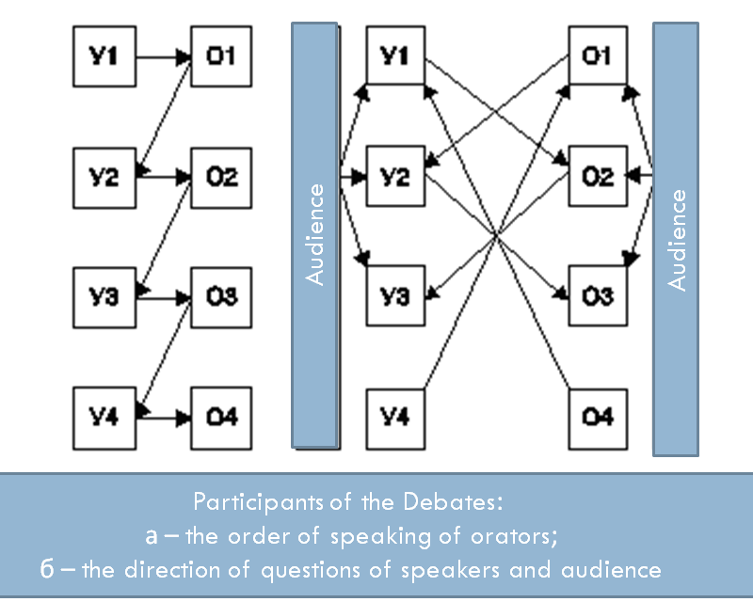

- Organize the Debates in your group and be ready to analyze the Debates.

Topic 4. Methods of planning a role play

- Discuss the following:
- Definition of the role play.
- Classification of the role plays.
- Requirements for the role plays for young learners, middle class pupils and seniours.
- Stages of the role play. The role of the teacher in the play.

Technology of the role play
- Analyse the types of the role plays: short-term, long-term/ domestic role-plays – social role plays – professional role plays:
Example: The teacher gives the roles of the wolf, hare, fox to children. They are to play the roles for 30 minutes.
The type of the play is 1) short-term; 2) social role play (fairy tale).
- The teacher gives the roles for pupils to play situation in the family. The pupils are playing for 2 lessons.
- Children are playing for 15 minutes according to the topic of “In the library”.
- The teacher gives the task to play the roles of the shop-assistant and a customer, they play for 30 minutes.

- Fill in the missing words, phrases to complete the overall idea:
- Stages of the role play include:
- Individual, group and mass are types of …
- The method of duty is included into the group of … methods.
- The method based on appraising for good work is called…
- The method based on giving information about certain topic is called…

- Fill in the technological card of the role play:
Stage | Aim of the stage | Time | Pupils’ role | Teacher’s role
Motivational | Presenting the topic, engaging into the game | 4 min | Sharing opinions, discussion | Engaging pupils into discussion and sharing opinions
Preparatory (warm-up)
Organizatio-nal
Discussion-based
Presenting
Analyzing
Evaluating
Total

- Create 3 topics for the role plays per each category of pupils:
    - For young learners
    - For 5th form
    - For 9th form
    - For 11th form

- Find any other examples of technological card of the role play.
- Make up a cluster/mind map about the role play.

- Organize a role play. 2 people for 15-20 minutes each. You are to prepare all the stages of the role play (preparing a play till analysis).

Topic 5. Methods of planning the guest show

- Overall revision.
Playing a revision game “Magic boxes”.
Instruction: Students are to be divided into two teams. Ever student of each team chooses a box with points and tasks to be done. The group that has more points wins. 10 – explanation; 20 – practical task; 30 – creation:
 | 10 |  | 10 | 10
 | 20 |  | 20 | 20
 | 30 |  | 30 | 30
10 Explain, please:  COMPETITION |  | 10 Explain, please:  PROFESSIONAL ROLE PLAY |  |  | 10 Explain, please:  DUTY
20 Present any name for the social situational role-play for the 6th class |  | 20 Identify the method(s) used here:  The teacher advises to fill in the dairy by pupils of the 2nd class by themselves. She takes the dairy of Asel and presents it as a good item to be imitated. |  |  | 20 What method/s would you use in these situations:  - The child refuses to write saying he is tired.  - The pupil is always late
30 Make up a poem using the following words:  ________upbringing  ___________singing  _____________play  ______________say! |  | 30 What mistake did the teacher make?  The bell rang. The lesson is over. One of the pupils told the teacher that she was very strict to her that she hadn’t done her home task because of the competition in school. But the teacher said that it was not her problem. The competition is not the excuse for not being ready! |  |  | 30 Tell any poem (Kazakh, Russian, English) about school/upbringing or sing any song concerning school/upbringing/teachers, etc.
- Colloquium. The list of questions to be answered:

- Upbringing is…
- Methods of upbringing
- Humanistic and technocratic upbringing
- Stages of the role play
- Conception of upbringing in Kazakhstan.
- The Convention of children’s rights in Kazakhstan.
- Trainings and their functions.
- Requirement for choosing methods of upbringing.
- Classification of role plays
- Documentation of the class supervisor
- School of V.A. Karakovsky.
- Main upbringing objectives.
- Motivating force of upbringing. Maslow’s hierarchy.
- The origin of upbringing.
- Classification of methods of upbringing by N.E. Schurkova.

- Present the stages of organizing the guest show.

- List the rules aimed at the host/hostess and the guest of the show.

Rules for guests | Rules for the host/hostess

- Organize a ‘guest show’ (огонек). – 2 people. You are to prepare all the stages of the training (preparing till analysis).

Topic 6. Methods of planning trainings

- Discuss the following:
- Psychological training. Definitions.
- Types of trainings at school.
- Rules for trainings. Principles for training tasks/exercises.
- Difficulties in organizing trainings.

Technology of the training task/exercise

- Find any trainings aimed at (1 training for each type):
        - Uniting the group
        - Developing imagination
        - Developing attention
        - Enriching memory of pupils

- List the differences between the following notions:
Prolonged Psychological training
Psychological exercise, task

- Analyse the possible effectiveness of the following training. Identify: 1) a type; 2) structure; 3) aim and purposes for the chosen age group:
Exercise “Continue frankly”
Instruction: everybody is sitting in a circle. The leader comes up to everyone according to the turn and asks to take a card. The participator reads aloud the text on the card and continues the text frankly!! The rest without speaking should raise their hands if she/he thinks the speech of the participator is frank. If the person was frank he is allowed to move his chair to the middle direction. But if his speech wasn’t accepted as a frank one, he must take another chance (card) and do the same procedure. One person can ask participator only one question for further details. It’s prohibited to discuss the opinions. No remarks are allowed!
When everybody finishes the leader says: “Take a deep breath out, then slowly breath in while I’m speaking. Now on you breathing out you must cry shout any words, sounds as you wish. So, go!”
- When I’m surrounded by the opposite gender I feel…
- I have enough drawbacks (недостатки), for example…
- It happened that my close people made me angry and hated. Once I remember…
- I can be a coward. Once I remember…
- I have much assets (достоинства). For example…
- I remember the occasion when I felt ashamed. I…
- What I really want is…
- I know how it is to be alone. I remember…
- Once I felt insulted and offended (обиженный) when my parents…
- When I fell in love for the first time I…
- My best wish is
- I feel that my mom…
- I think that love in my life…
- When I’m being hurt (Когда мне приносят боль) I’m ready to…
- It happens that I quarrel with my parents when…
- Frankly speaking, the work at school is…
- Blank card. Say something on any theme you want.
- I dislike the pupils who…
- I am ready to help everybody when…
- They say that I am…
- My favourite saying/proverb is…
- I am very happy when…
- I usually cry when…

- Organize the training. 2 people for 15 minutes each. You are to prepare all the stages of the training (preparing till analysis).

- Elaborate the card for analyzing the training. See the example below:
Analysis of the training
criteria | Bad Fair Good Excellent
criteria | 1 | 2 | 3 | 4 | 5 | 6 | 7 | 8 | 9
Clear instructions
Voice
Feeling of support by the teacher

Feeling comfortable during the activity
Effectiveness of the activity
Feedback of the teacher
Rapport

- Present possible quotes the teacher may use while performing the stage of reflection. See the example below:
Meaningful reflection:
- Do you like this training?
Emotional reflection:
- Do you like this training?

Topic 7. Monitoring of the upbringing activity

- Discuss the following:
- Monitoring the results of upbringing activity
- Algorithm of analysis of the upbringing situation
- Diagnosing the upbringing activity.
- Methods of monitoring upbringing work in Kazakhstan.

- List the differences between notions:
Notion | Definition | Source
Monitoring

Diagnosing

Analysis

- Present the levels of Monitoring in Kazakhstan :
Body:
State Level of Monitoring

Body:
Regional Level of Monitoring

Body:
…

- Enumerate the criteria of monitoring of upbringing activity at school:
Procedural criterion
Statistic criterion

- Find at least two questionnaires concerning monitoring the upbringing activity of the class supervisor or upbringing activity of the school. You may refer to the site http://infourok.ru/monitoring_vospitatelnoy_raboty_v_obrazovatelnom_uchrezhdenii-548913.htm

- Enumerate methods of monitoring the upbringing activity: ex.: interview, testing, etc.

Conclusion

“Purposeful, systematic shaping of a personality in preparation for active participation in public, productive, and cultural life” (upbringing, Encyclopedia) has been the core issue for many centuries at a row.
This manual has shaped the key points in training future teachers applied to the sphere of real school life. As a result of the use of such manual the student will be able to master knowledge in the sphere of the upbringing activity. Practical readiness of the student will be successfully achieved by systematic monitoring on the process of peer organizing, planning and analyzing various upbringing events (class hours, games, role plays, trainings, guest show, etc.) including solution of pedagogical situations, cases.
Upbringing activity as a way of personality forming cannot be parted form education. Thus, as Ekanem and Ekefre (Ekanem and Ekefre, 2013) state “… education remains the best and basic means of transmitting and perpetuating culture for general development and technological advancement”.
The given manual can be useful not only for the students of polylingual groups, but also for all subjects of education who are willing to enrich their knowledge in the sphere of upbringing.
The issues of this topic applied to modern education can be formulated as follows:
- The absence of direct alternative of the word “upbringing” in foreign pedagogy with all the meaning in local pedagogy enclosed;
- Contradictions between the existing requirements applied to future teachers in the sphere of upbringing activity and the level of practical readiness for such pedagogical phenomenon.

Mid-term test 1
“Theory and Methods of Upbringing Activity”
(40 points max – 100%)

- True or False? – 5 points
- The “father” of the school for self-identification is C.Rogers.
- The system of upbringing work includes: control, content, management, communication.
- One of the functions of upbringing is socialization function
- The minimal unit of upbringing is pedagogical aim
- Complex Program of Upbringing in Kazakhstan was accepted in 2011.
- Match the names, please: - 6 points
Related phenomenon | Name
Adaptive school | E.V. Bondarevskaya
School of dialogue of cultures | B.Skinner
Conception of the person of the culture | V.Bibler
Technocratic paradigm | E.Yamburg
“How to love a child” | Janusz Korczak
Rules for the teacher | O.Gazman
- Write the definitions: - 6 points
- Upbringing is…
- The content of upbringing is…
- Upbringing paradigm is…

- Label the type of upbringing – 3 points:
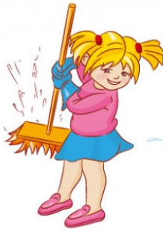
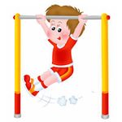
A._______________ B._______________ C.___________
- Fill in the missing words: - 5 points
- Stages of the system development include: 1. Formation. 2. ___________ 3. Final formation
- The motivating force of upbringing is the ________________.
- _____________is the study of development based on contradictions in upbringing process
- In Upbringing Conceptions of the USA social roles of people include: 1. Citizen; 2. Worker; 3. Family man; 4. ____________.
- The main value of the upbringing according to the program of upbringing in Kazakhstan is_____________.
- Translate the following words: - 5 points
- Aptitude –
- Skill –
- Obligation –
- Spiritual –
- Extra-curricular activities –
7. Read the pedagogical situation and answer the questions below – 10 points:
It is the first of September. The teacher of English/Biology is just a beginner – this day is her/his first day. She/he meets the class – 8 “a” but instead of the smile she/he sees the angry faces. One of the pupils says, “Where is our previous teacher?” and sits down with utter disappointment. The teacher answers hotly, “I don’t know. I was asked to teach you. It is my first day and you have spoilt it”.
- Analyze the environment. Do you remember the first of the September day? Did you like it? What could make it unhappy?
- Fill in the table below (general reasons of being happy/disappointed):
Name | Reasons for being happy on the 1st of September | Reasons for being unhappy on the 1st of September
- Give the psychological characteristics of the teenager (8th grade).
- What were the expectations of the teacher? Prove it.
- Why was the reaction of dissatisfied pupils so weird for the teacher?
- Why were the pupils so upset?
- Why did the teacher answer back with the same anger?
- Who was wrong in the situation?
- How could the teacher react back to avoid the conflict?
- Write one of your decisions for this situation.


Calculations:
If the student gained 40 out of 40 he is given 100%.
If the student scored, for example, 38 out of 40, the calculations are the following:
38*100/40=95%
or x*5/2=, where ‘x’ is the score of the student.

Mid-term test 2
“Theory and Methods of Upbringing Activity”
(40 points max. – 100%)
- True or False? – 5 points
- Admonition as a method belongs to the group of methods of organization of activity and forming the experience of social behavior.
- The discussion is a form of polemics.
- Psychological trainings can be used at any stage of the lesson.
- The aim of the Debates is to assure the neutral side (jury) in correctness of the one side and incompleteness of the opposite side.
- The criteria for the non-traditional class hour is the quality of information and its acquisition.
- Distribute the methods below, please: - 6 points
Methods of forming conscience of the personality | Methods of organization of activity and forming the experience of social behavior | Methods of stimulating of behaviour and activity

duty suggestion report reward competition pedagogical demand

- Write the definitions or continue it: - 6 points
- Discussion is…
- The structure of the role play includes : 1)________________, 2)______________, 3)____________
- Psychological training is…
- Traditional class hour is…
4. What would you do if…? – 3 points:
- Your pupils are not ready for the lesson. Nobody is ready, even excellent pupils…
_______________________________________________________
- Your pupils always forget to water plants in the class.
_______________________________________________________
- Two girls disagree to work in one team during a game. They argue.
_______________________________________________________

- Write what is defined: - 5 points
- The system of regulation principles and rules of organization of pedagogical interaction between the teacher and pupils used for reaching upbringing aims is______________________.
- The material side of the set of methods and activities is_________________.
- ____________________ is a less technologically elaborate form of simulations based on imitation of the social behavior
- ____________________ is a form of teaching communication aimed at self-work of pupils with literature, forming skills of leading discussion and protecting own viewpoints with respect to the opposite ones
- The situation having stable formal content and requiring the analysis and argumentative decisions is _____________.
- Translate the following words: - 5 points
- Admonition –
- Means of upbringing –
- Visual aids –
- CCD –
- Mindset –
7.Read the pedagogical situation and explain what methods you would use – 10 points:
1. At a lesson in the 5th class you asked two boys to give you diaries, but they refused to do it. On the one hand, there is a lesson and it is a pity to waste time on them, on the other hand – it is necessary to achieve pedagogical demand, because pupils will understand this case as a signal that it is possible not to obey you at all. What would you do?
______________________________________________________________
Method(s):_____________________________________________________
2. I come into the favourite class and I don't recognize it. Pupils played "snowballs" during the break (играли в «снежки»). Therefore they are amused and hyperactive. I look at their red faces, they are still laughing. What should I do now?
______________________________________________________________
Method(s):_____________________________________________________
Calculations:
If the student gained 40 out of 40 he is given 100%.
If the student scored, for example, 38 out of 40, the calculations are the following:
38*100/40=95%
or x*5/2=, where ‘x’ is the score of the student.

Questions for final control (TMUA)
The examination card contains 2 theoretical and 1 practical task
- Forming spiritual and moral culture of the pupil (aim, objectives, content)
- Forming healthy life style of the pupil (aim, objectives, content)
- Forming aesthetic feelings of the pupil (aim, objectives, content)
- Present main objectives of The Complex program of upbringing in Kazakhstan
- The definition of Upbringing. Its functions
- A class supervisor. His functions
- The meaning of upbringing in humanistic concept, its main positions, aims and objectives.
- Individual and anthropocentric approach as methodological base for humanistic concept of upbringing.
- Characteristics of humanistic authorial upbringing system by E.V. Bondarevskaya
- Characteristics of humanistic authorial upbringing system by O.S. Gasman
- Humanistic paradigm of upbringing
- Technocratic paradigm of upbringing
- Janusz Korczak. 10 commandments to parents
- Social upbringing and its aims, objectives, role.
- School upbringing and its aims, objectives, role
- Family upbringing and its aims, objectives, role
- Religious upbringing and its aims, objectives, role
- Penitentiary upbringing and its aims, objectives, role
- Professional upbringing and its aims, objectives, role
- National upbringing and its aims, objectives, role
- Foreign concepts of upbringing
- Requirements to the selection of the content of upbringing
- The Program of Upbringing as the main document reflecting the content. The structure of the Program.
- School of V.A. Karakovsky.
- The school of the Dialogue of cultures
- Adaptive school
- The technology of the author school of self-identification of A.N. Tubelskoy
- Convention of the Rights of Children of Kazakhstan and World. Common and different points
- Documentation of the class supervisor (register, diary, medical card, etc.)
- Traditional and non-traditional upbringing activities
- The method of Debates. Its stages.
- The method of discussion, talk, workshop
- The method of Collective creative deeds (CCD)
- The method of parental meeting. Forms of meetings
- IT-planning, methods of blogging, webinars, collective journal, etc.
- Analysis of the upbringing work
- Types of extra-curricular activities
- Case-study method in upbringing
- Guest show. Stages. Procedure.
- Traditional class hour. Differences from non-traditional.
- Forms and means of upbringing
- Methods of upbringing by G.I.Schukina
- Principles of the choosing of the method of upbringing
- Planning of upbringing work. Types of plans
- Aims of the upbringing activity. The structure of aims and putting aims.
- Types of diagnosing the upbringing activity.
- Types of cases in upbringing.
- Algorithm of solving cases.
- Monitoring of upbringing process.
- Results of upbringing process (problems and perspectives).

Examination Ticket (sample):
Қостанай мемлекеттiк педагогикалық институты
Костанайский государственный педагогический институт
Емтихан билетi № 1
Экзаменационный билет № 1
Шетел тілі кафедрасы (кафедра иностранных языков)
Пәннің аты (дисциплина): Тәрбие жұмысының теория және әдістемесі, 2 курс (күндiзгi оқу) / Теория и методика воспитательной работы, 2 курс (очное отделение)
Сұрақтар/Вопросы:
- Forming aesthetic feelings of the pupil (aim, objectives, content)
- Janusz Korczak. 10 commandments to parents
- Practical situation: Present any topics for forming patriotic feelings of pupils of the 10th class. Formulate the methods, forms and means you need.
Бекіту күні «29 қараша» 2015ж. Хаттама № 3
Дата утверждения «29 ноября» 2015 г. Протокол № 3

Оқытушысы
Преподаватель _____________________ Данилова В.В.

Кафедра меңгерушiсi
Заведующий кафедрой__________ Кудрицкая М.И.

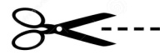
Appendix A
Card 1  Translate the words:  - Skill –  - Aptitude –  - Need –  - Life preservation –  - Upbringing objective – | Card 2  True or False?  - Upbringing process is dynamic.  - Minimal unit of upbringing is the lesson.  - Aesthetic function of the upbringing is based on the love to art.  - The system of upbringing includes management, content, organization and development.  - The results of upbringing are visible (явный, видимый).
Card 3    Formulate the objective of upbringing according to the pictures:    - В.      С. D. | Card 4  What are the levels of system illustrated here?  - We must plan beforehand.  - We are having a dialogue.  - We give knowledge and form qualities.  - We control the system.
Card 5  Two definitions of upbringing are correct, and one is not correct. Find the incorrect one.  - Upbringing is the result of education and it is measured in knowledge we child gets.  - Upbringing is the transfer of experience to young generations.  - Upbringing is the purposeful shaping of the personality for preparation to the active life. | Card 6  Give the definitions:  - Upbringing objective –  - Upbringing –  - Upbringing system -

Appendix B

The content of the Folder on Upbringing Activity

Name, Surname, Specialty, Discipline

- Glossary
- Professiogram of the class supervisor.
- Scenario of the upbringing activity
- Copy of one of the following Programs of Upbringing in Kazakhstan:
  - Atameken,
  - Elim-ai,
  - Kausar-Bulak,
  - Zhasyl El,
  - The Program of moral and spiritual upbringing of pupils
- The Complex program of upbringing in Kazakhstan
- The scheme for analysis of CCD
- 10 commandments of J. Korczak
- Scenario of the parents meeting.
- The scheme of analysis the parents meeting.
- The act of visiting the family of the pupil

Appendix C

Content of the Diary of the Class Supervisor (sample):
1. Problems of educational activity for academic year.
2. The list of normative and methodical documents on upbringing work.
3. The analysis of upbringing work of the class teacher for last year.
4. Upbringing purpose of a class monitoring.
5. The list of a class with biographical particulars (year of birth, the house, address, first name, middle initial, last name parents, place of work).
6. Employment of pupils on a term of academic year.
7. Class assessment.
8. Statistics on year of birth of pupils of a class.
9. National structure.
10. Observation on a class.
11. Observation on a class for a year.
12. Control of attendance of pupils for academic year on months.
13. Page of control of diaries of pupils.
14. Monitoring of participation of pupils of a class in all-school actions for terms.
15. Monitoring of participation of pupils of a class following the results of the academic year.
16. Monitoring of participation of pupils of a class in labor activities.
17. Employment of pupils of a class hours (lesson schedule, time, day) on half-year.
18. Social passport of a class.
19. The map – the characteristic of a class (progress, advantages, shortcomings, interests of each pupil are designated).
20. The plan of educational work in a class on weeks, months, terms in which the following directions of educational work in a class are designated: decades, months, education of the Kazakhstani patriotism and civic consciousness, legal education, Healthy lifestyle, traffic regulations, Fundamentals of Health and Safety, moral education, ecological and labor education, esthetic, work with parents, work with pupils
21. Subject of class hours of programs for traffic regulations, Fundamentals of Health and Safety, HIV/AIDS.
22. Page of individual work with pupils.
25. Individual work with pupils of "the risk group".
26. Plan of individual work with pupils of "the risk group".
27. Work with parents. Plan of work of parental committee for academic year.
28. Data on visit of families of pupils.
29. The report of the class supervisor on study for each term.
30. Scope of parental meetings for academic year.
31. Control of visit of parental meetings by parents.
32. Protocols of parental meetings.
33. Methodical recommendations about writing of the characteristic of a class.
34. A matrix for drawing up the analysis of educational work for academic year.

References:

- Ekanem, S.A., Ekefre, E.N. (2013). Ethics and Professionalism in Education as Tools for Social Reconstruction and Development, Mediterranean Journal of Social Sciences, 4 (14), 15-21.
- Khuziakhmetov, A.N., Nasibullov, R. R. ( 2015 ) Dialectics Of Correlation Of The Schoolchild Personality Socialization And Individualization // Procedia - Social and Behavioral Sciences, pp.843 – 847
- Афонина Г.М. Педагогика – Р-н-Д, 2002, лекция 9.
- Балашова В.А. и др. Планирование работы средней школы – М., 2003
- Безрукова В. С. Педагогика. - Екатеринбург: Деловая книга, 1996. - С. 80.
- Болдырев Н.И. Методика воспитательной работы. – М., 1981.
- Болдырев Н.И. Методика работы классного руководителя. – М., 1984.
- Василькова Ю.В. Социальная педагогика – М., 2000. Лекция 11,15
- Воронов В.В. Педагогика школы в двух словах – М., 1999 - С. 39-43
- Вульфов Б.З., Поташник М.М. Организация внеклассной и внешкольной работы – М., 1978, 48-69 стр.
- Григоренко Ю.Н., Кострецова У.Ю. КТД. – М.,1999
- Дереклеева Н.И. Справочник классного руководителя – М., 2003, 52-71 стр.
- Джуринский А.Н. История педагогики – М., 2000 - С.399-402.
- Календарное планирование. Планирование деятельности классного руководителя // Классный руководитель, 2003, № 5;
- Калечиц Т.Н., Кейлина З.А. Внеклассная и внешкольная работа с учащимися – М., 1980, 47-56 стр.
- Классному руководителю о воспитательной системе класса /Под ред. Е.Н. Степанова. – М., 2001.
- Коджаспирова Г.М. Педагогика – М., 2003 - С.112-116.
- Комплексная программа воспитания в образовательных организациях РК. – А., 2006.
- Концепция воспитания детей дошкольного и школьного возраста //Учитель Казахстана, 1993, № 4, 18.02.
- Кукушин В.С. Общие основы педагогики – М., 2002, гл. 2.
- Кукушин В.С. Теория и методика воспитательной работы – Р-н-Д, 2004 - С.26-46
- Лизинский В.М. Практическое воспитание в школе – М., 2002, часть 1, 91-126 стр.
- Маленкова Л.И. Теория и методика воспитания – М., 2002 - С.14-18.
- Педагогические теории, системы, технологии / Под ред. Смирнова С.А., М., 2001, 566-371 стр.
- Планирование и организация воспитательной работы // Классный руководитель, 2004, № 3;
- Подласый И.П. Педагогика, кн.1. М., 2002 - С.145-151, 154-158
- Рожков М.И. Классному руководителю. – М., 1999.
- Рувинский Л.Н. Методика воспитательной работы. – М., 1989.
- Симоненко В.Д. Общая и профессиональная педагогика. – М., 2005. С. 259
- Сластёнин В.А. Методика воспитательной работы, - М., 2002, гл.1, § 2,3.
- Сластёнин В.А. Общая педагогика. Часть 2. - М., 2003, гл. 11, § 1
- Степанова Е.А. Воспитательная система класса. – Псков, 1998.
- Степанова Е.Н. Классному руководителю о воспитательной системе класса – М., 2001. гл.2
- Степанова Е.Н. Планирование воспитательной работы в классе – М., 2003.
- Стефановская Т.А. Педагогика: наука или искусство – М., 1998, С. 281-293
- Столяренко Л.Д. Педагогика – Р-н-Д, 2000 - С.100-108.
- Титов В.А. Общая педагогика – М., 2003 - С.58-63.
- Титова Е.В. Если знать, как действовать. - М.: Просвещение, 1993. - С. 103.
- Щуркова Н.Е. Вы стали классным руководителем - М., 1988
- Щуркова Н.Е. Классное руководство - М.,1999

