ҚМПИ ЖАРШЫСЫ №3 (47), 2017 ВЕСТНИК КГПИ №3 (47), 2017
ISSN 2310-3353 ISSN 2310-3353

ПӘНДЕРДІ ОҚЫТУ ӘДІСТЕМЕСІ ЖӘНЕ ТЕХНОЛОГИЯСЫ МЕТОДИКА И ТЕХНОЛОГИЯ ПРЕПОДАВАНИЯ ДИСЦИПЛИН

УДК 372.881.111.1

Assan, Zh.A.,
4th-year student of specialty «5B011900 – Foreign language: two foreign languages», KSPI, Kostanai, Kazakhstan

Matveeva, N.A.,
candidate of pedagogical sciences,
senior lecturer, KSPI, Kostanai, Kazakhstan

TEACHING WORD ORDER IN AN ENGLISH SIMPLE SENTENCE TO KAZAKH-SPEAKING STUDENTS
Abstract
No doubt it is impossible to advance in a language without the knowledge of grammar, without the forming of a grammar mechanism. Thus, the present research is devoted to the study of grammar interference, one of the current problems in English language teaching to Kazakh native speaking students. Based on the theoretical analysis, the authors put forward the developed system of exercises on the formation of the simple sentence construction skills (grammatical skills), which helps to reduce the level of the native language interference when learning English as a foreign language. The reliability of the research results is confirmed by experimental data obtained in the course of personal practical experience of using the developed system of exercises.
Keywords: word order, system of exercises, foreign language learning.

Introduction.
In order to understand a language and to express oneself correctly one must assimilate the grammar mechanism of the language studied. Indeed, one may know all the words in a sentence and yet fail to understand it, if one does not see the relation between the words in the given sentence. And vice versa, a sentence may contain one, two, and more unknown words but if one has a good knowledge of the structure of the language one can easily guess the meaning of these words from context.
No doubt it is impossible to advance in a language without the knowledge of grammar, without the forming of a grammar mechanism. Nevertheless, the practice and results of scientific research indicate that graduates coming from the Kazakh schools have no such knowledge, and have difficulties with acquisition of grammatical material of «Basic English Language (A1, A2, B1- levels)» course [4], as English language learning is mainly based on textbooks of T. Ayapova [3], which is designed according to the modular format, where theory and practice of English grammar is not almost studied.
Moreover, we analyzed the teaching materials to see how much time is devoted to the study of English word order. The analysis of textbooks, teaching materials and programs used for teaching English at Kazakh schools testifies that in most of them the theme «Word order» is either completely absent, or is represented by separate non-systematic exercises. To teach word order as an objective was present in a couple of lesson plans.
Thus, the teachers of Kazakh speaking groups face greater challenges than teachers of Russian-speaking audience and do not cope with the task of to increase knowledge in the grammatical structure of the English language [4].

ПӘНДЕРДІ ОҚЫТУ ӘДІСТЕМЕСІ МЕТОДИКА И ТЕХНОЛОГИЯ ЖӘНЕ ТЕХНОЛОГИЯСЫ ПРЕПОДАВАНИЯ ДИСЦИПЛИН

In this regard, there is a need to justify new methods and techniques to form sentence con- struction skills. If a learner has acquired such skills, he can produce correct sentences in a foreign language, from simple sentences to compound and complex sentences.

The system of exercises.
We believe that the topic of «English Word Order» requires much more attention and more careful development of the system of exercises and tasks aimed at achieving the following objectives:
- to generate new knowledge about the laws of the word order in the English language;
- to generate knowledge about the differences between the regularities and patterns of word position in the Kazakh language;
- to develop strong skills of correct word position in word combinations of various types and in simple sentences with a different communicative orientation;
- to teach on their basis the word-ordering of statements in accordance with a certain module in the conditions of a certain situation.
When developing the system of exercises to teach English word order in a simple sentence, we took into account the functioning of this linguistic phenomenon at two levels: at the level of sentence (where the main factor determining the order of words is the actual division of the sentence), and at the level of the phrase (where the main factors are types of syntactic communication and the partial properties of the components).
Thus, the system of exercises included:
    - Level 1. Word order in the non-actualized word combinations.
    - Level 2. Word order in a meaningful sentence.
    - Level 3. Word order in a complex syntactic whole.
Training should begin by considering the word order in the non-actualized word combi- nations (the phrase acting as holistic nominative unit occupying one syntactic position in the com- municative organization of the sentence [2].
When starting the training it is necessary to draw the students’ attention to the fact that word combinations are formed by pairs of words, often belonging to different parts of speech, and in them a different order of components is observed. Therefore, the teacher challenges the students to perform the following system of tasks:
- read the phrase;
- find the main and dependent word;
- determine which part of the speech is the main word, and which is the dependent one;
- determine the nature of the syntactic connection;
- draw a conclusion about the order of the main and dependent components in relation to each other.
Thus, when teaching correct adjective order in a word combination and then in the sentence, we organized the work in the following way.
When more than one adjective comes before a noun, the adjectives are normally in a particular order. Adjectives which describe opinions or attitudes (e.g. amazing) usually come first, before more neutral, factual ones (e.g. red):
She was wearing an amazing red coat.
Not: … red amazing coat
If we don’t want to emphasize any one of the adjectives, the most usual sequence of adjectives is:

order | relating to | examples
1 | opinion | unusual, lovely, beautiful
2 | size | big, small, tall
3 | physical quality | thin, rough, untidy
4 | shape | round, square, rectangular

ҚМПИ ЖАРШЫСЫ №3 (47), 2017 ВЕСТНИК КГПИ №3 (47), 2017
ISSN 2310-3353 ISSN 2310-3353

5 | age | young, old, youthful
6 | colour | blue, red, pink
7 | origin | Dutch, Japanese, Turkish
8 | material | metal, wood, plastic
9 | type | general-purpose, four-sided, U-shaped
10 | purpose | cleaning, hammering, cooking

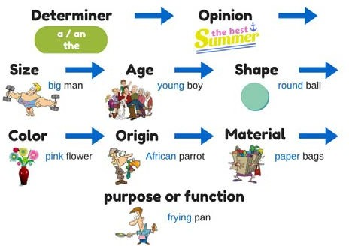

When doing the exercise, it is important to ensure that students, when composing a word-by- pattern, pay attention to the pattern-model of the phrase. For visual support it is useful to use mnemonics (see Picture 1).
Picture 1 – Mnemonics to teach adjective order in English

To form skills in the proper placement of adjectives in English word combination we used exercises with such tasks, for example:
  - Fill in the table with adjectives. Place them in the correct box, e.g.
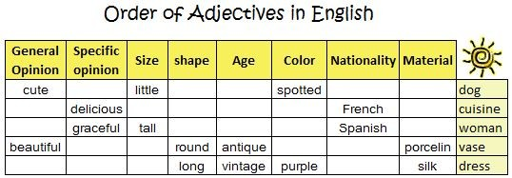
  - Correct the mistakes in the order of adjectives in the following word combinations;
  - You are given a noun. Add as many adjectives as you can to describe the noun;
  - Describe the picture.
In the similar way we taught word order in other types of word combinations: noun+verb, verb+adverb; verb+noun, noun+verb+adjective, etc.
In such way we divided the English simple sentence into constituent parts and taught word order in these constituents. To show the students that the word order in each type of word combination is due to the structure of the phrase itself, it was necessary to give appropriate explanations and confirm them with examples.
The next level was to teach how to combine the word combinations (constituent parts) in a meaningful sentence (see Picture 2). This stage was divided into several steps:
Step 1. Composition of a simple sentence from the words presented in grammatical forms required for this sentence.
The task could be the following: Make up sentences from the words given below without changing their grammatical forms. Use the correct word order.

ПӘНДЕРДІ ОҚЫТУ ӘДІСТЕМЕСІ МЕТОДИКА И ТЕХНОЛОГИЯ ЖӘНЕ ТЕХНОЛОГИЯСЫ ПРЕПОДАВАНИЯ ДИСЦИПЛИН

brown / The / dog / loudly / the / red / collar / always / with / barks.
Step 2. Composition of a simple sentence from the words presented in their “initial” forms – the infinitive for verbs, no possessive case or plural form of nouns, etc.
The tasks could be the following:
- Make up sentences from the words given below without changing their order. Put the words in the necessary grammatical form.
I / to be / from / Australia.
The / sun / to set / in / the / west. The / dog / always / to bark / loudly.
We / to like / to play / with / Alice / dolls.
- Make up sentences from the words given below. without changing their order. Put the words in the necessary grammatical form. Use the correct word order.
We began with three-word sentences and moved to a bigger number of words in the sentence.
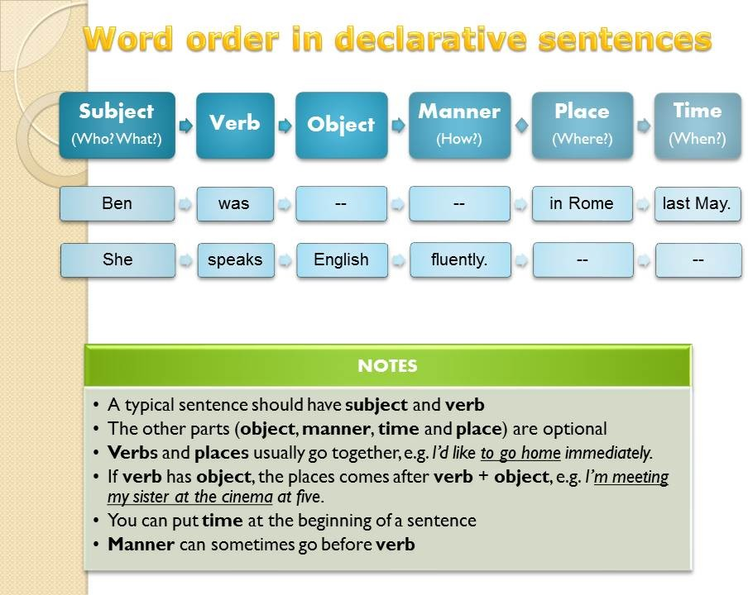
Picture 2 – Word Order in an English simple sentence

It was done using the same types of tasks listed above. In addition to them we added
comparison-contrast exercises, for example:
  - What is typical word order in the Kazak sentence? Is it different from the English?
  - How is Kazakh word order different from English?
  - What is similar in ordering words in Kazakh and English sentences?
Having studied positive sentence structure, we moved onto negatives and questions.
Word Order in Negative Sentences. The word order in negative sentences is the same as in affirmative sentences. However, in negative sentences we usually need an auxiliary verb. The following tasks were used:
- Fill in the table with the words given below. Place them in the correct box, e.g.:

subject | verbs | indirect object | direct object | place | time
I | will not tell | you | the story | at school | tomorrow.
- Write the negative form of the following sentences;
- Arrange the words to make negative sentences. Place time expressions at the end of the sentences.

ҚМПИ ЖАРШЫСЫ №3 (47), 2017 ВЕСТНИК КГПИ №3 (47), 2017
ISSN 2310-3353 ISSN 2310-3353

our holiday / will / at home / we / not / spend / next year did / I / him / see / not / last night / at the disco
to a party / not / we / tonight / going / are
will / a letter / not / next week / send / you / she not / the truth / did / he / tell / you
to the cinema / we / want / not / do / tonight / to go play / in the bar / did / he / last week / not / the piano not / now / she / in England / is
eat / in winter / ice-cream / do / not / I right now / have / not / we / time / do
- Translate the following sentences from Kazakh into English. Pay attention to word order.
Word Order in Questions. In questions, the word order subject-verbs-object is the same as in affirmative sentences. The only thing that’s different is that you usually have to put the auxiliary verb (or the main verb «be») before the subject. Interrogatives are put at the beginning of the sentences:
The following tasks were used:
- Fill in the table with the words given below. Place them in the correct box, e.g.:

interro- gative | auxiliary verb | subject | other verb(s) | indirect object | direct object | place | time
What | would | you | like | to tell | me
 | Did | you | have |  | a party | in your flat | yesterday?
When | were | you |  |  | here?
- Put questions to the underlined words;
- Arrange the words to make questions.
do / a dog / you / have you / coffee / do / like speak/ she / English / does he / can / dance
play / at / you / the weekends / do / tennis go / last night / out / you / did
the train / when / leave / does
him / she / did / the truth / tell / why on / they / holiday / are
she / Australia / from / is
- Translate the following sentences from Kazakh into English. Pay attention to word order.
The exercises of the next level are the complication of the previous ones; it acquires a completely new quality, since students must take into account the context when composing each sentence that is part of a complex syntactic whole.
Work with tasks of this type is traditionally built on the principle of increasing the number of sentences that constitute the unity [2], So, we began with short texts of 3-4 sentences, and day- by-day made them bigger up to 7-8 sentences.

Results.
The efficiency of the developed suggested system of exercises was tested in the framework of experimental training conducted during two terms in the 2016-2017 academic year. Approbation was of a natural character, as it took place in a real educational process of Shagalaly secondary school. 29 students of the 5 «Ә» grade and 2 teachers of English took part in the experiment.
As class is divided into 2 sub-groups for English lessons, the first sub-group was chosen as the control group (CG), and the second sub-group served as the experimental group (EG). In the CG the sentence construction training was not specially organized. The lessons were conducted in

ПӘНДЕРДІ ОҚЫТУ ӘДІСТЕМЕСІ МЕТОДИКА И ТЕХНОЛОГИЯ ЖӘНЕ ТЕХНОЛОГИЯСЫ ПРЕПОДАВАНИЯ ДИСЦИПЛИН

accordance with the traditional types of activities, while in the EG the lessons were enriched with the system of exercises and tasks aimed at formation of the English simple sentence construction skills.
A comparative analysis of the total number of errors of school students at the pre-knowledge evaluation stage and post-knowledge evaluation stage (see Table 1, Figure 1) showed a significant decrease in the influence of the native language of students on their English speech at the level of a simple sentence.
Table 1 – Dynamics of grammatical interference in the beginning and at the end of the experiment

Stages | Errors  caused by L1 interference | Errors  NOT caused by L1 interference
pre-knowledge evaluation stage | 633 (31,65%) | 189 (9,45%)
post-knowledge evaluation stage | 43 (2,15%) | 101 (5,05%)
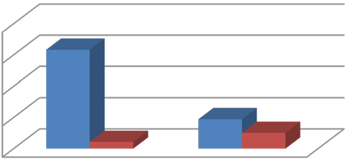
Errors caused by L1 Errors not caused by interference L1 interference
pre-knowledge evaluation stage
post-knowledge evaluation stage
40
30
20
10
0
Figure 1 – Dynamics of grammatical interference in the beginning and at the end of the experiment in EG

Thus, the results of the experimental training proved that the developed system of exercises with regular use in the educational process allowed achieving significant results in the formation, development and improvement of the simple sentence construction skills of students studying English as a foreign language.

Conclusions.
The suggested system of exercises in its content and structure corresponds to the general didactic principles, the target orientation and meets the requirements imposed on it from the point of view of pedagogy, psychology and methodology of teaching English at the national school. It should be emphasized that it is composed taking into account the main objective - the practical and communicative orientation of teaching the English language to Kazakh students. Exercises are of the same type, but the tasks are formulated in such a way that the analysis is based on the ability to compare the norms of the English word order with the Kazakh and translate from English into Kazakh, and vice versa.

References
- Крылова, О.А. Коммуникативный синтаксис русского языка [Текст] / О.А. Крылова. – М.: [б.и.], 2009. – 176 c.
- Рябова, О.В. Порядок слов в аспекте русского языка как иностранного [Текст]: специфика изучения (уровни В2 С1) / О.В. Рябова // Austrian Journal of Humanities and Social Sciences. – 2014. –
№3-4 – С. 62-66.
- Ayapova, T. English [Text]: a Textbook for General Educational Schools / Thanat Taniberdikyzy Ayapova, Danegali Berdibekuly Ukbaev. – 2nd ed., Ext. And rev. – Almaty: Atamura, 2005. – 208 p.

ҚМПИ ЖАРШЫСЫ №3 (47), 2017 ВЕСТНИК КГПИ №3 (47), 2017
ISSN 2310-3353 ISSN 2310-3353

- Kamzina, Zh. Difficulties in teaching grammar for Kazakh native speakers [Text] / Zh. Kamzina // The Kazakh-American Free University Academic Journal. – №4 – 2012. – p. 193-200.

Article submitted to editorial office: 07.06.2017

АСАН Ж.А., МАТВЕЕВА Н.А.
ҚАЗАҚ ТІЛДІ СТУДЕНТТЕРДІ АҒЫЛШЫН ТІЛІНДЕ ЖАЙ СӨЙЛЕМДІ ҚҰРУДА СӨЗ ТӘРТІБІН ҚОЛДАНУҒА ҮЙРЕТУ
Грамматиканы білмей, грамматикалық механизмдердің құрылымын білмей шетел тілін меңгеру мүмкін емес. Аталмыш зерттеу қазақ тілінде білім алушы студенттерге ағылшын тілін оқытудың бірден-бір өзекті мәселесі грамматикалық интерференцияға арналады. Өткізілген теориялық талдау негізінде авторлар грамматикалық білімдерді қалыптастыруға бағытталған ағылшын тілін шетел тілі ретінде меңгертуге арналған жаттығулар жүйесін ұсынады. Жұмыс нәтижесі ұсынылған жаттығуларды орындаудағы практикалық тәжірибе барысындағы экспери- менттік көрсеткіштер арқылы көрінеді.
Мақаланың мəнін ашатын сөздер: сөз тәртібі, жаттығулар жүйесі, шетел тілін оқыту.
АСАН, Ж.А., МАТВЕЕВА, Н.А.
ОБУЧЕНИЕ КАЗАХОГОВОРЯЩИХ СТУДЕНТОВ ПОРЯДКУ СЛОВ В ПРОСТОМ АНГЛИЙСКОМ ПРЕДЛОЖЕНИИ
Несомненно, невозможно преуспеть в изучении иностранного языка без знания грамматики, без формирования грамматического механизма. Таким образом, настоящее исследование посвящено изучению грамматической интерференции, одной из актуальных проблем преподавания английского языка для казахоговорящих обучающихся. На основании проведенного теоретического анализа авторы выдвигают собственную систему упражнений по формированию грамматических умений и навыков, способствующую снижению уровня интерференции родного языка при овладении английским как иностранным языком. Достоверность результатов работы подтверждается экспериментальными данными, полученными в процессе личного практического опыта применения разработанной системы упражнений.
Ключевые слова: порядок слов, система упражнений, обучение иностранному языку.

